Time and Subject  Monday | Learning Objective | Task/Link/Resources
8.45-9.00  Reading | LO: To practise and consolidate existing reading skills. | Read your individual reading book, either in your head or out loud.
9.00-9.15  Morning Maths | LO: To consolidate recall of number facts.  Revision LO: To identify numbers to 10000 on a number line. | Complete today’s Beat That- scroll down below today’s timetable to find the questions. Remember, it is the same one every day for a week. Can you beat your own score?  Morning Maths: In Morning Maths today, you are going to revise your knowledge of place value. Click the link below and select the video Number line to 10000.  Week 2 - Number: Place Value | White Rose Maths
9.15-9.45  Spelling | LO: To practise Unit Nine RWI spelling words. | This week, we are going to practise spelling words ending in zhun spelled -sion. Follow this link to help you to learn this spelling rule: Which words end with -sion? - BBC Bitesize  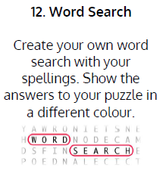  Use the activity above to practise spelling this week’s words:  collision, division, confusion, division, erosion, explosion, invasion, revision, television
9.45-10.00  Active break | LO: To boost my concentration through movement. | Join in with the Go Noodle clip below to get you moving!  Pump It Up - Fresh Start Fitness | GoNoodle - YouTube
10.00-11.00  English | SPaG Revision LO: To identify concrete and abstract nouns.  LO: To generate and develop vocabulary. | For today’s SPaG Daily Practice, revise your knowledge of nouns by answering the question below. Watch this video to help you to understand concrete and abstract nouns:  Concrete Nouns Vs. Abstract Nouns - YouTube  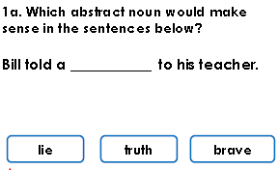  Follow the link below to have a go at today’s English lesson:  To generate and develop vocabulary (Part 1) (thenational.academy)
11.00- 11.15
Break
11.15-12.15  Maths | LO: To practise my recall of the 2 times table.  LO: To compare unit fractions using a fraction wall. | Follow the link below to practise the 2 times table and get moving!  https://www.bbc.co.uk/teach/supermovers/ks1-maths-the-2-times-table-with-bridget-the-lioness/zrrx92p  Follow the link below to have a go at today’s maths lesson:  Compare unit fractions using a fraction wall (thenational.academy)
12.15-1.00
Dinner
1.00-1.15  Storytime | LO: To listen to a story for pleasure. | Listen to Chapter 21 of The Mystwick School of Musicraft:  Audible Stories: Free Audiobooks for Kids | Audible.com
1.15-2.30  Topic- Geography | LO: To understand what resources the UK has. | Follow the link below to have a go at today’s lesson:  What resources does the UK have? (thenational.academy)
2.30-3.00  Music | LO: To review your learning on improvising. | Follow the link below to have a go at today’s lesson:  Reviewing your learning on improvising (thenational.academy)

Beat That!
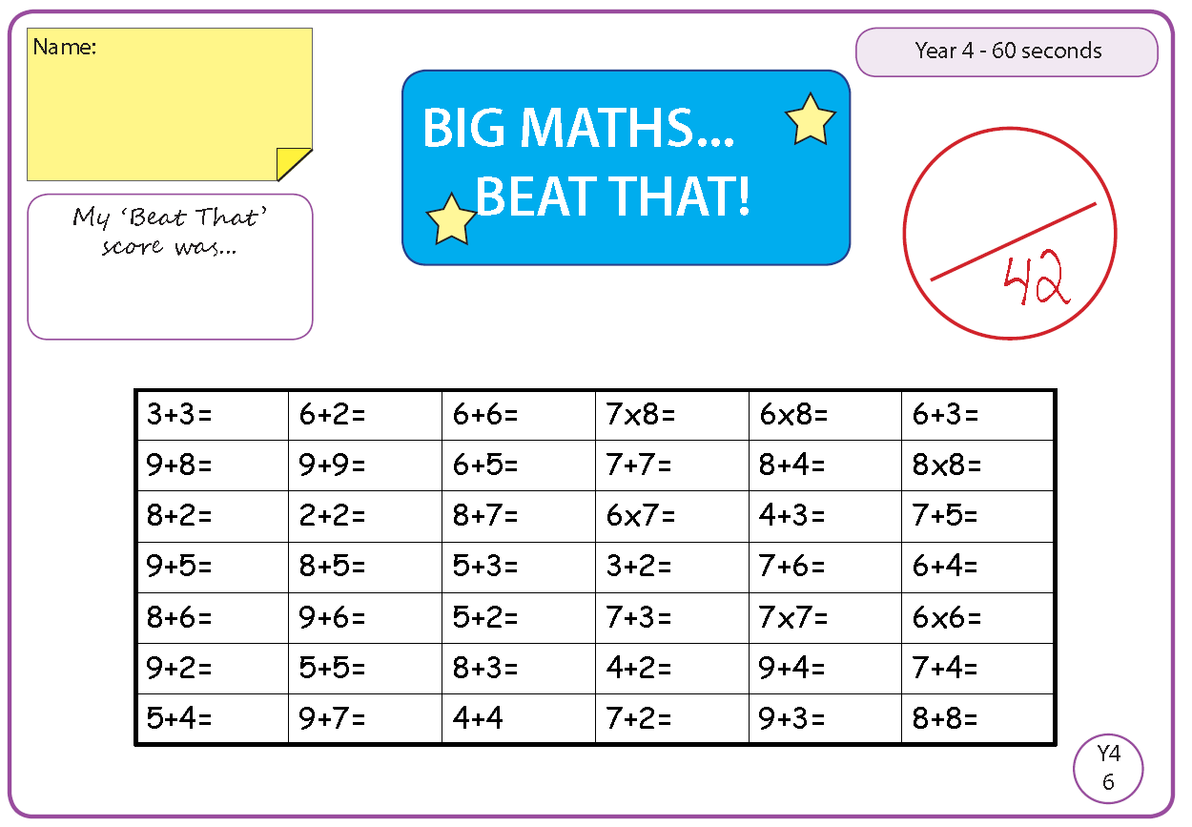

Time and Subject  Tuesday | Learning Objective | Task/Link/Resources
8.45-9.00  Reading | L.O: To practise and consolidate existing reading skills. | Read your individual reading book, either in your head or out loud.
9.00-9.15  Morning Maths | LO: To consolidate recall of number facts.  Revision LO: To find 1, 10 and 100 more or less than a number. | Complete today’s Beat That- scroll down below today’s timetable to find the questions. Remember, it is the same one every day for a week. Can you beat your own score?  Morning Maths: In Morning Maths today, you are going to revise your knowledge of place value. Click the link below and select the video 1 10 100 more or less.  Week 3 - Number: Place Value | White Rose Maths
9.15-9.45  Spelling | LO: To practise Unit Nine RWI spelling words. | This week, we are going to practise spelling words ending in zhun spelled -sion.  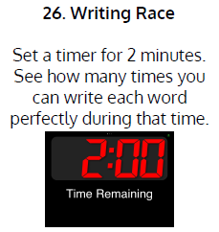  Use Writing Race to practise spelling this week’s words:  collision, division, confusion, division, erosion, explosion, invasion, revision, television
9.45-10.00  Active break | L.O: To boost my concentration through movement. | Join in with the Go Noodle clip below to get you moving!  Indoor Recess: The Ultimate Champ | GoNoodle - YouTube
10.00-11.00  English | SPaG Revision LO: To identify concrete and abstract nouns.  LO: To investigate suffixes: -ial. | For today’s SPaG Daily Practice, revise your knowledge of nouns by answering the question below:  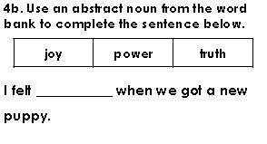  Follow the link below to have a go at today’s English lesson:  To investigate suffixes: -ial (thenational.academy)
11.00- 11.15
Break
11.15-12.15  Maths | LO: To practise my recall of the 2 times table.  LO: To reason about comparing unit fractions. | Follow the link below to practise the 2 times table:  https://www.timestables.co.uk/2-times-table.html  Follow the link below to have a go at today’s maths lesson:  Reason about comparing unit fractions (thenational.academy)
12.15-1.00
Dinner
1.00-1.15  Storytime | LO: To listen to a story for pleasure. | Listen to Chapter 22 of The Mystwick School of Musicraft:  Audible Stories: Free Audiobooks for Kids | Audible.com
1.15-2.30  Topic-Geography | LO: To explore how resource exploitation causes problems. | Follow the link below to have a go at today’s lesson:  How does resource exploitation cause problems? (thenational.academy)
2.30-3.00  French | LO: To talk about food and drink in French. | Follow the link below to have a go at today’s lesson:  Food and Drink - KS2 French - BBC Bitesize - BBC Bitesize

Beat That!

Time and Subject  Wednesday | Learning Objective | Task/Link/Resources
8.45-9.00  Reading | L.O: To practise and consolidate existing reading skills. | Read your individual reading book, either in your head or out loud.
9.00-9.15  Morning Maths | LO: To consolidate recall of number facts.  Revision LO: To find 1000 more or less than a number. | Complete today’s Beat That- scroll down below today’s timetable to find the questions. Remember, it is the same one every day for a week. Can you beat your own score?  Morning Maths: In Morning Maths today, you are going to revise your knowledge of place value. Click the link below and select the video 1000 more or less.  Week 3 - Number: Place Value | White Rose Maths
9.15-9.45  Spelling | LO: To practise Unit Nine RWI spelling words. | This week, we are going to practise spelling words ending in zhun spelled -sion.  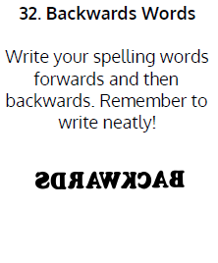  Use Writing Race to practise spelling this week’s words:  collision, division, confusion, division, erosion, explosion, invasion, revision, television
9.45-10.00  Active break | LO: To boost my concentration through movement. | Join in with the clip below to get you moving!  Sherlock Gnomes Move N' Groove | GoNoodle - YouTube
10.00-11.00  English | SPaG Revision LO: To identify concrete and abstract nouns.  LO: To explore expanded noun phrases. | For today’s SPaG Daily Practice, revise your knowledge of nouns by answering the question below:  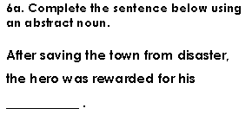  Follow the link below to have a go at today’s English lesson:  To explore expanded noun phrases (thenational.academy)
11.00- 11.15
Break
11.15-12.15  Maths | LO: To practise my recall of the 2 times table.  LO: To compare unit fractions in a measure’s context. | Follow the link below to practise the 2 times table and get moving!  https://www.youtube.com/watch?v=iiR8hqJeQsw  Follow the link below to have a go at today’s maths lesson:  Compare unit fractions in a measure's context (thenational.academy)
12.15-1.00
Dinner
1.00-1.15  Storytime | LO: To listen to a story for pleasure. | Listen to Chapter 23 of The Mystwick School of Musicraft:  Audible Stories: Free Audiobooks for Kids | Audible.com
1.15-2.30  Topic-Geography | LO: To understand what the circular economy is. | Follow the link to have a go at today’s lesson:  What is the circular economy? (thenational.academy)
2.30-3.00  RHE | LO: To understand the importance of looking after your teeth. | Follow the link to have a go at today’s lesson:  Pearly Whites (thenational.academy)

Beat That!

Time and Subject  Thursday | Learning Objective | Task/Link/Resources
8.45-9.00  Reading | L.O: To practise and consolidate existing reading skills. | Read your individual reading book, either in your head or out loud.
9.00-9.15  Morning Maths | LO: To consolidate recall of number facts.  Revision LO: To compare 4-digit numbers. | Complete today’s Beat That- scroll down below today’s timetable to find the questions. Remember, it is the same one every day for a week. Can you beat your own score?  Morning Maths: In Morning Maths today, you are going to revise your knowledge of place value. Click the link below and select the video Compare 4-digit numbers.  Week 3 - Number: Place Value | White Rose Maths
9.15-9.45  Spelling | LO: To practise Unit Nine RWI spelling words. | This week, we are going to practise spelling words ending in zhun spelled -sion.  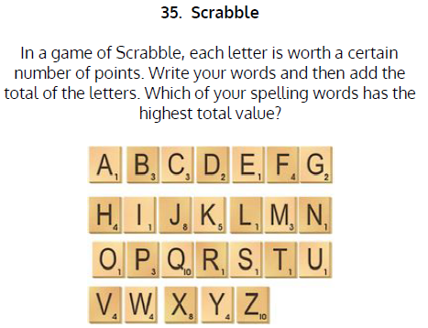  Use Scrabble to practise spelling this week’s words:  collision, division, confusion, division, erosion, explosion, invasion, revision, television
9.45-10.00  Active break | LO: To boost my concentration through movement. | Join in with the Go Noodle clip below to get you moving!  A-Moose-Ta-Cha - Moose Tube | GoNoodle - YouTube
10.00-11.00  English | SPaG Revision LO: To identify concrete and abstract nouns.  LO: To write a free verse poem. | For today’s SPaG Daily Practice, revise your knowledge of nouns by answering the question below:  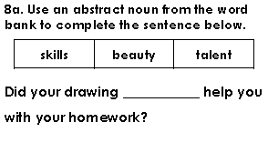  Follow the link below to have a go at today’s English lesson:  To write a free verse poem (thenational.academy)
11.00- 11.15
Break
11.15-12.15  Maths | LO: To practise my recall of the 2 times table.  LO: To compare unit fractions of different wholes. | Follow the link below to practise the 2 times table:  http://www.snappymaths.com/multdiv/2xtable/interactive/newlook/2xtablebtcd.htm  Follow the link below to have a go at today’s lesson:  Can we compare unit fractions of different wholes? (thenational.academy)
12.15-1.00
Dinner
1.00-1.15  Storytime | LO: To listen to a story for pleasure. | Listen to Chapter 24 of The Mystwick School of Musicraft:  Audible Stories: Free Audiobooks for Kids | Audible.com
1.15-3.00  PE | LO: To build strength and stamina. | Follow the link to have a go at today’s PE activity:  'AVENGERS TRAINING ACADEMY' - SPIDER-MAN HIIT WORKOUT - YouTube

Beat That!

Time and Subject  Friday | Learning Objective | Task/Link/Resources
8.45-9.00  Reading | L.O: To practise and consolidate existing reading skills. | Read your individual reading book, either in your head or out loud.
9.00-9.15  Morning Maths | LO: To consolidate recall of number facts.  Revision LO:  To order numbers. | Complete today’s Beat That- scroll down below today’s timetable to find the questions. Remember, it is the same one every day for a week. Can you beat your own score?  Morning Maths: In Morning Maths today, you are going to revise your knowledge of place value. Click the link below and select the video Order numbers.  Week 3 - Number: Place Value | White Rose Maths
9.15-9.45  Spelling | LO: To practise Unit Nine RWI spelling words. | This week, we are going to practise spelling words ending in zhun spelled -sion.  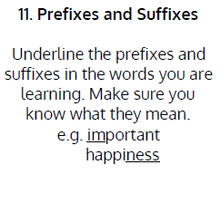  Use Scrabble to practise spelling this week’s words:  collision, division, confusion, division, erosion, explosion, invasion, revision, television  Spelling Test:  Scroll down below today’s timetable to use the look, cover, write, check sheet to help you to test yourself on this week’s words.
9.45-10.00  Active break | L.O: To boost my concentration through movement. | Join in with the Go Noodle clip to get you moving!  Pizza Man - Moose Tube | GoNoodle - YouTube
10.00-11.00  English | SPaG Revision LO: To identify concrete and abstract nouns.  LO: To develop a rich understanding of words associated with happiness. | For today’s SPaG Daily Practice, revise your knowledge of nouns by answering the question below:  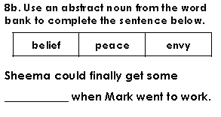  Follow the link below to have a go at today’s lesson:  To develop a rich understanding of words associated with happiness (Part 2) (thenational.academy)
11.00- 11.15
Break
11.15-12.15  Maths | LO: To practise my recall of the 2 times table.  LO: To construct a whole from a part and identify the fraction it represents. | Follow the link below to practise the 2 times table:  http://www.snappymaths.com/multdiv/2xtable/interactive/newlook/2xmissintd.htm  Follow the link below to have a go at today’s lesson:  Construct a whole from a part and identify the fraction it represents (thenational.academy)
12.15-1.00
Dinner
1.00-1.15  Storytime | LO: To listen to a story for pleasure. | Listen to Chapter 25 of The Mystwick School of Musicraft:  Audible Stories: Free Audiobooks for Kids | Audible.com
1.15-3:00  Art | Golden Time  LO: To create optical illusion art. | Collage  Using pieces of paper, create a collage of a flower. Take a look at Ben Giles to be inspired by an amazing collage artist!

Beat That!
Spelling Test
