Time and Subject  Monday | Learning Objective | Task/Link/Resources
8.45-9.00  Reading | LO: To practise and consolidate existing reading skills. | Read your individual reading book, either in your head or out loud.
9.00-9.15  Morning Maths | LO: To consolidate recall of number facts.  Revision LO: To represent numbers to 1000. | Complete today’s Beat That- scroll down below today’s timetable to find the questions. Remember, it is the same one every day for a week. Can you beat your own score?  Morning Maths: In Morning Maths today, you are going to revise your knowledge of place value. Click the link below and select the video Represent numbers to 1000.  Week 1 - Number: Place Value | White Rose Maths
9.15-9.45  Spelling | LO: To practise Unit Nine RWI spelling words. | This week, we are going to practise adding the suffix -ion.  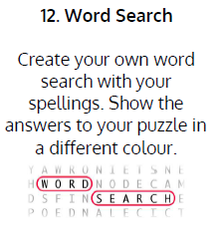  Use the activity above to practise spelling this week’s words:  collision, division, confusion, division, erosion, explosion, invasion, revision, television
9.45-10.00  Active break | LO: To boost my concentration through movement. | Join in with the Go Noodle clip below to get you moving!  Pump It Up - Fresh Start Fitness | GoNoodle - YouTube
10.00-11.00  English | SPaG Revision LO: To identify prepositions to express place.  LO: To identify the features of adverts. | For today’s SPaG Daily Practice, revise your knowledge of prepositions. Follow the link to have a go at today’s lesson:  Using prepositions - Year 5 - P6 - English - Catch Up Lessons - Home Learning with BBC Bitesize - BBC Bitesize  Follow the link below to have a go at today’s English lesson:  To understand the features of adverts (thenational.academy)
11.00- 11.15
Break
11.15-12.15  Maths | LO: To practise my recall of the 2 times table.  LO: To measure lengths to the nearest cm or mm. | Follow the link below to practise the 2 times table and get moving!  https://www.bbc.co.uk/teach/supermovers/ks1-maths-the-2-times-table-with-bridget-the-lioness/zrrx92p  Follow the link below to have a go at today’s maths lesson:  Measuring lengths to the nearest cm or mm (thenational.academy)
12.15-1.00
Dinner
1.00-1.15  Storytime | LO: To listen to a story for pleasure. | Listen to Chapter 10 of The Golden Orchid:  Audible Stories: Free Audiobooks for Kids | Audible.com
1.15-2.30  Topic- Geography | LO: To explore what happens when an earthquake occurs. | Follow the link below to have a go at today’s lesson:  What happens when an earthquake occurs? (thenational.academy)
2.30-3.00  Music | LO: To compose rhythms. | Follow the link below to have a go at today’s lesson:  Composing rhythms (thenational.academy)

Beat That!
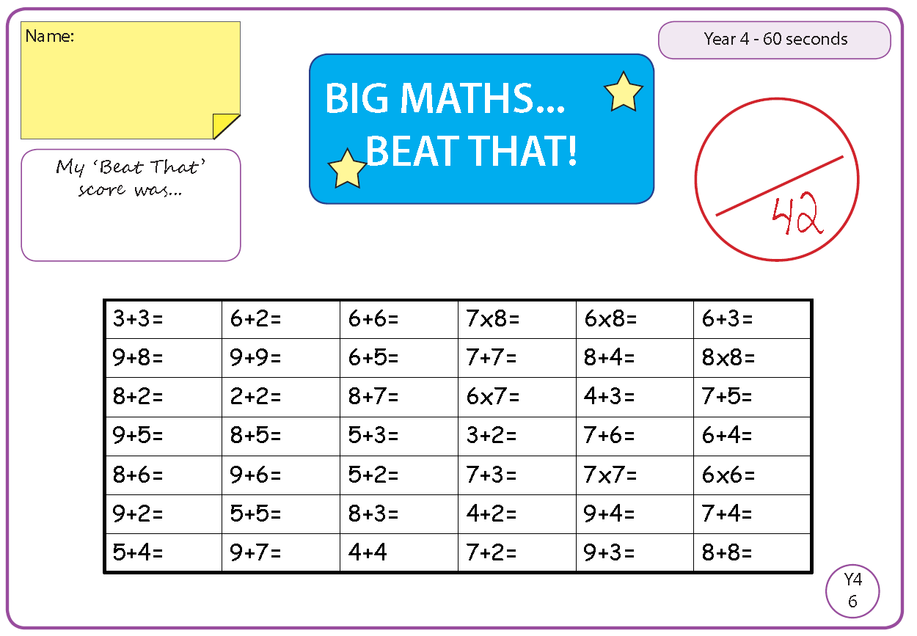

Time and Subject  Tuesday | Learning Objective | Task/Link/Resources
8.45-9.00  Reading | L.O: To practise and consolidate existing reading skills. | Read your individual reading book, either in your head or out loud.
9.00-9.15  Morning Maths | LO: To consolidate recall of number facts.  Revision LO: To understand the value of 10s and 1s. | Complete today’s Beat That- scroll down below today’s timetable to find the questions. Remember, it is the same one every day for a week. Can you beat your own score?  Morning Maths: In Morning Maths today, you are going to revise your knowledge of place value. Click the link below and select the video 10s and 1s using addition.  Week 1 - Number: Place Value | White Rose Maths
9.15-9.45  Spelling | LO: To practise Unit Nine RWI spelling words. | This week, we are going to practise adding the suffix -ion.  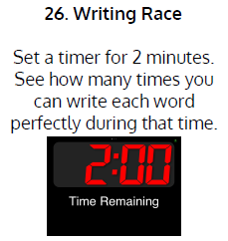  Use Writing Race to practise spelling this week’s words:  action, attraction, celebration, collection, concentration, construction, correction, education, exaggeration, hesitation, injection, invention
9.45-10.00  Active break | L.O: To boost my concentration through movement. | Join in with the Go Noodle clip below to get you moving!  Indoor Recess: The Ultimate Champ | GoNoodle - YouTube
10.00-11.00  English | SPaG Revision LO: To identify prepositions to express place.  LO: To investigate suffixes: -er and -est. | For today’s SPaG Daily Practice, revise your knowledge of prepositions by answering the question below:  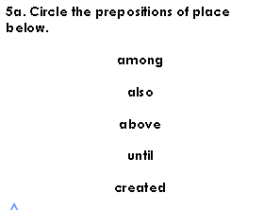  Follow the link below to have a go at today’s English lesson:  To investigate suffixes: More -er and -est suffixes (thenational.academy)
11.00- 11.15
Break
11.15-12.15  Maths | LO: To practise my recall of the 2 times table.  LO: To measure length and draw lines of a given length in mixed units. | Follow the link below to practise the 2 times table:  https://www.timestables.co.uk/2-times-table.html  Follow the link below to have a go at today’s maths lesson:  Measuring length and drawing lines of a given length in mixed units (thenational.academy)
12.15-1.00
Dinner
1.00-1.15  Storytime | LO: To listen to a story for pleasure. | Listen to Chapter 11 of The Golden Orchid:  Audible Stories: Free Audiobooks for Kids | Audible.com
1.15-2.30  Topic-Geography | LO: To understand how we can protect against earthquakes. | Follow the link below to have a go at today’s lesson:  How can we protect against earthquakes? (thenational.academy)
2.30-3.00  French | LO: To talk about food and drink in French. | Follow the link below to have a go at today’s lesson:  Food and Drink - KS2 French - BBC Bitesize - BBC Bitesize

Beat That!

Time and Subject  Wednesday | Learning Objective | Task/Link/Resources
8.45-9.00  Reading | L.O: To practise and consolidate existing reading skills. | Read your individual reading book, either in your head or out loud.
9.00-9.15  Morning Maths | LO: To consolidate recall of number facts.  Revision LO: To understand the value of hundreds. | Complete today’s Beat That- scroll down below today’s timetable to find the questions. Remember, it is the same one every day for a week. Can you beat your own score?  Morning Maths: In Morning Maths today, you are going to revise your knowledge of place value. Click the link below and select the video Hundreds.  Week 1 - Number: Place Value | White Rose Maths
9.15-9.45  Spelling | LO: To practise Unit Nine RWI spelling words. | This week, we are going to practise adding the suffix -ion.  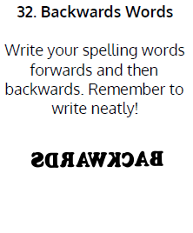  Use Writing Race to practise spelling this week’s words:  action, attraction, celebration, collection, concentration, construction, correction, education, exaggeration, hesitation, injection, invention
9.45-10.00  Active break | LO: To boost my concentration through movement. | Join in with the clip below to get you moving!  Sherlock Gnomes Move N' Groove | GoNoodle - YouTube
10.00-11.00  English | SPaG Revision LO: To identify prepositions to express place.  LO: To explore prepositions. | For today’s SPaG Daily Practice, revise your knowledge of prepositions by answering the question below:  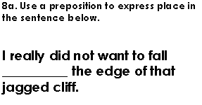  Follow the link below to have a go at today’s English lesson:  To explore prepositions (thenational.academy)
11.00- 11.15
Break
11.15-12.15  Maths | LO: To practise my recall of the 2 times table.  LO: To make appropriate estimates of length by comparing. | Follow the link below to practise the 2 times table and get moving!  https://www.youtube.com/watch?v=iiR8hqJeQsw  Follow the link below to have a go at today’s maths lesson:  Making Appropriate Estimates of Length by Comparing (thenational.academy)
12.15-1.00
Dinner
1.00-1.15  Storytime | LO: To listen to a story for pleasure. | Listen to Chapter 12 of The Golden Orchid:  Audible Stories: Free Audiobooks for Kids | Audible.com
1.15-2.30  Music | LO: To perform rhythms. | Follow the link to have a go at today’s lesson:  Performing rhythms (thenational.academy)
2.30-3.00  RHE | LO: To understand the importance of looking after your teeth. | Follow the link to have a go at today’s lesson:  Pearly Whites (thenational.academy)

Beat That!
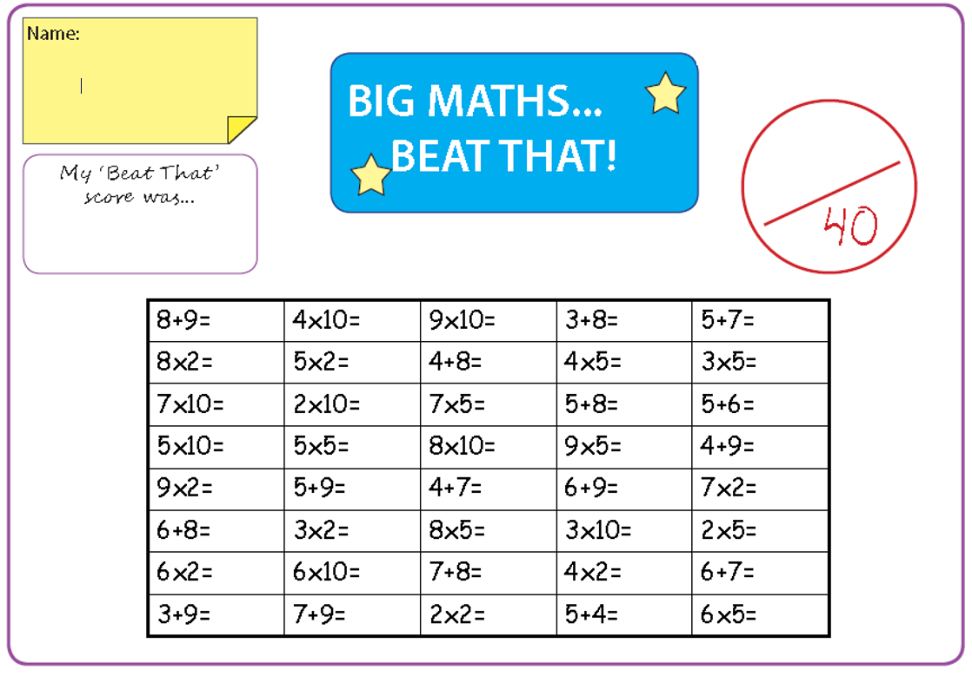

Time and Subject  Thursday | Learning Objective | Task/Link/Resources
8.45-9.00  Reading | L.O: To practise and consolidate existing reading skills. | Read your individual reading book, either in your head or out loud.
9.00-9.15  Morning Maths | LO: To consolidate recall of number facts.  Revision LO: To use numbers to 1000. | Complete today’s Beat That- scroll down below today’s timetable to find the questions. Remember, it is the same one every day for a week. Can you beat your own score?  Morning Maths: In Morning Maths today, you are going to revise your knowledge of place value. Click the link below and select the video Numbers to 1000.  Week 1 - Number: Place Value | White Rose Maths
9.15-9.45  Spelling | LO: To practise Unit Nine RWI spelling words. | This week, we are going to practise adding the suffix -ion.  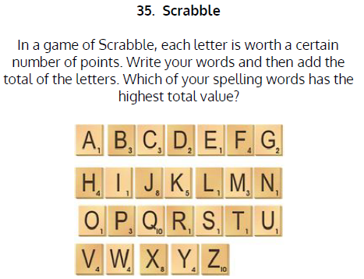  Use Scrabble to practise spelling this week’s words:  action, attraction, celebration, collection, concentration, construction, correction, education, exaggeration, hesitation, injection, invention
9.45-10.00  Active break | LO: To boost my concentration through movement. | Join in with the Go Noodle clip below to get you moving!  A-Moose-Ta-Cha - Moose Tube | GoNoodle - YouTube
10.00-11.00  English | SPaG Revision LO: To identify prepositions to express place.  LO: To build scientific vocabulary to describe healthy snacks. | For today’s SPaG Daily Practice, revise your knowledge of prepositions by answering the question below:  Follow the link below to have a go at today’s English lesson:  To build scientific vocabulary to describe healthy snacks (thenational.academy)
11.00- 11.15
Break
11.15-12.15  Maths | LO: To practise my recall of the 2 times table.  LO: To apply knowledge of length and measurement. | Follow the link below to practise the 2 times table:  http://www.snappymaths.com/multdiv/2xtable/interactive/newlook/2xtablebtcd.htm  Follow the link below to have a go at today’s lesson:  Length and Measurement Application (thenational.academy)
12.15-1.00
Dinner
1.00-1.15  Storytime | LO: To listen to a story for pleasure. | Listen to Chapter 13 of The Golden Orchid:  Audible Stories: Free Audiobooks for Kids | Audible.com
1.15-3.00  PE | LO: To build strength and stamina. | Follow the link to have a go at today’s PE activity:  'AVENGERS TRAINING ACADEMY' - SPIDER-MAN HIIT WORKOUT - YouTube

Beat That!

Time and Subject  Friday | Learning Objective | Task/Link/Resources
8.45-9.00  Reading | L.O: To practise and consolidate existing reading skills. | Read your individual reading book, either in your head or out loud.
9.00-9.15  Morning Maths | LO: To consolidate recall of number facts.  Revision LO:  To understand the value of numbers to 1000. | Complete today’s Beat That- scroll down below today’s timetable to find the questions. Remember, it is the same one every day for a week. Can you beat your own score?  Morning Maths: In Morning Maths today, you are going to revise your knowledge of place value. Click the link below and select the video Numbers to 1000 on a place value grid.  Week 1 - Number: Place Value | White Rose Maths
9.15-9.45  Spelling | LO: To practise Unit Nine RWI spelling words. | This week, we are going to practise adding the suffix -ion.  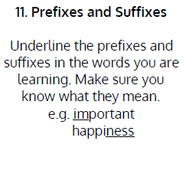  Use Scrabble to practise spelling this week’s words:  action, attraction, celebration, collection, concentration, construction, correction, education, exaggeration, hesitation, injection, invention  Spelling Test:  Scroll down below today’s timetable to use the look, cover, write, check sheet to help you to test yourself on this week’s words.
9.45-10.00  Active break | L.O: To boost my concentration through movement. | Join in with the Go Noodle clip to get you moving!  Pizza Man - Moose Tube | GoNoodle - YouTube
10.00-11.00  English | SPaG Revision LO: To express preposition of place.  LO: To develop a rich understanding of words associated with meals. | For today’s SPaG Daily Practice, revise your knowledge of prepositions by answering the question below:  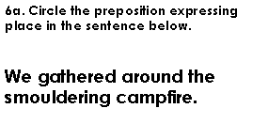  Follow the link below to have a go at today’s lesson:  To develop a rich understanding of words associated with meals (thenational.academy)
11.00- 11.15
Break
11.15-12.15  Maths | LO: To practise my recall of the 2 times table.  LO: To calculate perimeters of 2D shapes in cm and mm. | Follow the link below to practise the 2 times table:  http://www.snappymaths.com/multdiv/2xtable/interactive/newlook/2xmissintd.htm  Follow the link below to have a go at today’s lesson:  To calculate perimeters of 2D shapes in cm and mm (thenational.academy)
12.15-1.00
Dinner
1.00-1.15  Storytime | LO: To listen to a story for pleasure. | Listen to Chapter 14 of The Golden Orchid:  Audible Stories: Free Audiobooks for Kids | Audible.com
1.15-3:00  Art | Golden Time  LO: To create optical illusion art. | Collage  Using pieces of paper, create a collage of a flower. Take a look at Ben Giles to be inspired by an amazing collage artist!  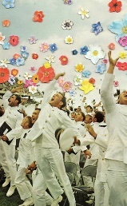

Beat That!

Spelling Test
