Time and Subject  Monday | Learning Objective | Task/Link/Resources
8.45-9.00  Reading | LO: To practise and consolidate existing reading skills. | Read your individual reading book, either in your head or out loud.
9.00-9.15  Morning Maths | LO: To consolidate recall of number facts.  Revision LO: To round to the nearest 100. | Complete today’s Beat That- scroll down below today’s timetable to find the questions. Remember, it is the same one every day for a week. Can you beat your own score?  Morning Maths: In Morning Maths today, you are going to revise your knowledge of rounding. Click the link below and select the video Round to the nearest 100.  Week 1 - Number: Place Value | White Rose Maths
9.15-9.45  Spelling | LO: To practise Year 3/4 common exception words. | This week, we are going to practise spelling some of our tricky orange words!  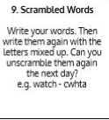  Use Scrambled Words to practise spelling this week’s orange words:  imagine, increase, important, interest, island, knowledge, learn, length, library, material, medicine, mention, material
9.45-10.00  Active break | LO: To boost my concentration through movement. | Join in with the Go Noodle clip below to get you moving!  Hola, Bonjour, HELLO! - Champiverse | GoNoodle - YouTube
10.00-11.00  English | SPaG Revision LO: To identify proper, common and collective nouns.  LO: To explore and respond to John Lyons’ poetry. | For today’s SPaG Daily Practice, you are going to revise common, proper and collective nouns. Use the links below to learn about these different types of nouns:  Can you guess the collective noun for these animals? - BBC Bitesize  What are nouns? - BBC Bitesize  Follow the link below to have a go at today’s English lesson:  To explore and respond to John Lyons' poetry: Dancing in the rain (Part 2) (thenational.academy)
11.00- 11.15
Break
11.15-12.15  Maths | LO: To practise my recall of the 8 times table.  LO: To assign unit fraction names and notation to 3D representations. | Follow the link below to practise the 8 times table and get moving!  https://www.bbc.co.uk/teach/supermovers/ks2-maths-the-8-times-table-with-filbert-fox/z4mrhbk  Follow the link below to have a go at today’s maths lesson:  Assign unit fraction names and notation to 3D representations (thenational.academy)
12.15-1.00
Dinner
1.00-1.15  Storytime | LO: To listen to a story for pleasure. | Listen to Chapter 16 of The Mystwick School of Musicraft:  Audible Stories: Free Audiobooks for Kids | Audible.com
1.15-2.30  Topic- Geography | LO: To identify the world’s natural resources. | Follow the link below to have a go at today’s lesson:  Where are the world's natural resources? (thenational.academy)
2.30-3.00  Music | LO: To explore 6 beats in a bar. | Follow the link below to have a go at today’s lesson:  https://classroom.thenational.academy/lessons/exploring-6-beats-in-a-bar-6cw38d

Beat That!
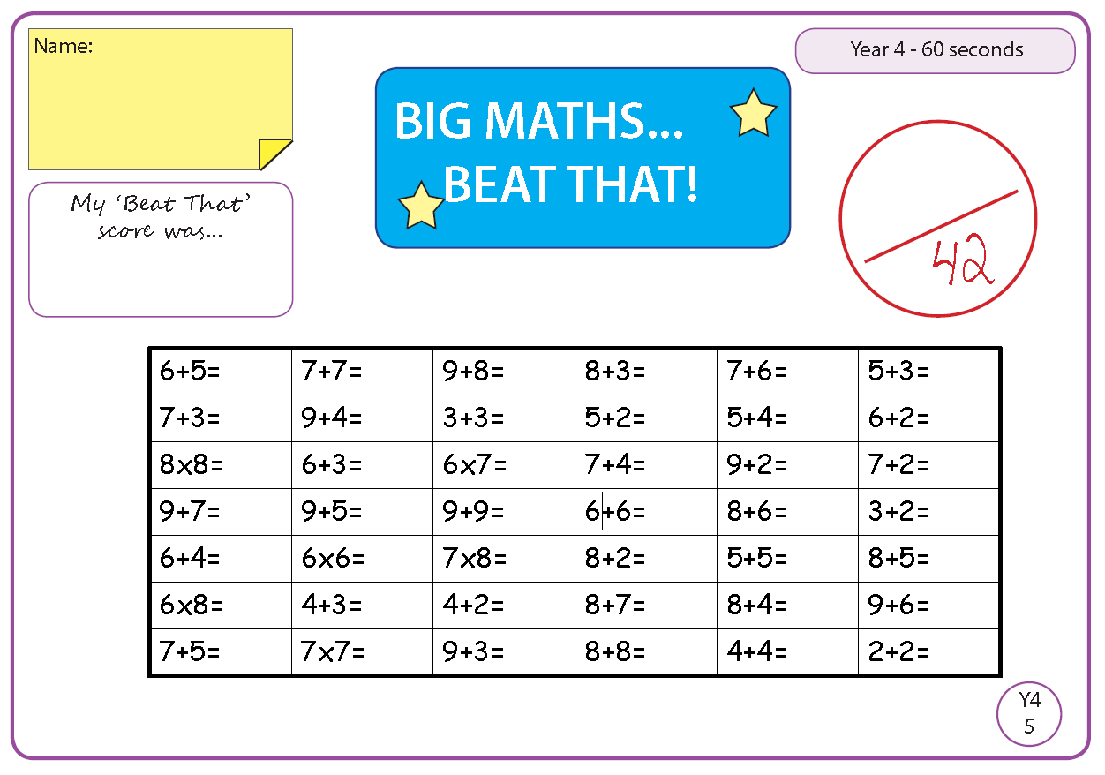

Time and Subject  Tuesday | Learning Objective | Task/Link/Resources
8.45-9.00  Reading | L.O: To practise and consolidate existing reading skills. | Read your individual reading book, either in your head or out loud.
9.00-9.15  Morning Maths | LO: To consolidate recall of number facts.  Revision LO: To count in 1000s. | Complete today’s Beat That- scroll down below today’s timetable to find the questions. Remember, it is the same one every day for a week. Can you beat your own score?  Morning Maths: In Morning Maths today, you are going to revise your knowledge of thousands. Click the link below and select the video Count in 1000s.  Week 2 - Number: Place Value | White Rose Maths
9.15-9.45  Spelling | LO: To practise Year 3/4 common exception words. | This week, we are going to practise spelling some of our tricky orange words!  Use Scrambled Words to practise spelling this week’s orange words. Can you unscramble the words you scrambled yesterday?  imagine, increase, important, interest, island, knowledge, learn, length, library, material, medicine, mention, material
9.45-10.00  Active break | L.O: To boost my concentration through movement. | Join in with the Go Noodle clip below to get you moving!  Run The Red Carpet - Hot Ticket | GoNoodle - YouTube
10.00-11.00  English | SPaG Revision LO: To identify proper, common and collective nouns.  LO: To practise and apply knowledge of suffixes: -ous. | For today’s SPaG Daily Practice, use your knowledge of nouns to answer the question below:  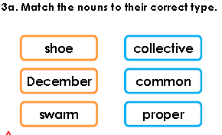  Follow the link below to have a go at today’s English lesson:  To practise and apply knowledge of suffixes: -ous, including test (thenational.academy)
11.00- 11.15
Break
11.15-12.15  Maths | LO: To practise my recall of the 8 times table.  LO: To assign unit fraction names and notation to equal parts of quantities. | Follow the link below to practise the 8 times table:  https://www.timestables.co.uk/8-times-table.html  Follow the link below to have a go at today’s maths lesson:  Assign unit fraction names and notation to equal parts of quantities (thenational.academy)
12.15-1.00
Dinner
1.00-1.15  Storytime | LO: To listen to a story for pleasure. | Listen to Chapter 17 of The Mystwick School of Musicraft:  Audible Stories: Free Audiobooks for Kids | Audible.com
1.15-2.30  Topic-Geography | LO: To understand how the use of natural resources has changed. | Follow the link below to have a go at today’s lesson:  How has the use of natural resources changed? (thenational.academy)
2.30-3.00  French | LO: To talk about school in French. | Follow the link below to have a go at today’s lesson:  Talking About School - KS2 French - BBC Bitesize - BBC Bitesize

Beat That!

Time and Subject  Wednesday | Learning Objective | Task/Link/Resources
8.45-9.00  Reading | L.O: To practise and consolidate existing reading skills. | Read your individual reading book, either in your head or out loud.
9.00-9.15  Morning Maths | LO: To consolidate recall of number facts.  Revision LO: To represent numbers to 10000. | Complete today’s Beat That- scroll down below today’s timetable to find the questions. Remember, it is the same one every day for a week. Can you beat your own score?  Morning Maths: In Morning Maths today, you are going to revise your knowledge of place value. Click the link below and select the video Represent numbers to 10000.  Week 2 - Number: Place Value | White Rose Maths
9.15-9.45  Spelling | LO: To practise Year 3/4 common exception words. | This week, we are going to practise spelling some of our tricky orange words!  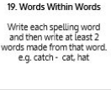  Use Words Within Words to practise spelling this week’s orange words:  imagine, increase, important, interest, island, knowledge, learn, length, library, material, medicine, mention, material
9.45-10.00  Active break | LO: To boost my concentration through movement. | Join in with the clip below to get you moving!  Kitty High Five - Awesome Sauce | GoNoodle - YouTube
10.00-11.00  English | SPaG Revision LO: To identify proper, common and collective nouns.  LO: To perform a poem. | For today’s SPaG Daily Practice, use your knowledge of nouns to answer the question below:  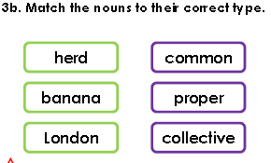  Follow the link below to have a go at today’s English lesson:  To perform a poem (thenational.academy)
11.00- 11.15
Break
11.15-12.15  Maths | LO: To practise my recall of the 8 times table.  LO: To recognise and reason about unit fractions in a variety of contexts. | Follow the link below to practise the 8 times table and get moving!  https://www.youtube.com/watch?v=SNFXWEXaCQw  Follow the link below to have a go at today’s maths lesson:  Recognise and reason about unit fractions in a variety of contexts (thenational.academy)
12.15-1.00
Dinner
1.00-1.15  Storytime | LO: To listen to a story for pleasure. | Listen to Chapter 18 of The Mystwick School of Musicraft:  Audible Stories: Free Audiobooks for Kids | Audible.com
1.15-2.30  Topic-Geography | LO: To understand what resources Chile have. | Follow the link to have a go at today’s lesson:  What resources does Chile have? (thenational.academy)
2.30-3.00  RHE | LO: To understand how images are used in the media. | Follow the link to have a go at today’s lesson:  Images in the media (thenational.academy)

Beat That!

Time and Subject  Thursday | Learning Objective | Task/Link/Resources
8.45-9.00  Reading | L.O: To practise and consolidate existing reading skills. | Read your individual reading book, either in your head or out loud.
9.00-9.15  Morning Maths | LO: To consolidate recall of number facts.  Revision LO: To understand the place value of 4-digit numbers. | Complete today’s Beat That- scroll down below today’s timetable to find the questions. Remember, it is the same one every day for a week. Can you beat your own score?  Morning Maths: In Morning Maths today, you are going to revise your knowledge of place value. Click the link below and select the video 1000s, 100s, 10s and 1s.  Week 2 - Number: Place Value | White Rose Maths
9.15-9.45  Spelling | LO: To practise Year 3/4 common exception words. | This week, we are going to practise spelling some of our tricky orange words!  Use the activity above to practise spelling this week’s orange words:  imagine, increase, important, interest, island, knowledge, learn, length, library, material, medicine, mention, material
9.45-10.00  Active break | LO: To boost my concentration through movement. | Join in with the Go Noodle clip below to get you moving!  Moose Fabio Don't Wear No Socks - Moose Tube | GoNoodle - YouTube
10.00-11.00  English | SPaG LO: To identify proper, common and collective nouns.  LO: To analyse ‘Carib Nightfall’. | For today’s SPaG Daily Practice, use your knowledge of nouns to answer the question below:  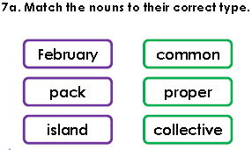  Follow the link below to have a go at today’s English lesson:  To analyse 'Carib Nightfall' (thenational.academy)
11.00- 11.15
Break
11.15-12.15  Maths | LO: To practise my recall of the 8 times table.  LO: To understand that equal parts can look different: Area. | Follow the link below to practise the 8 times table:  http://www.snappymaths.com/multdiv/8xtable/interactive/newlook/8xtablebtcd.htm  Follow the link below to have a go at today’s lesson:  Understand that equal parts can look different: Area (thenational.academy)
12.15-1.00
Dinner
1.00-1.15  Storytime | LO: To listen to a story for pleasure. | Listen to Chapter 19 of The Mystwick School of Musicraft:  Audible Stories: Free Audiobooks for Kids | Audible.com
1.15-3.00  PE | LO: To build strength and stamina. | Follow the link below to have a go at today’s PE activity:  GET KIDS MOVING - HARRY POTTER "AB WORKOUT" (7mins) - YouTube

Beat That!

Time and Subject  Friday | Learning Objective | Task/Link/Resources
8.45-9.00  Reading | L.O: To practise and consolidate existing reading skills. | Read your individual reading book, either in your head or out loud.
9.00-9.15  Morning Maths | LO: To consolidate recall of number facts.  Revision LO:  To partition 4-digit numbers. | Complete today’s Beat That- scroll down below today’s timetable to find the questions. Remember, it is the same one every day for a week. Can you beat your own score?  Morning Maths: In Morning Maths today, you are going to revise your knowledge of place value. Click the link below and select the video Partitioning.  Week 2 - Number: Place Value | White Rose Maths
9.15-9.45  Spelling | LO: To practise Year 3/4 common exception words. | This week, we are going to practise spelling some of our tricky orange words!  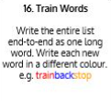  Use Train Words to practise spelling this week’s orange words:  imagine, increase, important, interest, island, knowledge, learn, length, library, material, medicine, mention, material  Spelling Test:  Scroll down below today’s timetable to use the look, cover, write, check sheet to help you to test yourself on this week’s words.
9.45-10.00  Active break | L.O: To boost my concentration through movement. | Join in with the Go Noodle clip to get you moving!  Go Bananas - Moose Tube | GoNoodle - YouTube
10.00-11.00  English | SPaG LO: To identify proper, common and collective nouns.  LO: To analyse ‘Dancing in the Rain.’ | For today’s SPaG Daily Practice, use your knowledge of nouns to answer the question below:  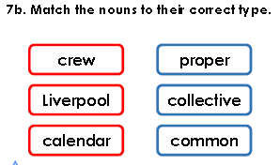  Follow the link below to have a go at today’s lesson:  To analyse 'Dancing in the Rain' (thenational.academy)
11.00- 11.15
Break
11.15-12.15  Maths | LO: To practise my recall of the 8 times table.  LO: To understand that equal parts can look different: Volume and area contexts. | Follow the link below to practise the 8 times table:  http://www.snappymaths.com/multdiv/8xtable/interactive/newlook/8xmissintd.htm  Follow the link below to have a go at today’s lesson:  Understand that equal parts can look different: Volume and area contexts (thenational.academy)
12.15-1.00
Dinner
1.00-1.15  Storytime | LO: To listen to a story for pleasure. | Listen to Chapter 20 of The Mystwick School of Musicraft:  Audible Stories: Free Audiobooks for Kids | Audible.com
1.15-3:00  Yoga | Golden Time  LO: To develop core strength and flexibility. | Join in with this relaxing yoga session:  Moana | A Cosmic Kids Yoga Adventure! - YouTube

Beat That!
Spelling Test
