Time and Subject  Monday | Learning Objective | Task/Link/Resources
8.45-9.00  Reading | LO: To practise and consolidate existing reading skills. | Read your individual reading book, either in your head or out loud.
9.00-9.15  Morning Maths | LO: To consolidate recall of number facts.  Revision LO: To tell the time to quarter to and quarter past. | Complete today’s Beat That- scroll down below today’s timetable to find the questions. Remember, it is the same one every day for a week. Can you beat your own score?  Morning Maths: In Morning Maths today, you are going to revise your knowledge of time. Click the link below, choose Summer Term Week 11 and select the video Lesson 4 quarter to and past:  https://whiterosemaths.com/homelearning/summer-archive/year-2/
9.15-9.45  Spelling | LO: To practise Year 3/4 common exception words. | This week, we are going to practise spelling some of our tricky orange words!  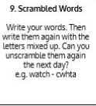  Use Scrambled Words to practise spelling this week’s orange words:  imagine, increase, important, interest, island, knowledge, learn, length, library, material, medicine, mention, material
9.45-10.00  Active break | LO: To boost my concentration through movement. | Join in with the Go Noodle clip below to get you moving!  Hola, Bonjour, HELLO! - Champiverse | GoNoodle - YouTube
10.00-11.00  English | SPaG Revision LO: To explore prepositions of time and place.  LO: To engage with a text. | For today’s SPaG Daily Practice, revise your knowledge of prepositions. Follow the link to have a go at today’s lesson:  To explore prepositions (thenational.academy)  Follow the link below to have a go at today’s English lesson:  To engage with a text (thenational.academy)
11.00- 11.15
Break
11.15-12.15  Maths | LO: To practise my recall of the 8 times table.  LO: To use round and adjust strategies to subtract and add near doubles. | Follow the link below to practise the 8 times table and get moving!  https://www.bbc.co.uk/teach/supermovers/ks2-maths-the-8-times-table-with-filbert-fox/z4mrhbk  Follow the link below to have a go at today’s maths lesson:  Using round and adjust strategies to subtract and add near doubles (thenational.academy)
12.15-1.00
Dinner
1.00-1.15  Storytime | LO: To listen to a story for pleasure. | Listen to Chapter 5 of The Golden Orchid:  Audible Stories: Free Audiobooks for Kids | Audible.com
1.15-2.30  Topic- Geography | LO: To understand how volcanoes are made. | Follow the link below to have a go at today’s lesson:  How are volcanoes made? (thenational.academy)
2.30-3.00  Music | LO: To develop reading rhythm. | Follow the link below to have a go at today’s lesson:  Developing reading rhythm (thenational.academy)

Beat That!
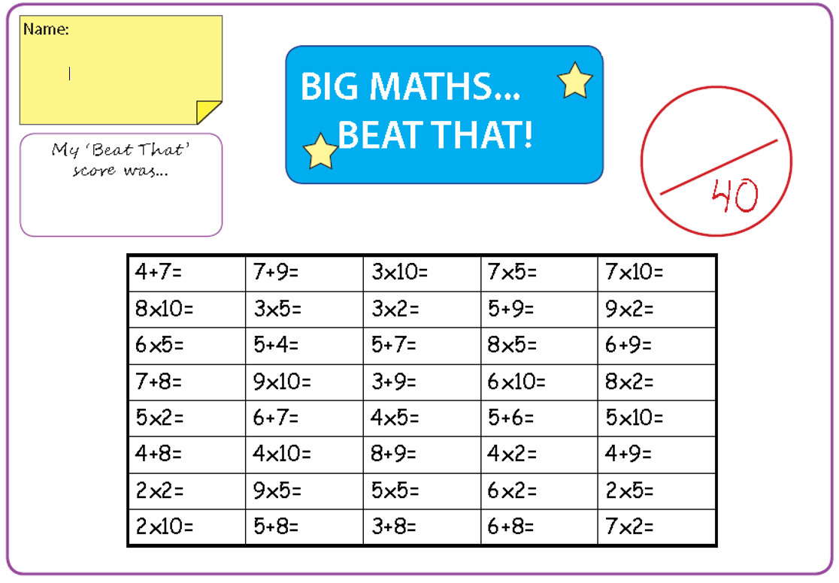

Time and Subject  Tuesday | Learning Objective | Task/Link/Resources
8.45-9.00  Reading | L.O: To practise and consolidate existing reading skills. | Read your individual reading book, either in your head or out loud.
9.00-9.15  Morning Maths | LO: To consolidate recall of number facts.  Revision LO: To tell the time to 5 minutes. | Complete today’s Beat That- scroll down below today’s timetable to find the questions. Remember, it is the same one every day for a week. Can you beat your own score?  Morning Maths: In Morning Maths today, you are going to revise your knowledge of time. Click the link below, choose Summer Term Week 12 and select the video Lesson 1 Telling time to 5 minutes:  https://whiterosemaths.com/homelearning/summer-archive/year-2/
9.15-9.45  Spelling | LO: To practise Year 3/4 common exception words. | This week, we are going to practise spelling some of our tricky orange words!  Use Scrambled Words to practise spelling this week’s orange words. Can you unscramble the words you scrambled yesterday?  imagine, increase, important, interest, island, knowledge, learn, length, library, material, medicine, mention, material
9.45-10.00  Active break | L.O: To boost my concentration through movement. | Join in with the Go Noodle clip below to get you moving!  Run The Red Carpet - Hot Ticket | GoNoodle - YouTube
10.00-11.00  English | SPaG Revision LO: To identify prepositions to express time.  LO: To answer questions on a text. | For today’s SPaG Daily Practice, use your knowledge of prepositions to answer the question below:  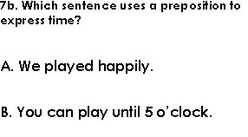  Follow the link below to have a go at today’s English lesson:  To answer questions on a text (Part 1) (thenational.academy)
11.00- 11.15
Break
11.15-12.15  Maths | LO: To practise my recall of the 8 times table.  LO: To use an ‘adding on’ strategy to find the difference. | Follow the link below to practise the 8 times table:  https://www.timestables.co.uk/8-times-table.html  Follow the link below to have a go at today’s maths lesson:  Using an 'adding on' strategy to find the difference (thenational.academy)
12.15-1.00
Dinner
1.00-1.15  Storytime | LO: To listen to a story for pleasure. | Listen to Chapter 6 of The Golden Orchid:  Audible Stories: Free Audiobooks for Kids | Audible.com
1.15-2.30  Topic-Geography | LO: To understand how volcanoes occur. | Follow the link below to have a go at today’s lesson:  How does an earthquake occur? (thenational.academy)
2.30-3.00  French | LO: To talk about school in French. | Follow the link below to have a go at today’s lesson:  Talking About School - KS2 French - BBC Bitesize - BBC Bitesize

Beat That!

Time and Subject  Wednesday | Learning Objective | Task/Link/Resources
8.45-9.00  Reading | L.O: To practise and consolidate existing reading skills. | Read your individual reading book, either in your head or out loud.
9.00-9.15  Morning Maths | LO: To consolidate recall of number facts.  Revision LO: To understand the length of an hour and a day. | Complete today’s Beat That- scroll down below today’s timetable to find the questions. Remember, it is the same one every day for a week. Can you beat your own score?  Morning Maths: In Morning Maths today, you are going to revise your knowledge of time. Click the link below, choose Summer Term Week 12 and select the video Lesson 2 hours and days:  https://whiterosemaths.com/homelearning/summer-archive/year-2/
9.15-9.45  Spelling | LO: To practise Year 3/4 common exception words. | This week, we are going to practise spelling some of our tricky orange words!  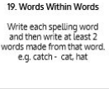  Use Words Within Words to practise spelling this week’s orange words:  imagine, increase, important, interest, island, knowledge, learn, length, library, material, medicine, mention, material
9.45-10.00  Active break | LO: To boost my concentration through movement. | Join in with the clip below to get you moving!  Kitty High Five - Awesome Sauce | GoNoodle - YouTube
10.00-11.00  English | SPaG Revision LO: To identify prepositions to express time.  LO: To answer questions on a text. | For today’s SPaG Daily Practice, use your knowledge of prepositions to answer the question below:  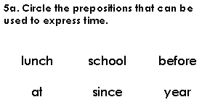  Follow the link below to have a go at today’s English lesson:  To answer questions on a text (Part 2) (thenational.academy)
11.00- 11.15
Break
11.15-12.15  Maths | LO: To practise my recall of the 8 times table.  LO: To use bar models to solve word problems. | Follow the link below to practise the 8 times table and get moving!  https://www.youtube.com/watch?v=SNFXWEXaCQw  Follow the link below to have a go at today’s maths lesson:  Using bar models to solve word problems (Part 1) (thenational.academy)
12.15-1.00
Dinner
1.00-1.15  Storytime | LO: To listen to a story for pleasure. | Listen to Chapter 7 of The Golden Orchid:  Audible Stories: Free Audiobooks for Kids | Audible.com
1.15-2.30  Topic-Geography | LO: To explore what happens when a volcano erupts. | Follow the link to have a go at today’s lesson:  What happens when a volcano erupts? (thenational.academy)
2.30-3.00  RHE | LO: To understand how images are used in the media. | Follow the link to have a go at today’s lesson:  Images in the media (thenational.academy)

Beat That!

Time and Subject  Thursday | Learning Objective | Task/Link/Resources
8.45-9.00  Reading | L.O: To practise and consolidate existing reading skills. | Read your individual reading book, either in your head or out loud.
9.00-9.15  Morning Maths | LO: To consolidate recall of number facts.  Revision LO: To explore durations of time. | Complete today’s Beat That- scroll down below today’s timetable to find the questions. Remember, it is the same one every day for a week. Can you beat your own score?  Morning Maths: In Morning Maths today, you are going to revise your knowledge of time. Click the link below, choose Summer Term Week 12 and select the video Lesson 3 Durations of time:  https://whiterosemaths.com/homelearning/summer-archive/year-2/
9.15-9.45  Spelling | LO: To practise Year 3/4 common exception words. | This week, we are going to practise spelling some of our tricky orange words!  Use the activity above to practise spelling this week’s orange words:  imagine, increase, important, interest, island, knowledge, learn, length, library, material, medicine, mention, material
9.45-10.00  Active break | LO: To boost my concentration through movement. | Join in with the Go Noodle clip below to get you moving!  Moose Fabio Don't Wear No Socks - Moose Tube | GoNoodle - YouTube
10.00-11.00  English | SPaG LO: To identify prepositions to express time.  LO: To explore character. | For today’s SPaG Daily Practice, use your knowledge of prepositions to answer the question below:  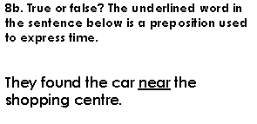  Follow the link below to have a go at today’s English lesson:  To explore character (thenational.academy)
11.00- 11.15
Break
11.15-12.15  Maths | LO: To practise my recall of the 8 times table.  LO: To use bar models to solve word problems. | Follow the link below to practise the 8 times table:  http://www.snappymaths.com/multdiv/8xtable/interactive/newlook/8xtablebtcd.htm  Follow the link below to have a go at today’s lesson:  Using bar models to solve word problems (Part 2) (thenational.academy)
12.15-1.00
Dinner
1.00-1.15  Storytime | LO: To listen to a story for pleasure. | Listen to Chapter 8 of The Golden Orchid:  Audible Stories: Free Audiobooks for Kids | Audible.com
1.15-3.00  PE | LO: To build strength and stamina. | Follow the link below to have a go at today’s PE activity:  GET KIDS MOVING - HARRY POTTER "AB WORKOUT" (7mins) - YouTube

Beat That!

Time and Subject  Friday | Learning Objective | Task/Link/Resources
8.45-9.00  Reading | L.O: To practise and consolidate existing reading skills. | Read your individual reading book, either in your head or out loud.
9.00-9.15  Morning Maths | LO: To consolidate recall of number facts.  Revision LO:  To compare durations of time. | Complete today’s Beat That- scroll down below today’s timetable to find the questions. Remember, it is the same one every day for a week. Can you beat your own score?  Morning Maths: In Morning Maths today, you are going to revise your knowledge of time. Click the link below, choose Summer Term Week 12 and select the video Lesson 4 Compare durations of time:  https://whiterosemaths.com/homelearning/summer-archive/year-2/
9.15-9.45  Spelling | LO: To practise Year 3/4 common exception words. | This week, we are going to practise spelling some of our tricky orange words!  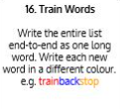  Use Train Words to practise spelling this week’s orange words:  imagine, increase, important, interest, island, knowledge, learn, length, library, material, medicine, mention, material  Spelling Test:  Scroll down below today’s timetable to use the look, cover, write, check sheet to help you to test yourself on this week’s words.
9.45-10.00  Active break | L.O: To boost my concentration through movement. | Join in with the Go Noodle clip to get you moving!  Go Bananas - Moose Tube | GoNoodle - YouTube
10.00-11.00  English | SPaG LO: To identify prepositions to express time.  LO: To explore themes. | For today’s SPaG Daily Practice, use your knowledge of prepositions to answer the question below:  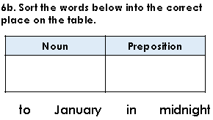  Follow the link below to have a go at today’s lesson:  To explore themes (thenational.academy)
11.00- 11.15
Break
11.15-12.15  Maths | LO: To practise my recall of the 8 times table.  LO: To apply our knowledge of mental calculation strategies. | Follow the link below to practise the 8 times table:  http://www.snappymaths.com/multdiv/8xtable/interactive/newlook/8xmissintd.htm  Follow the link below to have a go at today’s lesson:  Application Lesson (thenational.academy)
12.15-1.00
Dinner
1.00-1.15  Storytime | LO: To listen to a story for pleasure. | Listen to Chapter 9 of The Golden Orchid:  Audible Stories: Free Audiobooks for Kids | Audible.com
1.15-3:00  Yoga | Golden Time  LO: To develop core strength and flexibility. | Join in with this relaxing yoga session:  Moana | A Cosmic Kids Yoga Adventure! - YouTube

Beat That!
Spelling Test
