Time and Subject  Monday | Learning Objective | Task/Link/Resources
8.45-9.00  Reading | LO: To practise and consolidate existing reading skills. | Read your individual reading book, either in your head or out loud.
9.00-9.15  Morning Maths | LO: To consolidate recall of number facts.  Revision LO: To interpret bar charts. | Complete today’s Beat That- scroll down below today’s timetable to find the questions. Remember, it is the same one every day for a week. Can you beat your own score?  Morning Maths: In Morning Maths today, you are going to revise your knowledge of statistics. Click the link below, choose Summer Term Week 12 and select the video Lesson 4 Bar charts:  https://whiterosemaths.com/homelearning/summer-archive/year-3/
9.15-9.45  Spelling | LO: To practice Unit Eight RWI Spelling words. | This week, we are going to practise spelling words with the s sound spelled sc. Watch this video to help you learn this spelling rule:  When is the 's' sound spelt with 'sc'? - BBC Bitesize  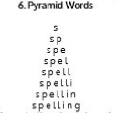  Use Pyramid Writing to practise spelling this week’s unit words:  ascend, fascinate, descend, muscle, scent, scene, science, scissors
9.45-10.00  Active break | LO: To boost my concentration through movement. | Join in with the Go Noodle clip below to get you moving!  Footloose - NTV | GoNoodle - YouTube
10.00-11.00  English | SPaG Revision LO: To understand the present perfect tense.  LO: To learn about John Lyons. | For today’s SPaG Daily Practice, revise your knowledge of the present perfect tense. Follow the link to have a go at today’s lesson:  When to Use the Present Perfect Tense | With example sentences - YouTube  Follow the link below to have a go at today’s English lesson:  To learn about John Lyons (thenational.academy)
11.00- 11.15
Break
11.15-12.15  Maths | LO: To practise my recall of the 5 times table.  LO: To divide and describe the same whole when divided into differing numbers of equal parts. | Follow the link below to practise the 5 times table and get moving!  https://www.bbc.co.uk/teach/supermovers/ks1-maths-the-5-times-table/zhbm47h  Follow the link below to have a go at today’s maths lesson:  Divide and describe the same whole when divided into differing numbers of equal parts (thenational.academy)
12.15-1.00
Dinner
1.00-1.15  Storytime | LO: To listen to a story for pleasure. | Listen to Chapter 11 of The Mystwick School of Musicraft:  Audible Stories: Free Audiobooks for Kids | Audible.com
1.15-2.30  Music | LO: To improvise within a piece of music. | Follow the link below to have a go at today’s lesson:  Improvising within a piece of music (thenational.academy)
2.30-3.00  RHE | LO: To be active. | Follow the link below to have a go at today’s lesson:  Time to get active! (thenational.academy)

Beat That!
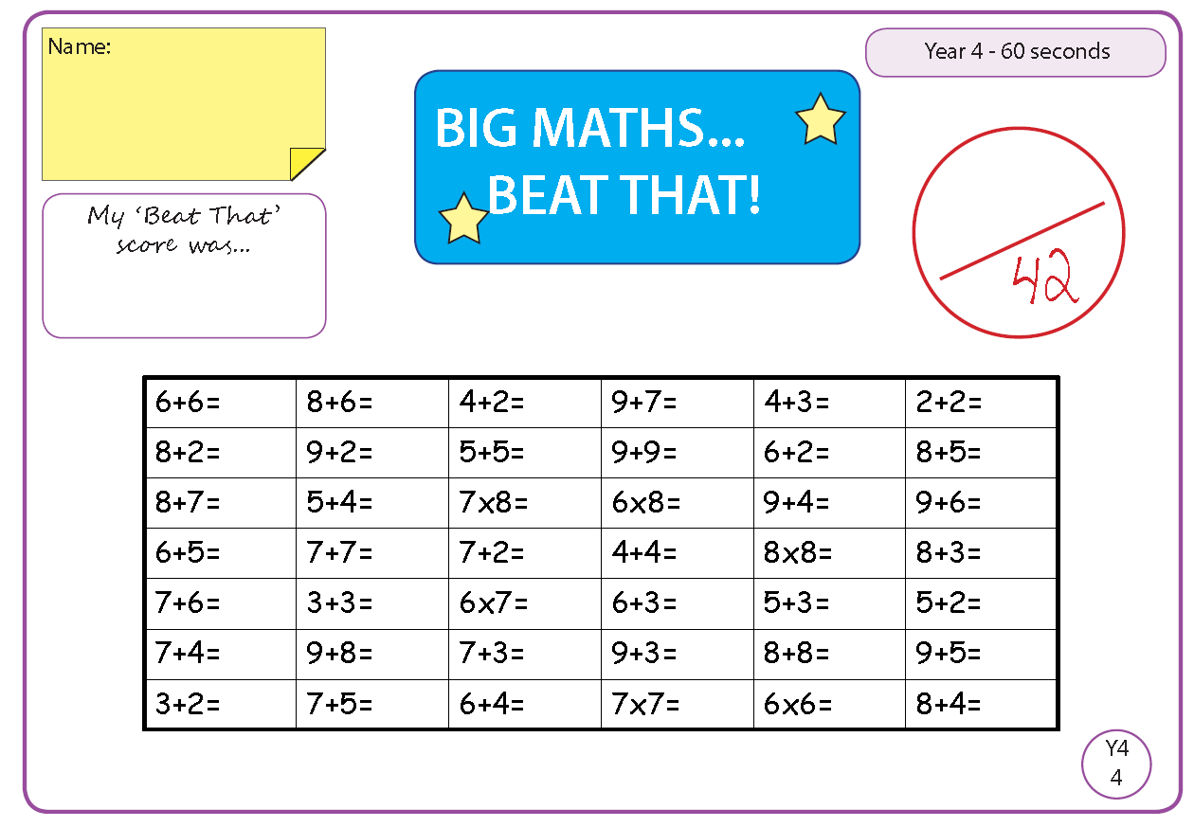

Time and Subject  Tuesday | Learning Objective | Task/Link/Resources
8.45-9.00  Reading | L.O: To practise and consolidate existing reading skills. | Read your individual reading book, either in your head or out loud.
9.00-9.15  Morning Maths | LO: To consolidate recall of number facts.  Revision LO: To read numbers to 1000. | Complete today’s Beat That- scroll down below today’s timetable to find the questions. Remember, it is the same one every day for a week. Can you beat your own score?  Morning Maths: In Morning Maths today, you are going to revise your knowledge of place value. Click the link below and select the video Numbers to 1000.  Week 1 - Number: Place Value | White Rose Maths
9.15-9.45  Spelling | LO: To practise Unit Eight RWI spelling words. | This week, we are going to practise spelling words with the s sound spelled sc.  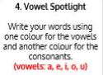  Use Vowel Spotlight to practise spelling this week’s unit words:  ascend, fascinate, descend, muscle, scent, scene, science, scissors
9.45-10.00  Active break | L.O: To boost my concentration through movement. | Join in with the Go Noodle clip below to get you moving!  Are You More Like Sand Or Dirt? - Blazer Fresh | GoNoodle - YouTube
10.00-11.00  English | SPaG Revision LO: To understand the present perfect tense.  LO: To investigate suffixes: -ous | For today’s SPaG Daily Practice, use your knowledge of the present perfect tense to answer the question below:  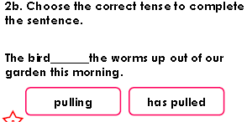  Follow the link below to have a go at today’s English lesson:  To investigate suffixes: -ous (thenational.academy)
11.00- 11.15
Break
11.15-12.15  Maths | LO: To practise my recall of the 5 times table.  LO: To understand fraction notation to represent a relationship between part and whole. | Follow the link below to practise the 5 times table:  https://www.timestables.co.uk/5-times-table.html  Follow the link below to have a go at today’s maths lesson:  Understand fraction notation to represent a relationship between part and whole (thenational.academy)
12.15-1.00
Dinner
1.00-1.15  Storytime | LO: To listen to a story for pleasure. | Listen to Chapter 12 of The Mystwick School of Musicraft:  Audible Stories: Free Audiobooks for Kids | Audible.com
1.15-2.30  Music | LO: To understand call and response in Samba music. | Follow the link below to have a go at today’s lesson:  Understanding call and response in Samba music (thenational.academy)
2.30-3.00  French | LO: To talk about your family in French. | Follow the link below to have a go at today’s lesson:  Talking About Your Family - KS2 French - BBC Bitesize - BBC Bitesize

Beat That!

Time and Subject  Wednesday | Learning Objective | Task/Link/Resources
8.45-9.00  Reading | L.O: To practise and consolidate existing reading skills. | Read your individual reading book, either in your head or out loud.
9.00-9.15  Morning Maths | LO: To consolidate recall of number facts.  Revision LO: To understand the value of each digit in a 3-digit number. | Complete today’s Beat That- scroll down below today’s timetable to find the questions. Remember, it is the same one every day for a week. Can you beat your own score?  Morning Maths: In Morning Maths today, you are going to revise your knowledge of place value. Click the link below and select the video Numbers to 100s, 10s and 1s.  Week 1 - Number: Place Value | White Rose Maths
9.15-9.45  Spelling | LO: To practise Unit Eight RWI spelling words. | This week, we are going to practise spelling words with the s sound spelled sc.  Use Rainbow Words to practise spelling this week’s unit words:  ascend, fascinate, descend, muscle, scent, scene, science, scissors
9.45-10.00  Active break | LO: To boost my concentration through movement. | Join in with the Go Noodle clip below to get you moving!  Show Us What You Got - Moose Tube + Harlem Globetrotters | GoNoodle - YouTube
10.00-11.00  English | SPaG Revision LO: To understand the present perfect tense.  LO: To explore word class. | For today’s SPaG Daily Practice, use your knowledge of the present perfect tense to answer the question below:  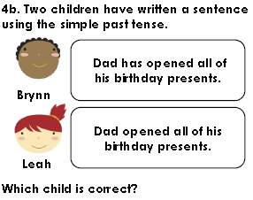  Follow the link below to have a go at today’s English lesson:  To explore word class (thenational.academy)
11.00- 11.15
Break
11.15-12.15  Maths | LO: To practise my recall of the 5 times table.  LO: To begin to understand the terms ‘Numerator’ and ‘Denominator’. | Follow the link below to practise the 5 times table and get moving!  https://www.youtube.com/watch?v=TFcwMi8l040  Follow the link below to have a go at today’s maths lesson:  Begin to use and understand the terms 'Numerator' and 'Denominator' (thenational.academy)
12.15-1.00
Dinner
1.00-1.15  Storytime | LO: To listen to a story for pleasure. | Listen to Chapter 13 of The Mystwick School of Musicraft:  Audible Stories: Free Audiobooks for Kids | Audible.com
1.15-2.30  Music | LO: To improvise in a Samba style. | Follow the link to have a go at today’s lesson:  Improvising in a Samba style (thenational.academy)
2.30-3.00  RHE | LO: To create my own workout. | Follow the link to have a go at today’s lesson:  My own workout (thenational.academy)

Beat That!

Time and Subject  Thursday | Learning Objective | Task/Link/Resources
8.45-9.00  Reading | L.O: To practise and consolidate existing reading skills. | Read your individual reading book, either in your head or out loud.
9.00-9.15  Morning Maths | LO: To consolidate recall of number facts.  Revision LO: To identify numbers to 1000 on a number line. | Complete today’s Beat That- scroll down below today’s timetable to find the questions. Remember, it is the same one every day for a week. Can you beat your own score?  Morning Maths: In Morning Maths today, you are going to revise your knowledge of place value. Click the link below and select the video Number line to 1000.  Week 1 - Number: Place Value | White Rose Maths
9.15-9.45  Spelling | LO: To practise Unit Eight RWI spelling words. | This week, we are going to practise spelling words with the s sound spelled sc.  Use the activity above to practise spelling this week’s words:  ascend, fascinate, descend, muscle, scent, scene, science, scissors
9.45-10.00  Active break | LO: To boost my concentration through movement. | Join in with the Go Noodle clip below to get you moving!  Sweet Georgia Brown - Moose Tube + Harlem Globetrotters | GoNoodle - YouTube
10.00-11.00  English | SPaG Revision LO: To understand the present perfect tense.  LO: To explore and respond to John Lyons’ poetry. | For today’s SPaG Daily Practice, use your knowledge of the present perfect tense to answer the question below:  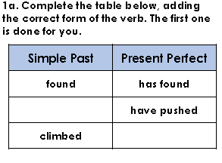  Follow the link below to have a go at today’s English lesson:  To explore and respond to John Lyons' poetry: Dancing in the rain (thenational.academy)
11.00- 11.15
Break
11.15-12.15  Maths | LO: To practise my recall of the 5 times table.  LO: To name unit fractions and match them with the fraction notation and a representation. | Follow the link below to practise the 5 times table:  http://www.snappymaths.com/multdiv/5xtable/interactive/newlook/5xtablebtcd.htm  Follow the link below to have a go at today’s lesson:  Name unit fractions and match them with the fraction notation and a representation (thenational.academy)
12.15-1.00
Dinner
1.00-1.15  Storytime | LO: To listen to a story for pleasure. | Listen to Chapter 14 of The Mystwick School of Musicraft:  Audible Stories: Free Audiobooks for Kids | Audible.com
1.15-3.00  PE | LO: To develop strength and stamina. | Follow the link below for today’s PE activity:  The Batman Kids Workout - YouTube

Beat That!

Time and Subject  Friday | Learning Objective | Task/Link/Resources
8.45-9.00  Reading | L.O: To practise and consolidate existing reading skills. | Read your individual reading book, either in your head or out loud.
9.00-9.15  Morning Maths | LO: To consolidate recall of number facts.  Revision LO:  To round numbers to the nearest 10. | Complete today’s Beat That- scroll down below today’s timetable to find the questions. Remember, it is the same one every day for a week. Can you beat your own score?  Morning Maths: In Morning Maths today, you are going to revise your knowledge of round. Click the link below and select the video Round to the nearest 10.  Week 1 - Number: Place Value | White Rose Maths
9.15-9.45  Spelling | LO: To practise Unit Eight RWI spelling words. | This week, we are going to practise spelling words with the s sound spelled sc.  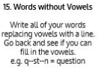  Use Words Without Vowels to practise spelling this week’s words:  ascend, fascinate, descend, muscle, scent, scene, science, scissors  Spelling Test:  Scroll down below today’s timetable to use the look, cover, write, check sheet to help you to test yourself on this week’s words.
9.45-10.00  Active break | L.O: To boost my concentration through movement. | Join in with the Go Noodle clip to get you moving!  Brain Breaks - Action Songs for Children - Move and Freeze - Kids Songs by The Learning Station - YouTube
10.00-11.00  English | SPaG Revision LO: To understand the present perfect tense.  LO: To develop a rich understanding of words associated with happiness. | For today’s SPaG Daily Practice, use your knowledge of the present perfect tense to answer the question below:  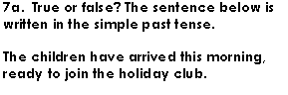  Follow the link below to have a go at today’s lesson:  To develop a rich understanding of words associated with happiness (Part 1) (thenational.academy)
11.00- 11.15
Break
11.15-12.15  Maths | LO: To practise my recall of the 5 times table.  LO: To embed previous fraction work using a linear model. | Follow the link below to practise the 5 times table:  http://www.snappymaths.com/multdiv/5xtable/interactive/newlook/5xmissintd.htm  Follow the link below to have a go at today’s lesson:  Embed previous fraction work using a linear model (thenational.academy)
12.15-1.00
Dinner
1.00-1.15  Storytime | LO: To listen to a story for pleasure. | Listen to Chapter 15 of The Mystwick School of Musicraft:  Audible Stories: Free Audiobooks for Kids | Audible.com
1.15-3:00  Art | Golden Time  LO: To use a range of materials to create a sculpture. | Sculpture scavenger hunt  Collect pieces of cardboard, paper, plastic and anything else you would like. Now try making a model. This could be a building, or character from a book or yourself! After this, try making a sculpture from natural materials. There is a very famous artist from Bradford who made sculptures out of natural materials. Do you know who it is?

Beat That!

Spelling Test
