Time and Subject  Monday | Learning Objective | Task/Link/Resources
8.45-9.00  Reading | LO: To practise and consolidate existing reading skills. | Read your individual reading book, either in your head or out loud.
9.00-9.15  Morning Maths | LO: To consolidate recall of number facts.  Revision LO: To compare volume. | Complete today’s Beat That- scroll down below today’s timetable to find the questions. Remember, it is the same one every day for a week. Can you beat your own score?  Morning Maths: In Morning Maths today, you are going to revise your knowledge of measure. Click the link below, choose Summer Term Week 10 and select the video Lesson 3 Compare volume:  https://whiterosemaths.com/homelearning/summer-archive/year-2/
9.15-9.45  Spelling | LO: To practice Unit Eight RWI Spelling words. | This week, we are going to practise spelling words with the sh sound spelled ch. Watch this video to help you learn this spelling rule:  When is the 'sh' sound spelt with 'ch'? - BBC Bitesize  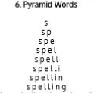  Use Pyramid Writing to practise spelling this week’s unit words:  brochure, chalet, chandelier, charade, chef, chute, machine, moustache, parachute
9.45-10.00  Active break | LO: To boost my concentration through movement. | Join in with the Go Noodle clip below to get you moving!  Footloose - NTV | GoNoodle - YouTube
10.00-11.00  English | SPaG Revision LO: To explore using apostrophes for plural possession.  LO: To explore a theme. | For today’s SPaG Daily Practice, revise your knowledge of apostrophes. Follow the link to have a go at today’s lesson:  To explore using apostrophes for plural possession (thenational.academy)  Follow the link below to have a go at today’s English lesson:  To explore a theme (thenational.academy)
11.00- 11.15
Break
11.15-12.15  Maths | LO: To practise my recall of the 5 times table.  LO: To derive new facts from number bonds. | Follow the link below to practise the 5 times table and get moving!  https://www.bbc.co.uk/teach/supermovers/ks1-maths-the-5-times-table/zhbm47h  Follow the link below to have a go at today’s maths lesson:  Deriving New Facts From Number Bonds (Part 2) (thenational.academy)
12.15-1.00
Dinner
1.00-1.15  Storytime | LO: To listen to a story for pleasure. | Listen to Chapter 9 of Zero G:  Audible Stories: Free Audiobooks for Kids | Audible.com
1.15-2.30  Music | LO: To read simple rhythms. | Follow the link below to have a go at today’s lesson:  Reading simple rhythms (thenational.academy)
2.30-3.00  RHE | LO: To be active. | Follow the link below to have a go at today’s lesson:  Time to get active! (thenational.academy)

Beat That!
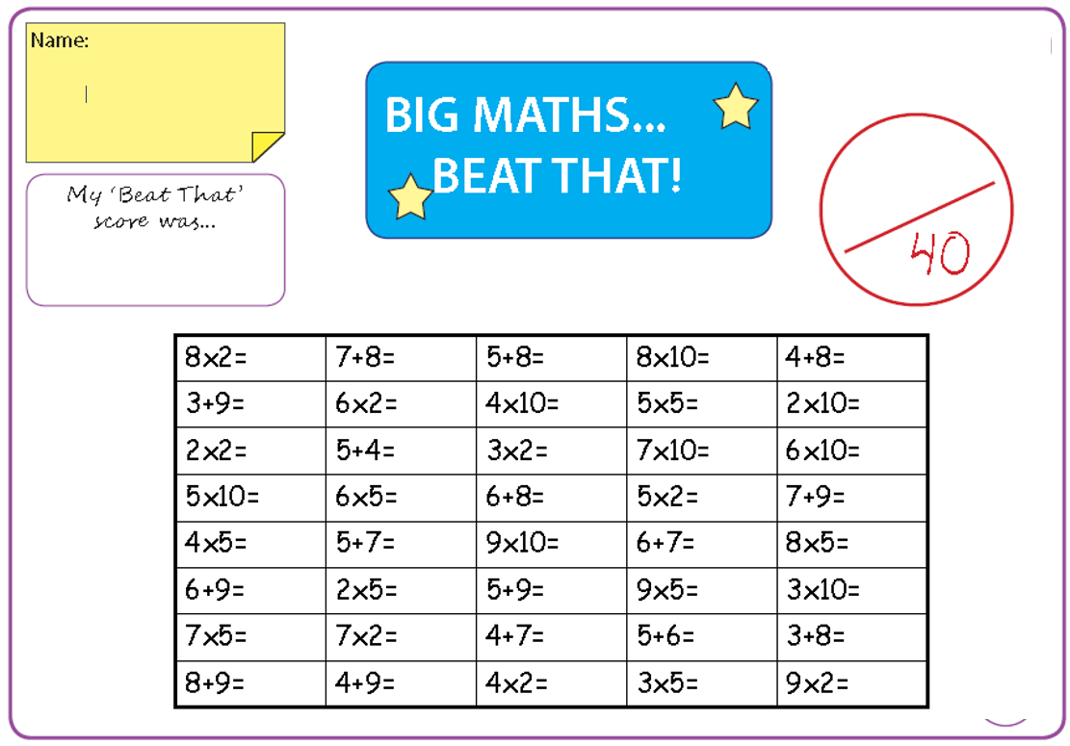

Time and Subject  Tuesday | Learning Objective | Task/Link/Resources
8.45-9.00  Reading | L.O: To practise and consolidate existing reading skills. | Read your individual reading book, either in your head or out loud.
9.00-9.15  Morning Maths | LO: To consolidate recall of number facts.  Revision LO: To explore millilitres. | Complete today’s Beat That- scroll down below today’s timetable to find the questions. Remember, it is the same one every day for a week. Can you beat your own score?  Morning Maths: In Morning Maths today, you are going to revise your knowledge of measure. Click the link below, choose Summer Term Week 10 and select the video Lesson 4 Millilitres:  https://whiterosemaths.com/homelearning/summer-archive/year-2/
9.15-9.45  Spelling | LO: To practise Unit Eight RWI spelling words. | This week, we are going to practise spelling words with the sh sound spelled ch.  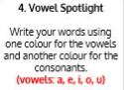  Use Vowel Spotlight to practise spelling this week’s unit words:  brochure, chalet, chandelier, charade, chef, chute, machine, moustache, parachute
9.45-10.00  Active break | L.O: To boost my concentration through movement. | Join in with the Go Noodle clip below to get you moving!  Are You More Like Sand Or Dirt? - Blazer Fresh | GoNoodle - YouTube
10.00-11.00  English | SPaG Revision LO: To identify apostrophes for plural possession.  LO: To engage with a text. | For today’s SPaG Daily Practice, use your knowledge of apostrophes to answer the question below:  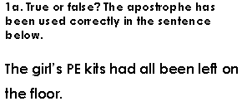  Follow the link below to have a go at today’s English lesson:  To engage with a text (thenational.academy)
11.00- 11.15
Break
11.15-12.15  Maths | LO: To practise my recall of the 5 times table.  LO: To find number bonds for numbers up to 20. | Follow the link below to practise the 5 times table:  https://www.timestables.co.uk/5-times-table.html  Follow the link below to have a go at today’s maths lesson:  Finding number bonds for numbers up to 20 (thenational.academy)
12.15-1.00
Dinner
1.00-1.15  Storytime | LO: To listen to a story for pleasure. | Listen to Chapter 1 of The Golden Orchid:  Audible Stories: Free Audiobooks for Kids | Audible.com
1.15-2.30  Topic- Geography | LO: To understand the structure of the earth and what it is made of. | Follow the link below to have a go at today’s lesson:  What is the earth made of? (thenational.academy)
2.30-3.00  French | LO: To talk about your family in French. | Follow the link below to have a go at today’s lesson:  Talking About Your Family - KS2 French - BBC Bitesize - BBC Bitesize

Beat That!

Time and Subject  Wednesday | Learning Objective | Task/Link/Resources
8.45-9.00  Reading | L.O: To practise and consolidate existing reading skills. | Read your individual reading book, either in your head or out loud.
9.00-9.15  Morning Maths | LO: To consolidate recall of number facts.  Revision LO: To understand litres. | Complete today’s Beat That- scroll down below today’s timetable to find the questions. Remember, it is the same one every day for a week. Can you beat your own score?  Morning Maths: In Morning Maths today, you are going to revise your knowledge of measure. Click the link below, choose Summer Term Week 11 and select the video Lesson 1 Litres:  https://whiterosemaths.com/homelearning/summer-archive/year-2/
9.15-9.45  Spelling | LO: To practise Unit Eight RWI spelling words. | This week, we are going to practise spelling words with the sh sound spelled ch.  Use Rainbow Words to practise spelling this week’s unit words:  brochure, chalet, chandelier, charade, chef, chute, machine, moustache, parachute
9.45-10.00  Active break | LO: To boost my concentration through movement. | Join in with the Go Noodle clip below to get you moving!  Show Us What You Got - Moose Tube + Harlem Globetrotters | GoNoodle - YouTube
10.00-11.00  English | SPaG Revision LO: To use apostrophes for possession.  LO: To analyse a character. | For today’s SPaG Daily Practice, use your knowledge of apostrophes to answer the question below:  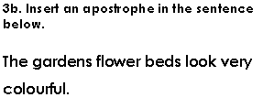  Follow the link below to have a go at today’s English lesson:  To analyse a character (thenational.academy)
11.00- 11.15
Break
11.15-12.15  Maths | LO: To practise my recall of the 5 times table.  LO: To apply number bonds within ten to add and subtract. | Follow the link below to practise the 5 times table and get moving!  https://www.youtube.com/watch?v=TFcwMi8l040  Follow the link below to have a go at today’s maths lesson:  Applying number bonds within ten to add and subtract (thenational.academy)
12.15-1.00
Dinner
1.00-1.15  Storytime | LO: To listen to a story for pleasure. | Listen to Chapter 2 of The Golden Orchid:  Audible Stories: Free Audiobooks for Kids | Audible.com
1.15-2.30  Topic- Geography | LO: To understand what fold mountains are and how they are made. | Follow the link to have a go at today’s lesson:  What are fold mountains? (thenational.academy)
2.30-3.00  RHE | LO: To create my own workout. | Follow the link to have a go at today’s lesson:  My own workout (thenational.academy)

Beat That!

Time and Subject  Thursday | Learning Objective | Task/Link/Resources
8.45-9.00  Reading | L.O: To practise and consolidate existing reading skills. | Read your individual reading book, either in your head or out loud.
9.00-9.15  Morning Maths | LO: To consolidate recall of number facts.  Revision LO: To explore temperature. | Complete today’s Beat That- scroll down below today’s timetable to find the questions. Remember, it is the same one every day for a week. Can you beat your own score?  Morning Maths: In Morning Maths today, you are going to revise your knowledge of measure. Click the link below, choose Summer Term Week 11 and select the video Lesson 2 Temperature:  https://whiterosemaths.com/homelearning/summer-archive/year-2/
9.15-9.45  Spelling | LO: To practise Unit Eight RWI spelling words. | This week, we are going to practise spelling words with the sh sound spelled ch.  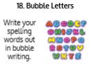  Use the activity above to practise spelling this week’s words:  brochure, chalet, chandelier, charade, chef, chute, machine, moustache, parachute
9.45-10.00  Active break | LO: To boost my concentration through movement. | Join in with the Go Noodle clip below to get you moving!  Sweet Georgia Brown - Moose Tube + Harlem Globetrotters | GoNoodle - YouTube
10.00-11.00  English | SPaG Revision LO: To use apostrophes for plural possession.  LO: To explore figurative language. | For today’s SPaG Daily Practice, use your knowledge of apostrophes to answer the question below:  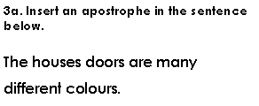  Follow the link below to have a go at today’s English lesson:  To explore figurative language (thenational.academy)
11.00- 11.15
Break
11.15-12.15  Maths | LO: To practise my recall of the 5 times table.  LO: To apply number bonds within 20 to add and subtract. | Follow the link below to practise the 5 times table:  http://www.snappymaths.com/multdiv/5xtable/interactive/newlook/5xtablebtcd.htm  Follow the link below to have a go at today’s lesson:  Applying number bonds within twenty to add and subtract (thenational.academy)
12.15-1.00
Dinner
1.00-1.15  Storytime | LO: To listen to a story for pleasure. | Listen to Chapter 3 of The Golden Orchid:  Audible Stories: Free Audiobooks for Kids | Audible.com
1.15-3.00  PE | LO: To develop strength and stamina. | Follow the link below for today’s PE activity:  The Batman Kids Workout - YouTube

Beat That!

Time and Subject  Friday | Learning Objective | Task/Link/Resources
8.45-9.00  Reading | L.O: To practise and consolidate existing reading skills. | Read your individual reading book, either in your head or out loud.
9.00-9.15  Morning Maths | LO: To consolidate recall of number facts.  Revision LO:  To tell the time to o’clock and half past. | Complete today’s Beat That- scroll down below today’s timetable to find the questions. Remember, it is the same one every day for a week. Can you beat your own score?  Morning Maths: In Morning Maths today, you are going to revise your knowledge of time. Click the link below, choose Summer Term Week 11 and select the video Lesson 3 o’clock and half past:  https://whiterosemaths.com/homelearning/summer-archive/year-2/
9.15-9.45  Spelling | LO: To practise Unit Eight RWI spelling words. | This week, we are going to practise spelling words with the sh sound spelled ch.  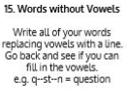  Use Words Without Vowels to practise spelling this week’s words:  brochure, chalet, chandelier, charade, chef, chute, machine, moustache, parachute  Spelling Test:  Scroll down below today’s timetable to use the look, cover, write, check sheet to help you to test yourself on this week’s words.
9.45-10.00  Active break | L.O: To boost my concentration through movement. | Join in with the Go Noodle clip to get you moving!  Brain Breaks - Action Songs for Children - Move and Freeze - Kids Songs by The Learning Station - YouTube
10.00-11.00  English | SPaG Revision LO: To use apostrophes for plural possession.  LO: To generate and explore themes. | For today’s SPaG Daily Practice, use your knowledge apostrophes to answer the question below:  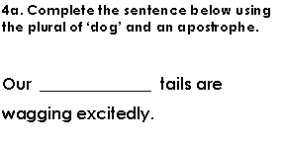  Follow the link below to have a go at today’s lesson:  To generate and explore themes (thenational.academy)
11.00- 11.15
Break
11.15-12.15  Maths | LO: To practise my recall of the 5 times table.  LO: To add and subtract using round and adjust. | Follow the link below to practise the 5 times table:  http://www.snappymaths.com/multdiv/5xtable/interactive/newlook/5xmissintd.htm  Follow the link below to have a go at today’s lesson:  Adding and subtracting using round and adjust (thenational.academy)
12.15-1.00
Dinner
1.00-1.15  Storytime | LO: To listen to a story for pleasure. | Listen to Chapter 4 of The Golden Orchid:  Audible Stories: Free Audiobooks for Kids | Audible.com
1.15-3:00  Art | Golden Time  LO: To use a range of materials to create a sculpture. | Sculpture scavenger hunt  Collect pieces of cardboard, paper, plastic and anything else you would like. Now try making a model. This could be a building, or character from a book or yourself! After this, try making a sculpture from natural materials. There is a very famous artist from Bradford who made sculptures out of natural materials. Do you know who it is?

Beat That!

Spelling Test
