Time and Subject  Monday | Learning Objective | Task/Link/Resources
8.45-9.00  Reading | LO: To practise and consolidate existing reading skills. | Read your individual reading book, either in your head or out loud.
9.00-9.15  Morning Maths | LO: To consolidate recall of number facts.  Revision LO: To add and subtract mass. | Complete today’s Beat That- scroll down below today’s timetable to find the questions. Remember, it is the same one every day for a week. Can you beat your own score?  Morning Maths: In Morning Maths today, you are going to revise your knowledge of mass. Click the link below, choose Summer Term Week 11 and select the video Lesson 3 Add and subtract mass:  https://whiterosemaths.com/homelearning/summer-archive/year-3/
9.15-9.45  Spelling | LO: To practice Year 3/4 common exception words. | This week, we are going to practise spelling some of our tricky orange words!  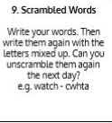  Use Scrambled Words to practise spelling this week’s orange words:  grammar, group, guard, guide, heart, heard, height, history
9.45-10.00  Active break | LO: To boost my concentration through movement. | Join in with the Go Noodle clip below to get you moving!  Young Dylan Dance Along | GoNoodle - YouTube
10.00-11.00  English | SPaG Revision LO: To understand expanded noun phrases.  LO: To engage with the text. | For today’s SPaG Daily Practice, revise your knowledge of expanded noun phrases. Click the link below, watch the video and complete the activities:  Expanded noun phrases - Year 4 - P5 - English - Catch Up Lessons - Home Learning with BBC Bitesize - BBC Bitesize  Follow the link below to have a go at today’s English lesson:  To engage with the text (thenational.academy)
11.00- 11.15
Break
11.15-12.15  Maths | LO: To practise my recall of the 4 times table.  LO: To develop strategies to plan and solve problems. | Follow the link below to practise the 4 times table and get moving!  https://www.bbc.co.uk/teach/supermovers/ks1-maths-the-4-times-table-with-cyril-the-swan/zmsw382  Follow the link below to have a go at today’s maths lesson:  To develop strategies to plan and solve problems (Part 1) (thenational.academy)
12.15-1.00
Dinner
1.00-1.15  Storytime | LO: To listen to a story for pleasure. | Listen to Chapter 6 of The Mystwick School of Musicraft:  Audible Stories: Free Audiobooks for Kids | Audible.com
1.15-2.30  Topic- Science | LO: To understand what changes of state are and why they happen. | Follow the link below to have a go at today’s lesson:  What are changes of state and why do they take place? (thenational.academy)
2.30-3.00  Music | LO: To improvise rhythmic patterns. | Follow the link below to have a go at today’s lesson:  Improvising rhythmic patterns (thenational.academy)

Beat That!
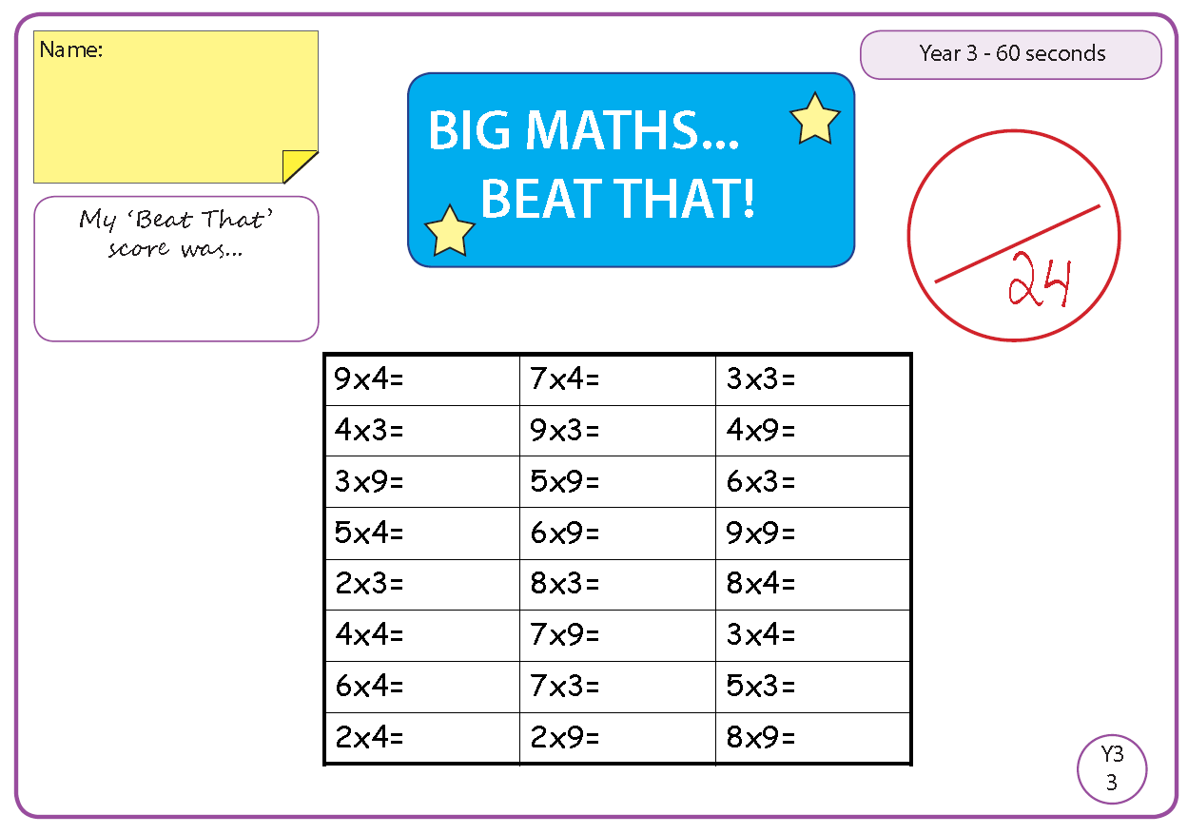

Time and Subject  Tuesday | Learning Objective | Task/Link/Resources
8.45-9.00  Reading | L.O: To practise and consolidate existing reading skills. | Read your individual reading book, either in your head or out loud.
9.00-9.15  Morning Maths | LO: To consolidate recall of number facts.  Revision LO: To measure capacity. | Complete today’s Beat That- scroll down below today’s timetable to find the questions. Remember, it is the same one every day for a week. Can you beat your own score?  Morning Maths: In Morning Maths today, you are going to revise your knowledge of capacity. Click the link below, choose Summer Term Week 11 and select the video Lesson 4 Measure capacity:  https://whiterosemaths.com/homelearning/summer-archive/year-3/
9.15-9.45  Spelling | LO: To practice Year 3/4 common exception words. | This week, we are going to practise spelling some of our tricky orange words!  Use Scrambled Words to practise spelling this week’s orange words. Can you unscramble the words you scrambled yesterday?  grammar, group, guard, guide, heart, heard, height, history
9.45-10.00  Active break | L.O: To boost my concentration through movement. | Join in with the Go Noodle clip below to get you moving!  Trolls: Can't Stop The Feeling | GoNoodle - YouTube
10.00-11.00  English | SPaG Revision LO: To understand expanded noun phrases.  LO: To answer questions on the text. | For today’s SPaG Daily Practice, use your knowledge of noun phrases to answer the question below:  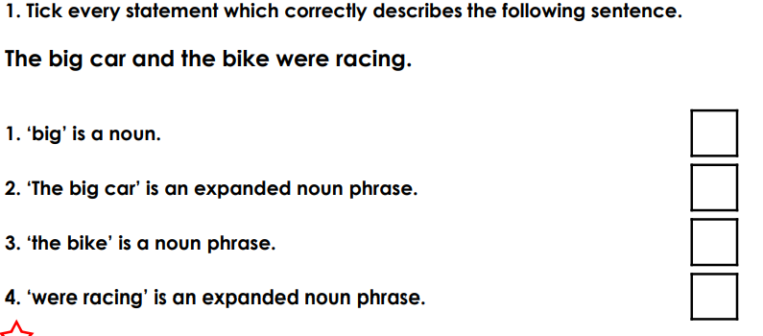  Follow the link below to have a go at today’s English lesson:  To answer questions on the text (Part 1) (thenational.academy)
11.00- 11.15
Break
11.15-12.15  Maths | LO: To practise my recall of the 4 times table.  LO: To develop strategies to plan and solve problems. | Follow the link below to practise the 4 times table:  https://www.timestables.co.uk/4-times-table.html  Follow the link below to have a go at today’s maths lesson:  To develop strategies to plan and solve problems (Part 2) (thenational.academy)
12.15-1.00
Dinner
1.00-1.15  Storytime | LO: To listen to a story for pleasure. | Listen to Chapter 7 of The Mystwick School of Musicraft:  Audible Stories: Free Audiobooks for Kids | Audible.com
1.15-2.30  Topic- Science | LO: To understand what melting and boiling points are. | Follow the link below to have a go at today’s lesson:  What are melting points and boiling points? (thenational.academy)
2.30-3.00  French | LO: To talk about animals and pets in French. | Follow the link below to have a go at today’s lesson:  Animals and Pets - KS2 French - BBC Bitesize - BBC Bitesize

Beat That!

Time and Subject  Wednesday | Learning Objective | Task/Link/Resources
8.45-9.00  Reading | L.O: To practise and consolidate existing reading skills. | Read your individual reading book, either in your head or out loud.
9.00-9.15  Morning Maths | LO: To consolidate recall of number facts.  Revision LO: To compare capacity. | Complete today’s Beat That- scroll down below today’s timetable to find the questions. Remember, it is the same one every day for a week. Can you beat your own score?  Morning Maths: In Morning Maths today, you are going to revise your knowledge of capacity. Click the link below, choose Summer Term Week 12 and select the video Lesson 1 Compare capacity:  https://whiterosemaths.com/homelearning/summer-archive/year-3/
9.15-9.45  Spelling | LO: To practise Year 3/4 common exception words. | This week, we are going to practise spelling some of our tricky orange words!  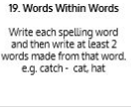  Use Words Within Words to practise spelling this week’s orange words:  grammar, group, guard, guide, heart, heard, height, history
9.45-10.00  Active break | LO: To boost my concentration through movement. | Join in with the clip below to get you moving!  Mood Walk - Blazer Fresh | GoNoodle - YouTube
10.00-11.00  English | SPaG Revision LO: To understand expanded noun phrases.  LO: To analyse characters. | For today’s SPaG Daily Practice, use your knowledge of noun phrases to answer the question below:  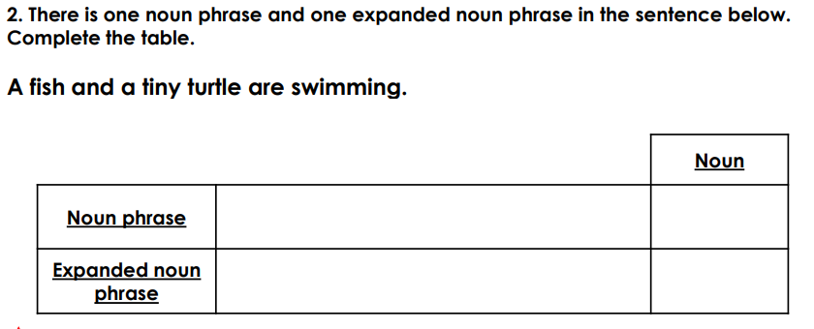  Follow the link below to have a go at today’s English lesson:  To analyse characters (thenational.academy)
11.00- 11.15
Break
11.15-12.15  Maths | LO: To practise my recall of the 4 times table.  LO: To develop strategies to plan and solve problems. | Follow the link below to practise the 4 times table and get moving!  https://www.youtube.com/watch?v=LT3t-uLB9qs  Follow the link below to have a go at today’s maths lesson:  To develop strategies to plan and solve problems (Part 3) (thenational.academy)
12.15-1.00
Dinner
1.00-1.15  Storytime | LO: To listen to a story for pleasure. | Listen to Chapter 8 of The Mystwick School of Musicraft:  Audible Stories: Free Audiobooks for Kids | Audible.com
1.15-2.30  Topic- Science | LO: To understand which substances do not fit into one state of matter. | Follow the link to have a go at today’s lesson:  Which substances do not fit into one state of matter? (thenational.academy)
2.30-3.00  RHE | LO: To explore what a diet is and why it is important. | Follow the link to have a go at today’s lesson:  Food, glorious food! (thenational.academy)

Beat That!

Time and Subject  Thursday | Learning Objective | Task/Link/Resources
8.45-9.00  Reading | L.O: To practise and consolidate existing reading skills. | Read your individual reading book, either in your head or out loud.
9.00-9.15  Morning Maths | LO: To consolidate recall of number facts.  Revision LO: To add and subtract capacity. | Complete today’s Beat That- scroll down below today’s timetable to find the questions. Remember, it is the same one every day for a week. Can you beat your own score?  Morning Maths: In Morning Maths today, you are going to revise your knowledge of capacity. Click the link below, choose Summer Term Week 12 and select the video Lesson 2 Add and subtract capacity:  https://whiterosemaths.com/homelearning/summer-archive/year-3/
9.15-9.45  Spelling | LO: To practise Year 3/4 common exception words. | This week, we are going to practise spelling some of our tricky orange words!  Use the activity above to practise spelling this week’s orange words:  grammar, group, guard, guide, heart, heard, height, history
9.45-10.00  Active break | LO: To boost my concentration through movement. | Join in with the Go Noodle clip below to get you moving!  Yes! I Want To Build A Snowman - Moose Tube | GoNoodle - YouTube
10.00-11.00  English | SPaG Revision LO: To understand expanded noun phrases.  LO: To answer questions on the text. | For today’s SPaG Daily Practice, use your knowledge of noun phrases to answer the question below:  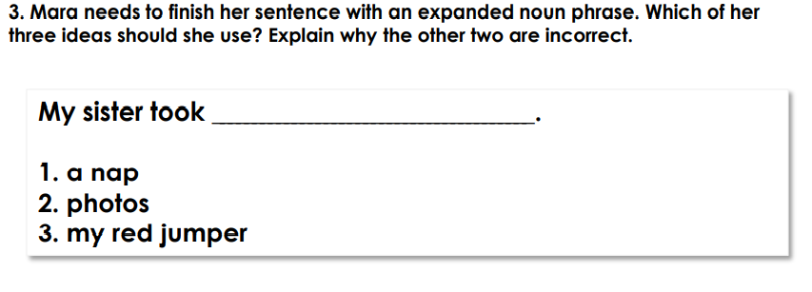  Follow the link below to have a go at today’s English lesson:  To answer questions on the text (Part 2) (thenational.academy)
11.00- 11.15
Break
11.15-12.15  Maths | LO: To practise my recall of the 4 times table.  LO: To develop strategies to plan and solve problems. | Follow the link below to practise the 4 times table:  http://www.snappymaths.com/multdiv/4xtable/interactive/newlook/4xtablebtcd.htm  Follow the link below to have a go at today’s lesson:  To develop strategies to plan and solve problems (Part 4) (thenational.academy)
12.15-1.00
Dinner
1.00-1.15  Storytime | LO: To listen to a story for pleasure. | Listen to Chapter 9 of The Mystwick School of Musicraft:  Audible Stories: Free Audiobooks for Kids | Audible.com
1.15-3.00  PE | LO: To develop strength and stamina. | Follow the link below for today’s PE activity:  The Wonder Woman Superhero Workout - YouTube

Beat That!

Time and Subject  Friday | Learning Objective | Task/Link/Resources
8.45-9.00  Reading | L.O: To practise and consolidate existing reading skills. | Read your individual reading book, either in your head or out loud.
9.00-9.15  Morning Maths | LO: To consolidate recall of number facts.  Revision LO:  To understand pictograms. | Complete today’s Beat That- scroll down below today’s timetable to find the questions. Remember, it is the same one every day for a week. Can you beat your own score?  Morning Maths: In Morning Maths today, you are going to revise your knowledge of statistics. Click the link below, choose Summer Term Week 12 and select the video Lesson 3 Pictograms:  https://whiterosemaths.com/homelearning/summer-archive/year-3/
9.15-9.45  Spelling | LO: To practise Year 3/4 common exception words. | This week, we are going to practise spelling some of our tricky orange words!  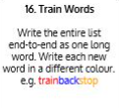  Use the Train Words to practise spelling this week’s orange words:  grammar, group, guard, guide, heart, heard, height, history  Spelling Test:  Scroll down below today’s timetable to use the look, cover, write, check sheet to help you to test yourself on this week’s words.
9.45-10.00  Active break | L.O: To boost my concentration through movement. | Join in with the Go Noodle clip to get you moving!  Stay On The Sunny Side - Moose Tube | GoNoodle - YouTube
10.00-11.00  English | SPaG Revision LO: To understand expanded noun phrases.  LO: To analyse the author’s use of language. | For today’s SPaG Daily Practice, use your knowledge of noun phrases to answer the question below:  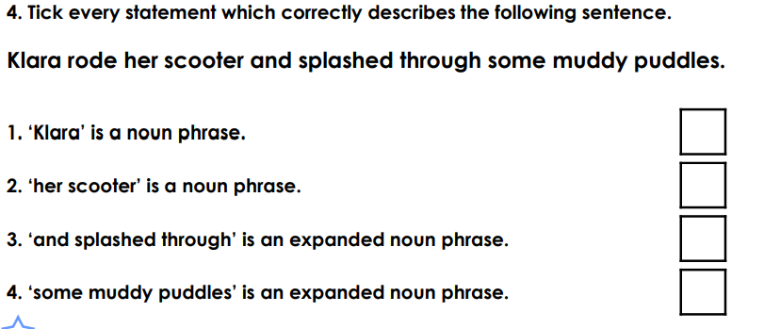  Follow the link below to have a go at today’s lesson:  To analyse the author's use of language (thenational.academy)
11.00- 11.15
Break
11.15-12.15  Maths | LO: To practise my recall of the 4 times table.  LO: To develop strategies to plan and solve problems. | Follow the link below to practise the 4 times table:  http://www.snappymaths.com/multdiv/4xtable/interactive/newlook/4xmissintd.htm  Follow the link below to have a go at today’s lesson:  To develop strategies to plan and solve problems (Part 5) (thenational.academy)
12.15-1.00
Dinner
1.00-1.15  Storytime | LO: To listen to a story for pleasure. | Listen to Chapter 10 of The Mystwick School of Musicraft:  Audible Stories: Free Audiobooks for Kids | Audible.com
1.15-3:00  Yoga | Golden Time  LO: To develop core strength and flexibility. | Join in with this relaxing yoga session:  Minecraft | A Cosmic Kids Yoga Adventure! - YouTube

Beat That!

Spelling Test
