Time and Subject  Monday | Learning Objective | Task/Link/Resources
8.45-9.00  Reading | LO: To practise and consolidate existing reading skills. | Read your individual reading book, either in your head or out loud.
9.00-9.15  Morning Maths | LO: To consolidate recall of number facts.  Revision LO: To recognise and describe 2D shapes. | Complete today’s Beat That- scroll down below today’s timetable to find the questions. Remember, it is the same one every day for a week. Can you beat your own score?  Morning Maths: In Morning Maths today, you are going to revise identifying 2D shapes. Click the link below, choose Summer Term Week 10 and select the video Lesson 2 Recognise and describe 2D shapes:  https://whiterosemaths.com/homelearning/summer-archive/year-3/
9.15-9.45  Spelling | LO: To practise Unit Seven RWI Spelling words. | This week, we are revising spelling words ending in ‘ous’.  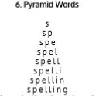  Use pyramid writing to practise spelling this week’s unit words:  anxious, curious, courageous, dangerous, enormous, glamorous, hideous, humorous, mountainous, obvious, outrageous, poisonous, serious, tremendous
9.45-10.00  Active break | LO: To boost my concentration through movement. | Join in with the Go Noodle clip below to get you moving!  https://www.youtube.com/watch?v=Imhi98dHa5w
10.00-11.00  English | SPaG Revision LO: To identify fronted adverbials.  LO: To engage with a text. | For today’s SPaG Daily Practice, revise your knowledge of fronted adverbials. Click the link below, watch the video and complete the activities:  https://www.bbc.co.uk/bitesize/topics/zwwp8mn/articles/zp937p3  Follow the link below to have a go at today’s English lesson:  To engage with a text (thenational.academy)
11.00- 11.15
Break
11.15-12.15  Maths | LO: To practise my recall of the 3 times table.  LO: To investigate the place value of different number systems. | Follow the link below to practise the 3 times table and get moving!  https://www.bbc.co.uk/teach/supermovers/ks2-maths-the-3-times-table/z6sw382  Follow the link below to have a go at today’s maths lesson:  To Investigate the Place Value of Different Number Systems (thenational.academy)
12.15-1.00
Dinner
1.00-1.15  Storytime | LO: To listen to a story for pleasure. | Listen to Chapter 1 of The Mystwick School of Musicraft:  Audible Stories: Free Audiobooks for Kids | Audible.com
1.15-2.30  Topic- Science | LO: To understand the properties of solids, liquids and gases. | Follow the link below to have a go at today’s lesson:  What are the properties of solids, liquids and gases? (thenational.academy)
2.30-3.00  Music | LO: To understand rhythm and pulse. | Follow the link below to have a go at today’s lesson:  Understanding rhythm and pulse (thenational.academy)

Beat That!
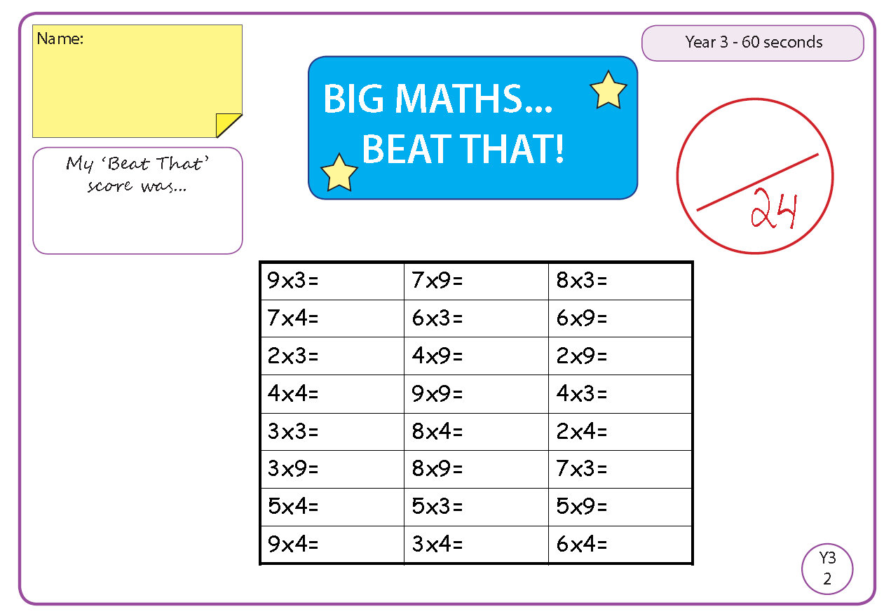

Time and Subject  Tuesday | Learning Objective | Task/Link/Resources
8.45-9.00  Reading | L.O: To practise and consolidate existing reading skills. | Read your individual reading book, either in your head or out loud.
9.00-9.15  Morning Maths | LO: To consolidate recall of number facts.  Revision LO: To identify 3D shapes. | Complete today’s Beat That- scroll down below today’s timetable to find the questions. Remember, it is the same one every day for a week. Can you beat your own score?  Morning Maths: In Morning Maths today, you are going to revise identifying 3D shapes. Click the link below, choose Summer Term Week 10 and select the video Lesson 3 Recognise and describe 3D shapes:  https://whiterosemaths.com/homelearning/summer-archive/year-3/
9.15-9.45  Spelling | LO: To practice Unit Seven RWI Spelling words. | This week, we are revising spelling words ending in ‘ous’.  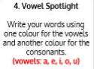  Use Vowel Spotlight to practise spelling this week’s unit words:  anxious, curious, courageous, dangerous, enormous, glamorous, hideous, humorous, mountainous, obvious, outrageous, poisonous, serious, tremendous
9.45-10.00  Active break | L.O: To boost my concentration through movement. | Join in with the Go Noodle clip to get you moving!  https://www.youtube.com/watch?v=1b6axyuaKcY
10.00-11.00  English | SPaG Revision LO: To identify fronted adverbials.  LO: To answer questions on the text. | For today’s SPaG Daily Practice, use your knowledge of fronted adverbials to answer the question below:  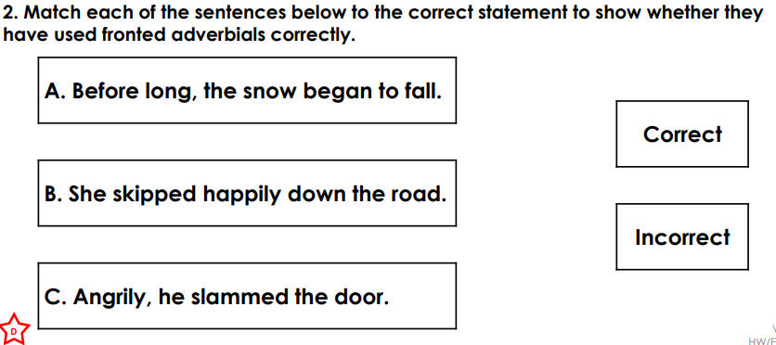  Follow the link below to have a go at today’s English lesson:  To answer questions on the text (thenational.academy)
11.00- 11.15
Break
11.15-12.15  Maths | LO: To practise my recall of the 3 times table.  LO: To investigate Roman Numerals up to one hundred. | Follow the link below to practise the 3 times table:  https://www.timestables.co.uk/3-times-table.html  Follow the link below to have a go at today’s maths lesson:  To investigate Roman Numerals up to one hundred (thenational.academy)
12.15-1.00
Dinner
1.00-1.15  Storytime | LO: To listen to a story for pleasure. | Listen to Chapter 2 of The Mystwick School of Musicraft:  Audible Stories: Free Audiobooks for Kids | Audible.com
1.15-2.30  Topic- Science | LO: To understand how particles behave in solids, liquids and gases. | Follow the link below to have a go at today’s lesson:  How do particles behave inside solids, liquids and gases? (thenational.academy)
2.30-3.00  French | LO: To practise introducing yourself in French. | Follow the link below to revise how to introduce yourself in French:  Talking About Yourself - KS2 French - BBC Bitesize - BBC Bitesize

Beat That!

Time and Subject  Wednesday | Learning Objective | Task/Link/Resources
8.45-9.00  Reading | L.O: To practise and consolidate existing reading skills. | Read your individual reading book, either in your head or out loud.
9.00-9.15  Morning Maths | LO: To consolidate recall of number facts.  Revision LO: To tell the time to 5 minutes. | Complete today’s Beat That- scroll down below today’s timetable to find the questions. Remember, it is the same one every day for a week. Can you beat your own score?  Morning Maths: In Morning Maths today, you are going to revise our knowledge of time. Click the link below, choose Summer Term Week 10 and select the video Lesson 4 Tell the time to 5 minutes:  https://whiterosemaths.com/homelearning/summer-archive/year-3/
9.15-9.45  Spelling | LO: To practise Unit Seven RWI Spelling words. | This week, we are revising spelling words ending in ‘ous’.  Use Rainbow Words to practise spelling this week’s unit words:  anxious, curious, courageous, dangerous, enormous, glamorous, hideous, humorous, mountainous, obvious, outrageous, poisonous, serious, tremendous
9.45-10.00  Active break | LO: To boost my concentration through movement. | Join in with the Go Noodle clip below to get you moving!  https://www.youtube.com/watch?v=psUPYR235O8
10.00-11.00  English | SPaG Revision LO: To identify fronted adverbials.  LO: To answer questions on the text. | For today’s SPaG Daily Practice, use your knowledge of fronted adverbials to answer the question below:  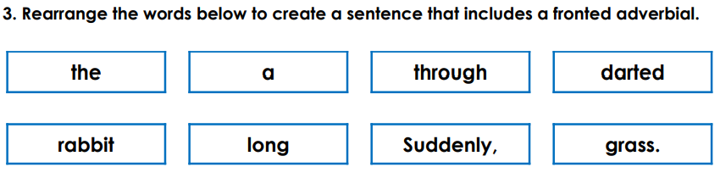  Follow the link below to have a go at today’s English lesson:  To answer questions on the text (thenational.academy)
11.00- 11.15
Break
11.15-12.15  Maths | LO: To practise my recall of the 3 times table.  LO: To identify sequences. | Follow the link below to practise the 3 times table and get moving!  https://www.youtube.com/watch?v=t03yW7Oxsoc  Follow the link below to have a go at today’s maths lesson:  Number sequences (Part 1) (thenational.academy)
12.15-1.00
Dinner
1.00-1.15  Storytime | LO: To listen to a story for pleasure. | Listen to Chapter 3 of The Mystwick School of Musicraft:  Audible Stories: Free Audiobooks for Kids | Audible.com
1.15-2.30  Topic- Science | LO: To understand what happens when you heat or cool each state of matter. | Follow the link below to have a go at today’s lesson:  What happens when you heat or cool each state of matter? (thenational.academy)
2.30-3.00  RHE | LO: To understand what makes a balanced lifestyle. | Follow the link below to have a go at today’s lesson:  Life is all about balance (thenational.academy)

Beat That!

Time and Subject  Thursday | Learning Objective | Task/Link/Resources
8.45-9.00  Reading | L.O: To practise and consolidate existing reading skills. | Read your individual reading book, either in your head or out loud.
9.00-9.15  Morning Maths | LO: To consolidate recall of number facts.  Revision LO: To measure mass. | Complete today’s Beat That- scroll down below today’s timetable to find the questions. Remember, it is the same one every day for a week. Can you beat your own score?  Morning Maths: In Morning Maths today, you are going to revise your knowledge of mass. Click the link below, choose Summer Term Week 11 and select the video Lesson 1 Measure mass:  https://whiterosemaths.com/homelearning/summer-archive/year-3/
9.15-9.45  Spelling | LO: To practise Unit Seven RWI Spelling words. | This week, we are revising spelling words ending in ‘ous’.  Use Bubble Letters to practise spelling this week’s unit words:  anxious, curious, courageous, dangerous, enormous, glamorous, hideous, humorous, mountainous, obvious, outrageous, poisonous, serious, tremendous
9.45-10.00  Active break | LO: To boost my concentration through movement. | Join in with the Go Noodle clip below to get you moving!  https://www.youtube.com/watch?v=_NWYeVyZz9I
10.00-11.00  English | SPaG Revision LO: To identify fronted adverbials.  LO: To analyse a character. | For today’s SPaG Daily Practice, use your knowledge of fronted adverbials to answer the question below:  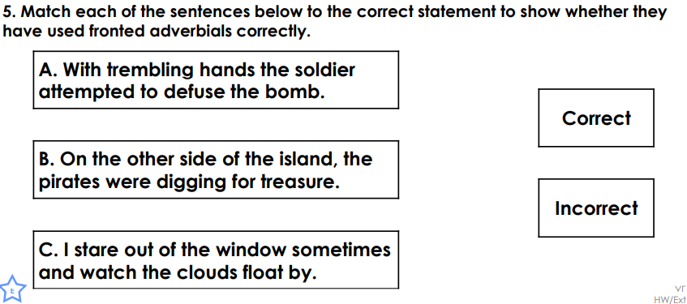  Follow the link below to have a go at today’s English lesson:  To analyse a character (thenational.academy)
11.00- 11.15
Break
11.15-12.15  Maths | LO: To practise my recall of the 3 times table.  LO: To investigate number sequences. | Follow the link below to practise the 3 times table:  http://www.snappymaths.com/multdiv/3xtable/interactive/newlook/3xtablebtcd.htm  Follow the link below to have a go at today’s lesson:  Number sequences (Part 2) (thenational.academy)
12.15-1.00
Dinner
1.00-1.15  Storytime | LO: To listen to a story for pleasure. | Listen to Chapter 4 of The Mystwick School of Musicraft:  Audible Stories: Free Audiobooks for Kids | Audible.com
1.15-3.00  PE | LO: To develop strength and stamina. | Follow the link below for today’s PE activity:  STAR WARS WORKOUT 'JEDI TRAINING ACADEMY' (8mins30secs) - YouTube

Beat That!

Time and Subject  Friday | Learning Objective | Task/Link/Resources
8.45-9.00  Reading | L.O: To practise and consolidate existing reading skills. | Read your individual reading book, either in your head or out loud.
9.00-9.15  Morning Maths | LO: To consolidate recall of number facts.  Revision LO:  To compare mass. | Complete today’s Beat That- scroll down below today’s timetable to find the questions. Remember, it is the same one every day for a week. Can you beat your own score?  Morning Maths: In Morning Maths today, you are going to revise your knowledge of mass. Click the link below, choose Summer Term Week 11 and select the video Lesson 2 Compare mass:  https://whiterosemaths.com/homelearning/summer-archive/year-3/
9.15-9.45  Spelling | LO: To practise Unit Seven RWI Spelling words. | This week, we are revising spelling words ending in ‘ous’.  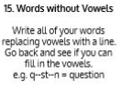  Use Words Without Vowels to practise spelling this week’s unit words:  anxious, curious, courageous, dangerous, enormous, glamorous, hideous, humorous, mountainous, obvious, outrageous, poisonous, serious, tremendous  Spelling Test:  Scroll down below today’s timetable to use the look, cover, write, check sheet to help you to test yourself on this week’s words.
9.45-10.00  Active break | L.O: To boost my concentration through movement. | Join in with the Go Noodle clip to get you moving!  https://www.youtube.com/watch?v=wPCGfa44bF0
10.00-11.00  English | SPaG Revision LO: To identify fronted adverbials.  LO: To explore genre. | For today’s SPaG Daily Practice, use your knowledge of fronted adverbials to answer the question below:  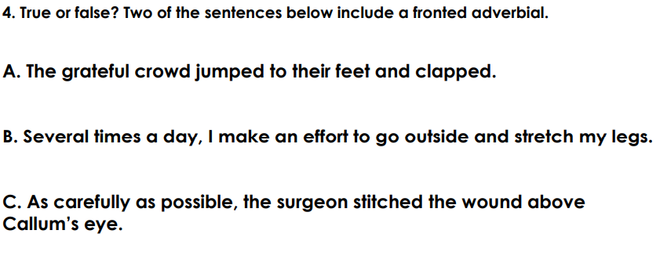  Follow the link below to have a go at today’s lesson:  To explore genre (thenational.academy)
11.00- 11.15
Break
11.15-12.15  Maths | LO: To practise my recall of the 3 times table.  LO: To identify patterns. | Follow the link below to practise the 3 times table:  http://www.snappymaths.com/multdiv/3xtable/interactive/newlook/3xmissintd.htm  Follow the link below to have a go at today’s lesson:  Identifying patterns (thenational.academy)
12.15-1.00
Dinner
1.00-1.15  Storytime | LO: To listen to a story for pleasure. | Listen to Chapter 5 of The Mystwick School of Musicraft:  Audible Stories: Free Audiobooks for Kids | Audible.com
1.15-3:00  Art | Golden Time  LO: To develop skills in drawing landscapes. | Below is the American artist Jackson Pollok. He created art by flicking paint onto his canvas. This is called action painting. Can you recreate this?

Beat That!

Spelling Test
