Time and Subject  Monday | Learning Objective | Task/Link/Resources
8.45-9.00  Reading | LO: To practise and consolidate existing reading skills. | Read your individual reading book, either in your head or out loud.
9.00-9.15  Morning Maths | LO: To consolidate recall of number facts.  Revision LO: To count sides and vertices on 2D shapes. | Complete today’s Beat That- scroll down below today’s timetable to find the questions. Remember, it is the same one every day for a week. Can you beat your own score?  Morning Maths: In Morning Maths today, you are going to revise your knowledge of shape. Click the link below, choose Summer Term Week 8 and select the video Lesson 1 Count sides and vertices on 2D shapes:  https://whiterosemaths.com/homelearning/summer-archive/year-2/
9.15-9.45  Spelling | LO: To practise Unit Seven RWI Spelling words. | This week, we are spelling words with the c sound spelt ‘ch’.  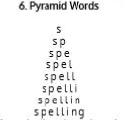  Use pyramid writing to practise spelling this week’s unit words:  ache, chaos, anchor, character, chemical, chemist, chorus, echo, mechanic, orchestra, school, scheme, stomach
9.45-10.00  Active break | LO: To boost my concentration through movement. | Join in with the Go Noodle clip below to get you moving!  https://www.youtube.com/watch?v=Imhi98dHa5w
10.00-11.00  English | SPaG Revision LO: To identify apostrophes for singular possession.  LO: To engage with a text. | For today’s SPaG Daily Practice, revise your knowledge of apostrophes. Click the link below, watch the video and complete the activities:  To introduce apostrophes for singular possession (thenational.academy)  Follow the link below to have a go at today’s English lesson:  To engage with a text (thenational.academy)
11.00- 11.15
Break
11.15-12.15  Maths | LO: To practise my recall of the 3 times table.  LO: To explore the commutativity between multiplication and division. | Follow the link below to practise the 3 times table and get moving!  https://www.bbc.co.uk/teach/supermovers/ks2-maths-the-3-times-table/z6sw382  Follow the link below to have a go at today’s maths lesson:  Commutativity between multiplication and division (thenational.academy)
12.15-1.00
Dinner
1.00-1.15  Storytime | LO: To listen to a story for pleasure. | Listen to Stone Soup:  Audible Stories: Free Audiobooks for Kids | Audible.com
1.15-2.30  Topic- Science | LO: To understand where raw materials come from and how they are used. | Follow the link below to have a go at today’s lesson:  What is a raw material? (thenational.academy)
2.30-3.00  Music | LO: To understand pulse and rhythm. | Follow the link below to have a go at today’s lesson:  Understanding pulse and rhythm (thenational.academy)

Beat That!
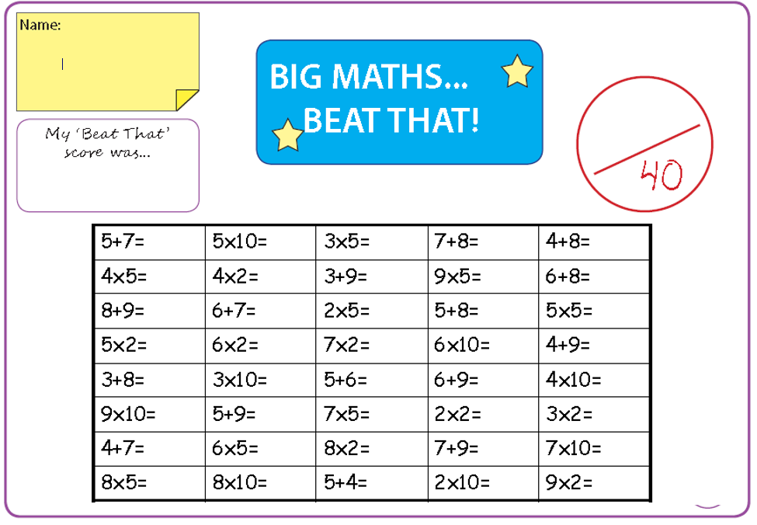

Time and Subject  Tuesday | Learning Objective | Task/Link/Resources
8.45-9.00  Reading | L.O: To practise and consolidate existing reading skills. | Read your individual reading book, either in your head or out loud.
9.00-9.15  Morning Maths | LO: To consolidate recall of number facts.  Revision LO: To identify the properties of 3D shapes. | Complete today’s Beat That- scroll down below today’s timetable to find the questions. Remember, it is the same one every day for a week. Can you beat your own score?  Morning Maths: In Morning Maths today, you are going to revise your knowledge of shape. Click the link below, choose Summer Term Week 8 and select the video Lesson 2 Count faces, edges and vertices on 3D shapes:  https://whiterosemaths.com/homelearning/summer-archive/year-2/
9.15-9.45  Spelling | LO: To practice Unit Seven RWI Spelling words. | This week, we are spelling words with the c sound spelt ‘ch’  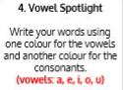  Use Vowel Spotlight to practise spelling this week’s unit words:  ache, chaos, character, chemical, chemist, chorus, echo, mechanic, orchestra, school, scheme, stomach
9.45-10.00  Active break | L.O: To boost my concentration through movement. | Join in with the Go Noodle clip to get you moving!  https://www.youtube.com/watch?v=1b6axyuaKcY
10.00-11.00  English | SPaG Revision LO: To identify apostrophes for singular possession.  LO: To answer retrieval questions. | For today’s SPaG Daily Practice, use your knowledge of apostrophes to answer the question below:  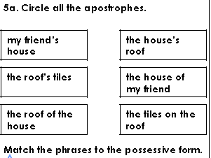  Follow the link below to have a go at today’s English lesson:  To answer retrieval questions (thenational.academy)
11.00- 11.15
Break
11.15-12.15  Maths | LO: To practise my recall of the 3 times table.  LO: To use known multiplication facts to derive our 6 times table. | Follow the link below to practise the 3 times table:  https://www.timestables.co.uk/3-times-table.html  Follow the link below to have a go at today’s maths lesson:  Use known multiplication facts to derive our 6 times table (thenational.academy)
12.15-1.00
Dinner
1.00-1.15  Storytime | LO: To listen to a story for pleasure. | Listen to The Chocolate Tree:  Audible Stories: Free Audiobooks for Kids | Audible.com
1.15-2.30  Topic- Science | LO: To understand what synthetic materials are and how they are used. | Follow the link below to have a go at today’s lesson:  What is a synthetic material? (thenational.academy)
2.30-3.00  French | LO: To practise introducing yourself in French. | Follow the link below to revise how to introduce yourself in French:  Talking About Yourself - KS2 French - BBC Bitesize - BBC Bitesize

Beat That!

Time and Subject  Wednesday | Learning Objective | Task/Link/Resources
8.45-9.00  Reading | L.O: To practise and consolidate existing reading skills. | Read your individual reading book, either in your head or out loud.
9.00-9.15  Morning Maths | LO: To consolidate recall of number facts.  Revision LO: To sort 2D and 3D shapes. | Complete today’s Beat That- scroll down below today’s timetable to find the questions. Remember, it is the same one every day for a week. Can you beat your own score?  Morning Maths: In Morning Maths today, you are going to revise your knowledge of shape. Click the link below, choose Summer Term Week 8 and select the video Lesson 3 Sorting 2D and 3D shapes:  https://whiterosemaths.com/homelearning/summer-archive/year-2/
9.15-9.45  Spelling | LO: To practise Unit Seven RWI Spelling words. | This week, we are spelling words with the c sound spelt ‘ch’  Use Rainbow Words to practise spelling this week’s unit words:  ache, chaos, character, chemical, chemist, chorus, echo, mechanic, orchestra, school, scheme, stomach
9.45-10.00  Active break | LO: To boost my concentration through movement. | Join in with the Go Noodle clip below to get you moving!  https://www.youtube.com/watch?v=psUPYR235O8
10.00-11.00  English | SPaG Revision LO: To identify apostrophes for singular possession.  LO: To answer inference questions. | For today’s SPaG Daily Practice, use your knowledge of apostrophes to answer the question below:  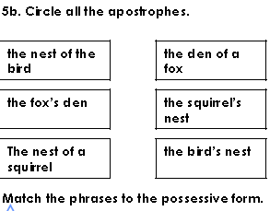  Follow the link below to have a go at today’s English lesson:  To answer inference questions (thenational.academy)
11.00- 11.15
Break
11.15-12.15  Maths | LO: To practise my recall of the 3 times table.  LO: To use known multiplication facts to derive our 8 times table. | Follow the link below to practise the 3 times table and get moving!  https://www.youtube.com/watch?v=t03yW7Oxsoc  Follow the link below to have a go at today’s maths lesson:  Use known multiplication facts to derive our 8 times table (thenational.academy)
12.15-1.00
Dinner
1.00-1.15  Storytime | LO: To listen to a story for pleasure. | Listen to Chapter 1 of Zero G:  Audible Stories: Free Audiobooks for Kids | Audible.com
1.15-2.30  Topic- Science | LO: To explore how synthetic materials are made from raw materials. | Follow the link below to have a go at today’s lesson:  How are synthetic materials made from raw materials? (thenational.academy)
2.30-3.00  RHE | LO: To understand what makes a balanced lifestyle. | Follow the link below to have a go at today’s lesson:  Life is all about balance (thenational.academy)
Beat That!

Time and Subject  Thursday | Learning Objective | Task/Link/Resources
8.45-9.00  Reading | L.O: To practise and consolidate existing reading skills. | Read your individual reading book, either in your head or out loud.
9.00-9.15  Morning Maths | LO: To consolidate recall of number facts.  Revision LO: To identify patterns with 2D and 3D shapes. | Complete today’s Beat That- scroll down below today’s timetable to find the questions. Remember, it is the same one every day for a week. Can you beat your own score?  Morning Maths: In Morning Maths today, you are going to revise your knowledge of shape. Click the link below, choose Summer Term Week 8 and select the video Lesson 4 Patterns with 2D and 3D shapes:  https://whiterosemaths.com/homelearning/summer-archive/year-2/
9.15-9.45  Spelling | LO: To practise Unit Seven RWI Spelling words. | This week, we are spelling words with the c sound spelt ‘ch’  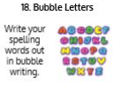  Use Bubble Letters to practise spelling this week’s unit words:  ache, chaos, character, chemical, chemist, chorus, echo, mechanic, orchestra, school, scheme, stomach
9.45-10.00  Active break | LO: To boost my concentration through movement. | Join in with the Go Noodle clip below to get you moving!  https://www.youtube.com/watch?v=_NWYeVyZz9I
10.00-11.00  English | SPaG Revision LO: To identify apostrophes for singular possession.  LO: To analyse language. | For today’s SPaG Daily Practice, use your knowledge of apostrophes to answer the question below:  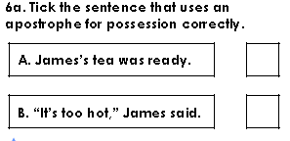  Follow the link below to have a go at today’s English lesson:  To analyse language (thenational.academy)
11.00- 11.15
Break
11.15-12.15  Maths | LO: To practise my recall of the 3 times table.  LO: To multiply 2-digit numbers by 6 using the partitioning method. | Follow the link below to practise the 3 times table:  http://www.snappymaths.com/multdiv/3xtable/interactive/newlook/3xtablebtcd.htm  Follow the link below to have a go at today’s lesson:  Multiply 2-digit numbers by 6 using the partitioning method (thenational.academy)
12.15-1.00
Dinner
1.00-1.15  Storytime | LO: To listen to a story for pleasure. | Listen to Chapter 2 of Zero G:  Audible Stories: Free Audiobooks for Kids | Audible.com
1.15-3.00  PE | LO: To develop strength and stamina. | Follow the link below for today’s PE activity:  STAR WARS WORKOUT 'JEDI TRAINING ACADEMY' (8mins30secs) - YouTube

Beat That!

Time and Subject  Friday | Learning Objective | Task/Link/Resources
8.45-9.00  Reading | L.O: To practise and consolidate existing reading skills. | Read your individual reading book, either in your head or out loud.
9.00-9.15  Morning Maths | LO: To consolidate recall of number facts.  Revision LO:  To measure length. | Complete today’s Beat That- scroll down below today’s timetable to find the questions. Remember, it is the same one every day for a week. Can you beat your own score?  Morning Maths: In Morning Maths today, you are going to revise your knowledge of measure. Click the link below, choose Summer Term Week 9 and select the video Lesson 1 Measure length:  https://whiterosemaths.com/homelearning/summer-archive/year-2/
9.15-9.45  Spelling | LO: To practise Unit Seven RWI Spelling words. | This week, we are spelling words with the c sound spelt ‘ch’  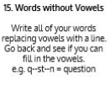  Use Words Without Vowels to practise spelling this week’s unit words:  ache, chaos, character, chemical, chemist, chorus, echo, mechanic, orchestra, school, scheme, stomach  Spelling Test:  Scroll down below today’s timetable to use the look, cover, write, check sheet to help you to test yourself on this week’s words.
9.45-10.00  Active break | L.O: To boost my concentration through movement. | Join in with the Go Noodle clip to get you moving!  https://www.youtube.com/watch?v=wPCGfa44bF0
10.00-11.00  English | SPaG Revision LO: To identify apostrophes for singular possession.  LO: To analyse a character’s emotions. | For today’s SPaG Daily Practice, use your knowledge of apostrophes to answer the question below:  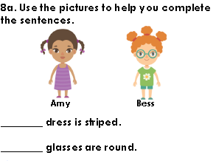  Follow the link below to have a go at today’s lesson:  To analyse a character's emotions (thenational.academy)
11.00- 11.15
Break
11.15-12.15  Maths | LO: To practise my recall of the 3 times table.  LO: To multiply 2-digit numbers by 8 using the partitioning method. | Follow the link below to practise the 3 times table:  http://www.snappymaths.com/multdiv/3xtable/interactive/newlook/3xmissintd.htm  Follow the link below to have a go at today’s lesson:  Multiply 2-digit numbers by 8 using the partitioning method (thenational.academy)
12.15-1.00
Dinner
1.00-1.15  Storytime | LO: To listen to a story for pleasure. | Listen to Chapter 3 of Zero G:  Audible Stories: Free Audiobooks for Kids | Audible.com
1.15-3:00  Art | Golden Time  LO: To develop skills in drawing landscapes. | Below is the American artist Jackson Pollok. He created art by flicking paint onto his canvas. This is called action painting. Can you recreate this?
Beat That!
Spelling Test
