Mexico Theme Day Learning Journey
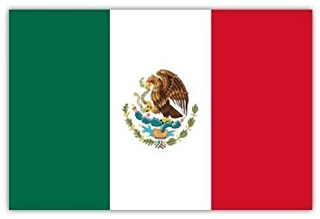

We are describing and explaining where Mexico is on the globe, and which countries are near it.
We are exploring the climate of Cancun, comparing this to Wakefield and explaining why the cities have different climates.
We are learning how to introduce ourselves in Spanish.
We are experimenting with and tasting food from Mexican culture.
We are learning how to say which foods we like and do not like in Spanish.
We are using a variety of food preparation techniques to make quesadillas.
We are learning and performing a traditional Mexican dance.

