Year 2
Computing and Coding Unit
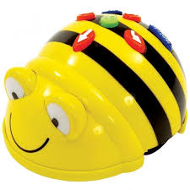

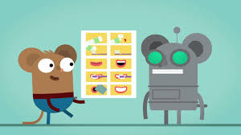

As part of our unit we will:
- Understand that an algorithm is a form of instruction.
- Use detailed and precise algorithms to instruct each other.
- Implement algorithms using an electronic device.
- Use technology safely and respectfully.
- Create and debug simple programmes using Purple Mash.

