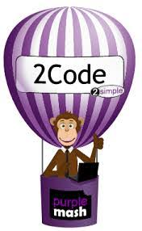
Computing Learning Journey

- To define what coding is and understand it’s purpose.
- To use repeating actions, timers and different commands within code to manipulate characters.
- To introduce “if” statements to allow selections within programs.
- To introduce and understand variables within code.
- To create a program using repeat commands.
- To program a character to respond to user keyboard input.
- To debug programs using the “design, code, execute, refine” process.

