Week 1
I can discuss Art and identify sculpture and drawing.
In today’s Art lesson, we will start with a short story. While you listen to the story, have a think about what the theme of the story is.
https://www.bbc.co.uk/teach/school-radio/audio-stories-ice-cream-team/znm67nb
Once, you have listened to the story we are going to learn about sculpture, which is a form of Art. Sculpture is a 3D object, something that we could pick up and feel the different dimensions and textures. There are many materials a sculpture can be made from, plastic, metal, wood or stone. Try to remember this word for next week.
Take a look at the images below and sort them into two categories: Sculpture and not sculpture. Finally, if you decided they are not a sculpture, what do you think they could be? Choose from the words below.
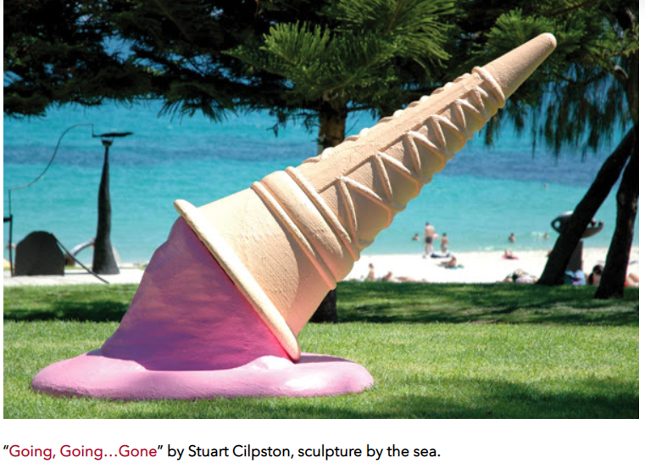
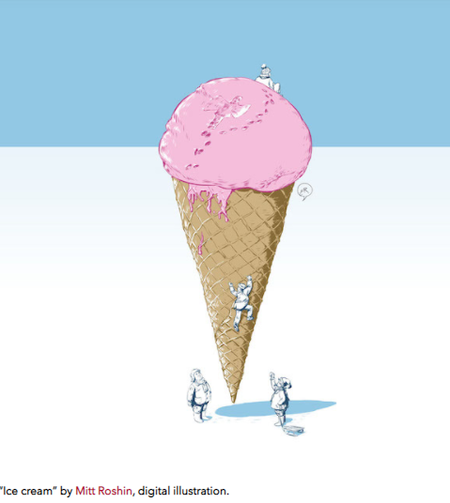

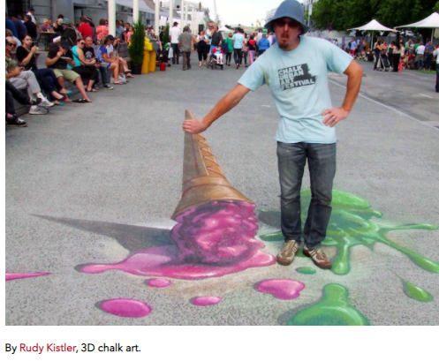
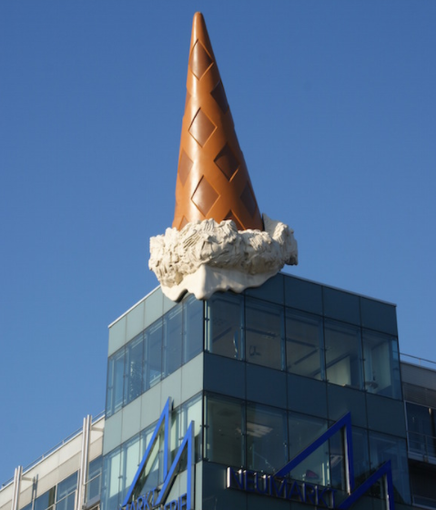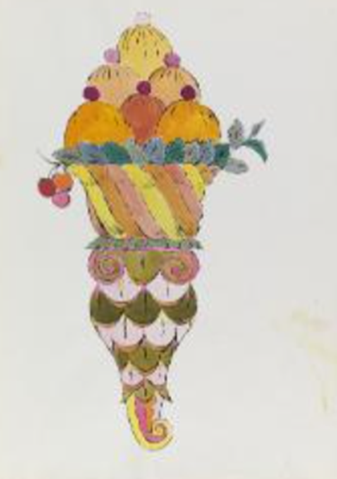
“Ice Cream Dessert” by Andy Warhol,

Week 2 I can use sketching to draw an image of an ice-cream.
Today, we will continue our work based on the theme of ice-cream! Yum, yum! Can you remember what important word we learned last week? Yes, sculpture!
Before, we look at an Artist, can you do a quick warm-up for me? Brilliant. Let’s take our pencil and some paper. I would like you to sketch any image you like onto the paper, this could be yourself, a flower, your bed, an item of clothing. . . anything at all.
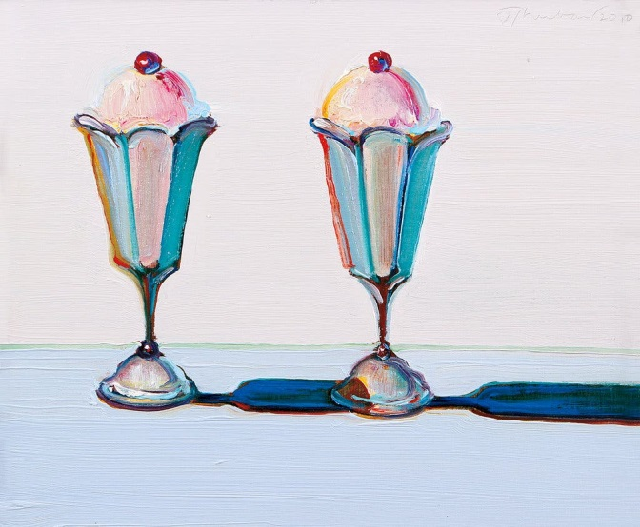
Great, now let’s focus on our Artist for today: Wayne Theibaud.
Take a look at some of the images below and discuss the use of colours, and texture (how the picture looks 3D).
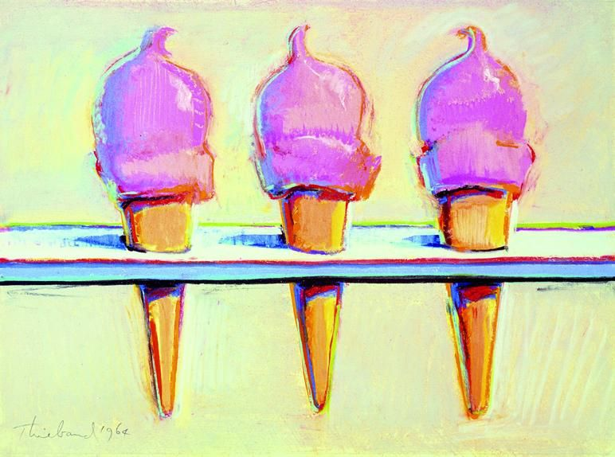
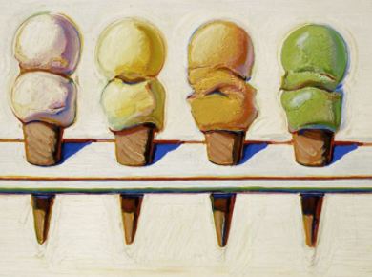
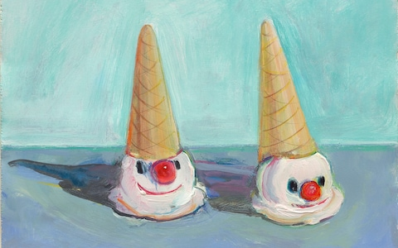

After looking at the images, we are now going to create our own drawing on a piece of paper. You might want to draw one ice-cream or two ice-creams. Will they be upside down? Will they fruit or a chocolate flake? Remember to use all of the space on the paper. Have a look at some of the images below to help you.
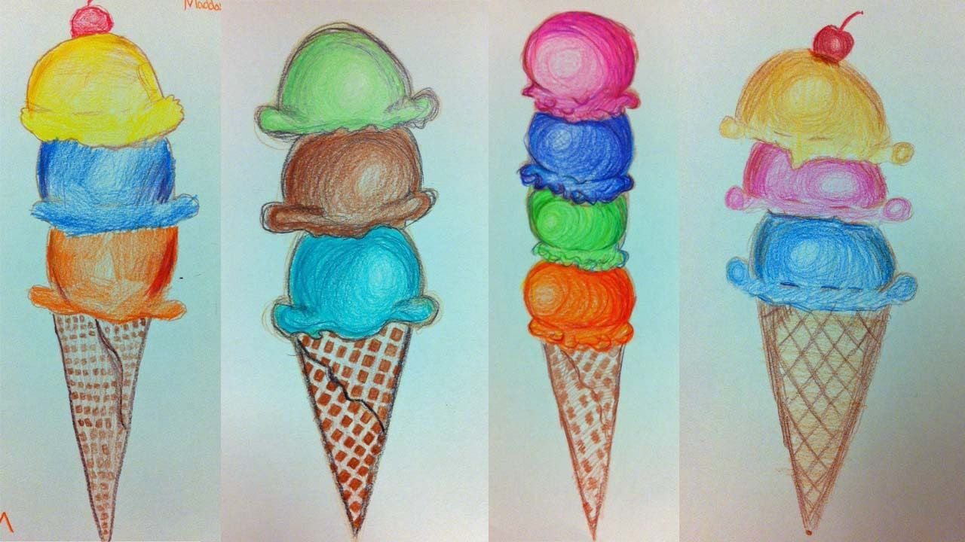

Week 3 I can create a collage
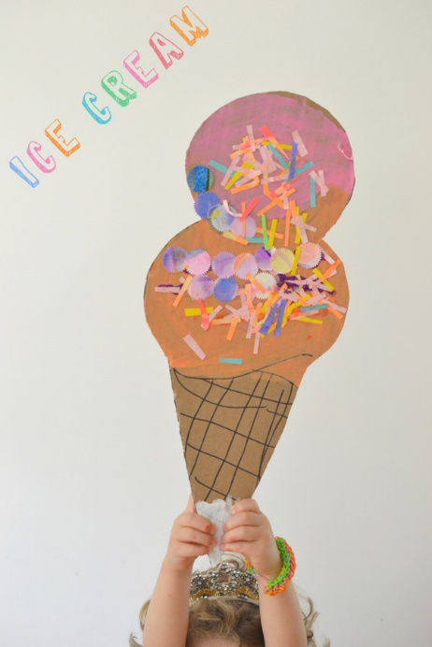
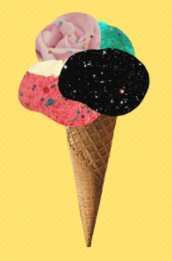
Today, we will be looking at a different form of Art called “collage”. Collage is pasting, sticking or gluing certain materials together. We could use leaves to create a collage, pieces of wrapping or bits from a magazine or newspaper. The link below shows how to create a collage inspired by the ice-cream artist, Wayne Theibaud. Watch it carefully to see how he glues together different materials to make his artwork.
https://www.youtube.com/watch?v=WKc0tGWsfwU
To collage we need to stick and layer up our materials. Take a look at the images below to explore how the children have cut or torn the paper and then glued it onto paper.
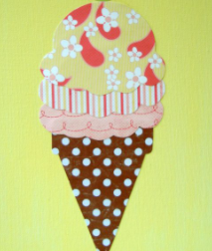 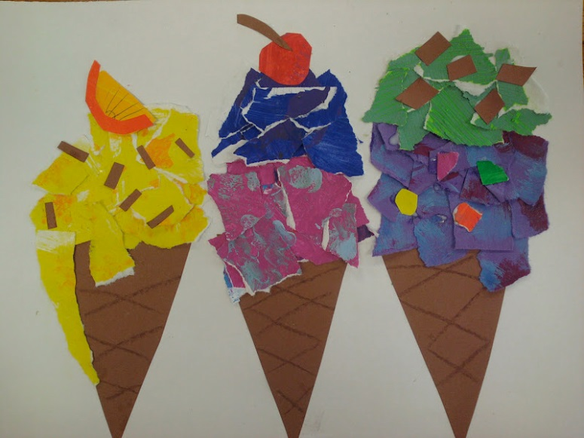
Your task is to create an ice-cream collage. You could colour some paper and cut it out, you could use old wrapping paper, magazines or newspapers. Try to find materials you can easily cut out. Ask a parent to help.

Week 4 I can create a sculpture.
Today, we will continue our artwork based around ice-creams. Can you remember that different types of Art we have looked at already? Yes, collage, drawing and sculpture. In our first week, we looked at sculptures of ice-creams. Now we are going to create one.
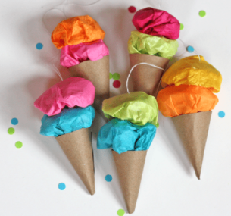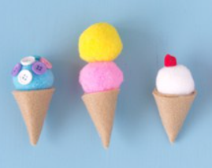
To keep it simple, you could use paper for the cone part of the ice-cream and coloured paper for the actual ice-cream.
You could try and fine will extra materials like cardboard (cereal boxes, toilet roll tubes, kitchen roll tubes), playdough, tinfoil, paper, old socks, pom poms, tissue paper, cotton wool...anything you find around the house that could be shaped into looking like an ice-cream. Always check with a parent first.

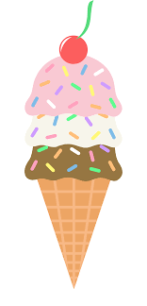
Good luck, I can’t wait to see your finished product.

Week 5 I can use my hands to create a print.
Today, we will look at printing. Printing is another type of art. Can you remember how many different types of Art we have looked at now? Yes, that’s right 4: drawing, sculpting, collaging and printing.
Watch the video to look at different types of printing, we won’t be using these at home today but maybe you will use them in school soon.
https://www.bbc.co.uk/teach/class-clips-video/art-and-design-printmaking-different-materials/zhytscw

To create our print we will need some paper, a pencil and paint. You can decide if you use one colour or two colours. You will use your finger dipped into the paint and press it onto the paper. Look at the images below and try to create your own print.
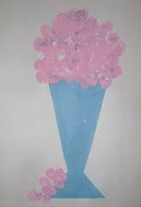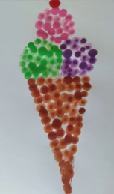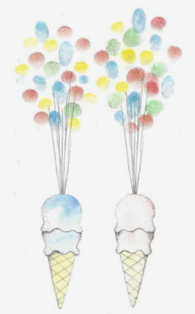

Week 6 I can use objects to create a print.
Today, we will continue with printing. We will develop our skills and now select an object to help us print. Can you remember which vegetable Emma used when she demonstrated printing? Watch the video again to find out which vegetable it was.
https://www.bbc.co.uk/teach/class-clips-video/art-and-design-printmaking-different-materials/zhytscw
During Art today, we will use a sponge to help us do printing. If you haven’t got an old sponge, use cotton wool. You will need two colours of paint. They can be any two colours. It is up to you because it is your artwork. It could be green and orange, red and blue or pink and yellow. The cone doesn’t have to be brown - the more creative you are, the better your art will be.
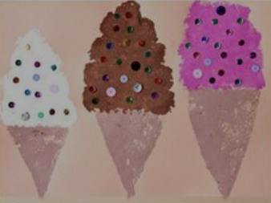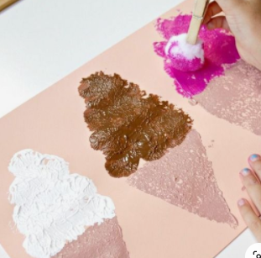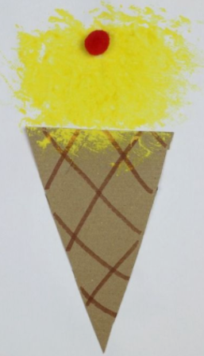

Remember, it is your interpretation of art that matters, you might want to print the full picture and create a background. You may want to draw half and print the other half or maybe you would like to add some sequins or glitter. The list is endless, have fun and enjoy creating.

Week 7 I can listen to music and identify the tempo.
Today, we will be listening to two sets of music and identifying the tempo. The tempo is how fast or slow the music is so we can say “It has a fast tempo” meaning the music is fast or we can say “It has a slow tempo” meaning the music is slow. Listen to the examples of ice-cream van sounds on the link below. You will need to identify the tempo, is it fast or is it slow.
https://www.youtube.com/watch?v=ZzC7hl17tqs
Did you get it right? The tempo is fast. Why do you think this is?
Now listen to a few minutes of the second video and decide if it has a fast tempo or a slow tempo.
https://www.youtube.com/watch?v=QGdOB46icV4
To finish with, can you try creating your own ice-cream van tune. This could be by singing, using your own musical instruments or using pots and pans to gently tap on. Try to recreate a fast tempo like ice-cream vans use to get the attention of children, fast tempo’s give us happiness and positivity which is what I feel when I eat ice-cream. The fast tempo makes us jump up and go outside, where as a slow tempo makes us relaxed. Do you like ice-cream? What is your favourite flavour?

