Time and Subject  Monday | Learning Objective | Task/Link/Resources
8.45-9.00  Reading | LO: To practise and consolidate existing reading skills. | Read your individual reading book, either in your head or out loud.
9.00-9.15  Morning Maths | LO: To consolidate recall of number facts.  Revision LO: To order lengths. | Complete today’s Beat That- scroll down below today’s timetable to find the questions. Remember, it is the same one every day for a week. Can you beat your own score?  Morning Maths: In Morning Maths today, you are going to revise ordering lengths. Click the link below, choose Summer Term Week 2 and select the video Lesson 2 Order lengths:  https://whiterosemaths.com/homelearning/summer-archive/year-2/
9.15-9.45  Spelling | LO: To practise Unit Four RWI spelling words. | This week, we are going to practise adding the suffix -ly. Watch this video to help you to learn this spelling rule: https://www.bbc.co.uk/bitesize/topics/z8mxrwx/articles/zqghtyc  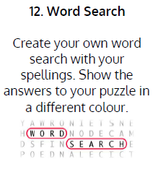  Use Word Search to practise spelling this week’s words:  suddenly, carefully, finally, completely, humbly, gently, simply, horribly, merrily, carefully, politely, giggly, simply, feebly, nicely, comically, rudely, feebly
9.45-10.00  Active break | LO: To boost my concentration through movement. | Join in with the Go Noodle clip below to get you moving!  https://www.youtube.com/watch?v=jBidsDA410s
10.00-11.00  English | SPaG Revision LO: To explore punctuating speech.  LO: To explore complex sentences. | For today’s SPaG Daily Practice, revise your knowledge of punctuation for speech:  https://classroom.thenational.academy/lessons/to-explore-punctuating-speech-first-c9j30c  Follow the link below to have a go at today’s English lesson:  https://classroom.thenational.academy/lessons/to-explore-complex-sentences-60t66c
11.00- 11.15
Break
11.15-12.15  Maths | LO: To practise my recall of the 3 times table.  LO: To understand that multiplication and division are inverse operations. | Follow the link below to practise the 3 times table and get moving!  https://www.youtube.com/watch?v=WuhjqdLLWmk  Follow the link below to have a go at today’s maths lesson:  https://classroom.thenational.academy/lessons/understanding-that-multiplication-and-division-are-inverse-operations-61gk0r
12.15-1.00
Dinner
1.00-1.15  Storytime | LO: To listen to a story for pleasure. | Listen to Chapter 31 of Timeless Tales of Beatrix Potter.  https://stories.audible.com/pdp/B00T50R42I?ref=adbl_ent_anon_ds_pdp_plc
1.15-2.30  Topic- History | LO: To explore what life was like in a Neolithic settlement. | Follow the link below to have a go at today’s lesson:  https://classroom.thenational.academy/lessons/what-was-life-like-in-a-neolithic-settlement-64r3ce
2.30-3.00  Music | LO: To explore the different types of percussion. | Follow the link below to have a go at today’s lesson:  https://classroom.thenational.academy/lessons/exploring-percussion-chk66t

Beat That!
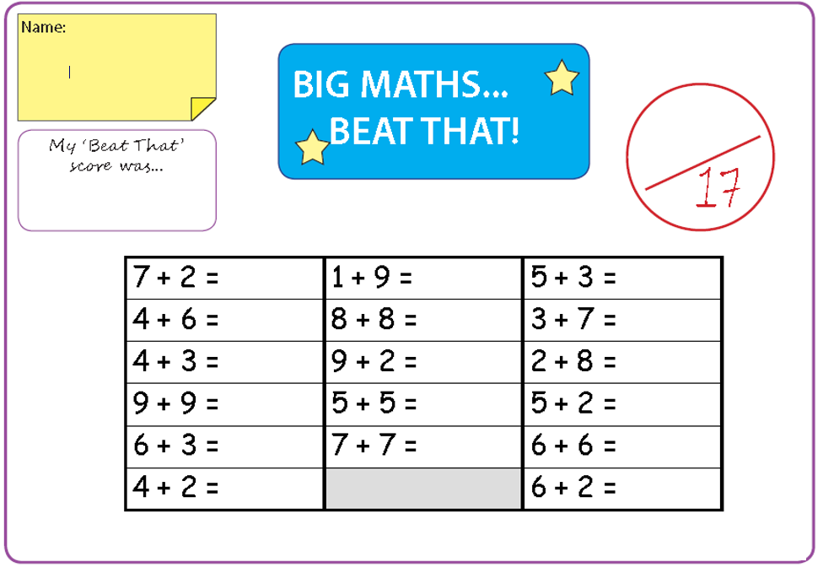

Time and Subject  Tuesday | Learning Objective | Task/Link/Resources
8.45-9.00  Reading | L.O: To practise and consolidate existing reading skills. | Read your individual reading book, either in your head or out loud.
9.00-9.15  Morning Maths | LO: To consolidate recall of number facts.  Revision LO: To use the four operation to solve calculations involving length. | Complete today’s Beat That- scroll down below today’s timetable to find the questions. Remember, it is the same one every day for a week. Can you beat your own score?  Morning Maths: In Morning Maths today, you are going to revise solving calculations involving length. Click the link below, choose Summer Term Week 2 and select the video Lesson 3 Four operations with length:  https://whiterosemaths.com/homelearning/summer-archive/year-2/
9.15-9.45  Spelling | LO: To practise Unit Four RWI spelling words. | This week, we are going to practise adding the suffix -ly.  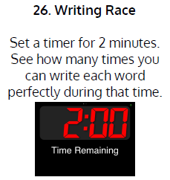  Use Writing Race to practise spelling this week’s words:  suddenly, carefully, finally, completely, humbly, gently, simply, horribly, merrily, carefully, politely, giggly, simply, feebly, nicely, comically, rudely, feebly
9.45-10.00  Active break | L.O: To boost my concentration through movement. | Join in with the Go Noodle clip below to get you moving!  https://www.youtube.com/watch?v=2ERLMzBk3Qk
10.00-11.00  English | SPaG Revision LO: To explore using apostrophes for plural possession.  LO: To explore suffixes: More plurals | For today’s SPaG Daily Practice, click the link below to revise your knowledge of using apostrophes for plural possession:  https://classroom.thenational.academy/lessons/to-explore-conjunctions-c4wkee  Follow the link below to have a go at today’s English lesson:  https://classroom.thenational.academy/lessons/to-investigate-suffixes-more-plurals-6rtpcd
11.00- 11.15
Break
11.15-12.15  Maths | LO: To practise my recall of the 3 times table.  LO: To use the inverse operation to find missing numbers. | Play hit the button to practise the 3 times table:  https://www.topmarks.co.uk/maths-games/hit-the-button  Follow the link below to have a go at today’s maths lesson:  https://classroom.thenational.academy/lessons/using-the-inverse-operation-to-find-missing-numbers-cgt32c
12.15-1.00
Dinner
1.00-1.15  Storytime | LO: To listen to a story for pleasure. | Listen to Chapter 32 of Timeless Tales of Beatrix Potter.  https://stories.audible.com/pdp/B00T50R42I?ref=adbl_ent_anon_ds_pdp_plc
1.15-2.30  Topic-History | LO: To understand how farming changed how humans lived. | Follow the link below to have a go at today’s lesson:  https://classroom.thenational.academy/lessons/how-did-farming-change-how-humans-lived-69gkce
2.30-3.00  French | LO: To name common animals in French. | Follow the link below to have a go at today’s lesson:  https://www.youtube.com/watch?v=y0JBUEiLYXI

Beat That!

Time and Subject  Wednesday | Learning Objective | Task/Link/Resources
8.45-9.00  Reading | L.O: To practise and consolidate existing reading skills. | Read your individual reading book, either in your head or out loud.
9.00-9.15  Morning Maths | LO: To consolidate recall of number facts.  Revision LO: To practise problem solving. | Complete today’s Beat That- scroll down below today’s timetable to find the questions. Remember, it is the same one every day for a week. Can you beat your own score?  Morning Maths: In Morning Maths today, you are going to practise problem solving. Click the link below, choose Summer Term Week 2 and select the video Lesson 4 Problem solving:  https://whiterosemaths.com/homelearning/summer-archive/year-2/
9.15-9.45  Spelling | LO: To practise Unit Four RWI spelling words. | This week, we are going to practise adding the suffix -ly.  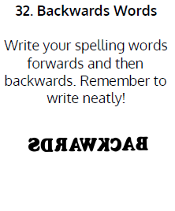  Use Backwards Words to practise spelling this week’s words:  suddenly, carefully, finally, completely, humbly, gently, simply, horribly, merrily, carefully, politely, giggly, simply, feebly, nicely, comically, rudely, feebly
9.45-10.00  Active break | LO: To boost my concentration through movement. | Join in with the Go Noodle clip below to get you moving!  https://www.youtube.com/watch?v=zFQWVN4xip0
10.00-11.00  English | SPaG Revision LO: To use commas in a list.  LO: To write complex sentences for a report. | For today’s SPaG Daily Practice, have a go at the question below. Watch this video to help you:  https://www.bbc.co.uk/teach/supermovers/ks1-english-punctuation-with-karim-hacker/zrksqp3  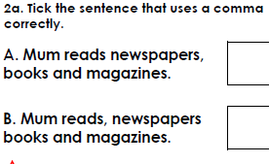  Follow the link below to have a go at today’s English lesson:  https://classroom.thenational.academy/lessons/to-write-complex-sentences-for-a-report-61k3ed
11.00- 11.15
Break
11.15-12.15  Maths | LO: To practise my recall of the 3 times table.  LO: To recall multiplication and division facts. | Follow the link below to practise the 3 times table and get moving!  https://www.youtube.com/watch?v=1OPTfVcoCO4  Follow the link below to have a go at today’s maths lesson:  https://classroom.thenational.academy/lessons/recalling-multiplication-and-division-facts-cmwk0d
12.15-1.00
Dinner
1.00-1.15  Storytime | LO: To listen to a story for pleasure. | Listen to Chapter 33 of Timeless Tales of Beatrix Potter.  https://stories.audible.com/pdp/B00T50R42I?ref=adbl_ent_anon_ds_pdp_plc
1.15-2.30  Topic- History | LO: To explore who the Celts were and how they used iron. | Follow the link to have a go at today’s lesson:  https://classroom.thenational.academy/lessons/who-were-the-celts-and-why-did-they-use-iron-cnhkjr
2.30-3.00  RHE | LO: To understand how to keep yourself safe on Bonfire Night. | Follow the link to have a go at today’s lesson:  https://classroom.thenational.academy/lessons/beautiful-explosions-6hh3gt

Beat That!

Time and Subject  Thursday | Learning Objective | Task/Link/Resources
8.45-9.00  Reading | L.O: To practise and consolidate existing reading skills. | Read your individual reading book, either in your head or out loud.
9.00-9.15  Morning Maths | LO: To consolidate recall of number facts.  Revision LO: To use addition and subtraction bonds to 20. | Complete today’s Beat That- scroll down below today’s timetable to find the questions. Remember, it is the same one every day for a week. Can you beat your own score?  Morning Maths: In Morning Maths today, you are going to revise number bonds to 20. Click the link below, choose Summer Term Week 3 and select the video Lesson 1 Fact families addition and subtraction bonds to 20:  https://whiterosemaths.com/homelearning/summer-archive/year-2/
9.15-9.45  Spelling | LO: To practise Unit Four RWI spelling words. | This week, we are going to practise adding the suffix -ly.  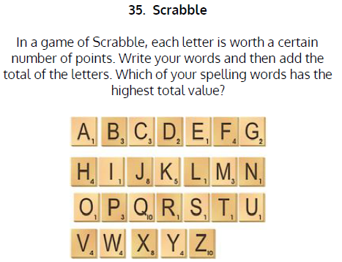  Use Scrabble to practise spelling this week’s words:  suddenly, carefully, finally, completely, humbly, gently, simply, horribly, merrily, carefully, politely, giggly, simply, feebly, nicely, comically, rudely, feebly
9.45-10.00  Active break | LO: To boost my concentration through movement. | Join in with the Go Noodle clip below to get you moving!  https://www.youtube.com/watch?v=epb6f8JiLrw
10.00-11.00  English | SPaG Revision LO: To use commas in a list.  LO: To write the first section of a non-chronological report. | For today’s SPaG Daily Practice, have a go at the question below. Watch this video to help you:  https://www.youtube.com/watch?v=tERTn9r-S-o  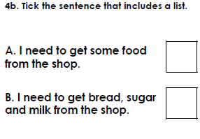  Follow the link below to have a go at today’s English lesson:  https://classroom.thenational.academy/lessons/to-write-the-first-section-6gu38t
11.00- 11.15
Break
11.15-12.15  Maths | LO: To practise my recall of the 3 times table.  LO: To use factors and products to solve problems. | Follow the link below to practise the 3 times table:  http://www.snappymaths.com/multdiv/3xtable/interactive/newlook/3xtableintd.htm  Follow the link below to have a go at today’s lesson:  https://classroom.thenational.academy/lessons/using-factors-and-products-to-solve-division-problems-cmtp4e
12.15-1.00
Dinner
1.00-1.15  Storytime | LO: To listen to a story for pleasure. | Listen to Chapter 34 of Timeless Tales of Beatrix Potter.  https://stories.audible.com/pdp/B00T50R42I?ref=adbl_ent_anon_ds_pdp_plc
1.15-3.00  PE | LO: To learn and perform a dance routine. | Follow the link below to learn a dance routine inspired by The Lion King!  https://www.youtube.com/watch?v=1QRmKit2NXw

Beat That!

Time and Subject  Friday | Learning Objective | Task/Link/Resources
8.45-9.00  Reading | L.O: To practise and consolidate existing reading skills. | Read your individual reading book, either in your head or out loud.
9.00-9.15  Morning Maths | LO: To consolidate recall of number facts.  Revision LO:  To compare number sentences. | Complete today’s Beat That- scroll down below today’s timetable to find the questions. Remember, it is the same one every day for a week. Can you beat your own score?  Morning Maths: In Morning Maths today, you are going to revise comparing number sentences. Click the link below, choose Summer Term Week 3 and select the video Lesson 2 Compare number sentences:  https://whiterosemaths.com/homelearning/summer-archive/year-2/
9.15-9.45  Spelling | LO: To practise Unit Four RWI spelling words. | This week, we are going to practise adding the suffix -ly.  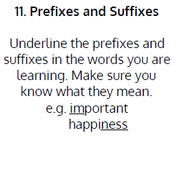  Use Scrabble to practise spelling this week’s words:  angrily, automatically, bossily, breezily, cheekily, comically, cosily, dramatically, finally, frantically, happily, hastily, heavily, heroically, magically, merrily, nicely, physically, sadly, sleepily, slowly.  Spelling Test:  Scroll down below today’s timetable to use the look, cover, write, check sheet to help you to test yourself on this week’s words.
9.45-10.00  Active break | L.O: To boost my concentration through movement. | Join in with the Go Noodle clip to get you moving!  https://www.youtube.com/watch?v=T9T5fJDy_ig
10.00-11.00  English | SPaG Revision LO: To use commas in a list.  LO: To develop a rich understanding of words associated with the jungle. | For today’s SpaG Daily Practice, have a go at the question below. Watch this video to help you:  https://www.youtube.com/watch?v=drTyYqbz6Xk  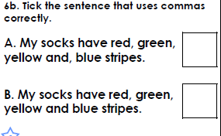  Follow the link below to have a go at today’s lesson:  https://classroom.thenational.academy/lessons/to-write-the-first-section-6gu38t
11.00- 11.15
Break
11.15-12.15  Maths | LO: To practise my recall of the 3 times table.  LO: To consolidate multiplication and division knowledge. | Play Coconut Multiples to practise the 3 times table:  https://www.topmarks.co.uk/times-tables/coconut-multiples  Follow the link below to have a go at today’s lesson:  https://classroom.thenational.academy/lessons/consolidating-multiplication-and-division-knowledge-part-1-70vkec
12.15-1.00
Dinner
1.00-1.15  Storytime | LO: To listen to a story for pleasure. | Listen to Chapter 35 of Timeless Tales of Beatrix Potter.  https://stories.audible.com/pdp/B00T50R42I?ref=adbl_ent_anon_ds_pdp_plc
1.15-3:00  Mindfulness | Golden Time  LO: To practise mindfulness. | Have a go at creating some mindfulness art:  https://www.youtube.com/watch?v=VXs0czMhsZw  Have a go at mindfulness meditation:  https://www.youtube.com/watch?v=DWOHcGF1Tmc

Beat That!

Spelling Test
