Time and Subject  Monday | Learning Objective |  |  | Task/Link/Resources
8.45-9.00  Reading | LO: To practise and consolidate existing reading skills. |  |  | Read your individual reading book, either in your head or out loud.
9.00-9.15  Morning Maths | LO: To consolidate recall of number facts.  Revision LO: To find three quarters. |  |  | Complete today’s Beat That- scroll down below today’s timetable to find the questions. Remember, it is the same one every day for a week. Can you beat your own score?  Morning Maths: In Morning Maths today, you are going to revise finding 3 quarters of numbers and groups of objects. Click the link below, choose Summer Term Week 1 and select the video Lesson 1 Find three quarters:  https://whiterosemaths.com/homelearning/summer-archive/year-2/
9.15-9.45  Spelling | LO: To practise Year 3/4 Common Exception words. |  |  | This week, we are going to practise spelling some of our tricky orange words!  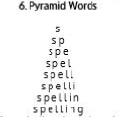  Use Pyramid Words to practise spelling this week’s orange words:  caught, centre, century, certain, circle, complete, consider, continue
9.45-10.00  Active break | LO: To boost my concentration through movement. |  |  | Join in with the Go Noodle clip below to get you moving!  https://www.youtube.com/watch?v=aZru-M3TUlI
10.00-11.00  English | SPaG Revision LO: To explore prepositions.  LO: To develop vocabulary to describe the Portia Spider. |  |  | For today’s SPaG Daily Practice, revise your knowledge of prepositions:  https://classroom.thenational.academy/lessons/to-explore-prepositions-74t66r  Follow the link below to have a go at today’s English lesson:  https://classroom.thenational.academy/lessons/to-develop-vocabulary-to-describe-the-portia-spider-6xjk2c
11.00- 11.15
Break
11.15-12.15  Maths | LO: To practise my recall of the 8 times table.  LO: To recall the 3 times table. |  |  | Follow the link below to practise the 8 times table and get moving!  https://www.bbc.co.uk/teach/supermovers/ks2-maths-the-8-times-table-with-filbert-fox/z4mrhbk  Follow the link below to have a go at today’s maths lesson:  https://classroom.thenational.academy/lessons/recalling-the-3-times-table-c8tp4d
12.15-1.00
Dinner
1.00-1.15  Storytime | LO: To listen to a story for pleasure. |  |  | Listen to Chapter 26 of Timeless Tales of Beatrix Potter.  https://stories.audible.com/pdp/B00T50R42I?ref=adbl_ent_anon_ds_pdp_plc
1.15-2.30  Topic- History |  | LO: To identify the different periods in the Stone Age. | Follow the link below to have a go at today’s lesson:  https://classroom.thenational.academy/lessons/what-were-the-different-periods-in-the-stone-age-crtkad
2.30-3.00  Music | LO: To recognise time signatures. |  |  | Follow the link below to have a go at today’s lesson:  https://classroom.thenational.academy/lessons/recognising-time-signatures-6rv36d

Beat That!

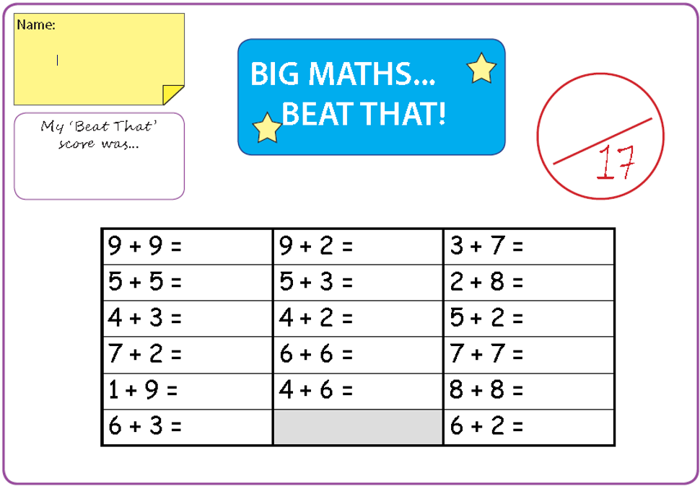

Time and Subject  Tuesday | Learning Objective | Task/Link/Resources
8.45-9.00  Reading | L.O: To practise and consolidate existing reading skills. | Read your individual reading book, either in your head or out loud.
9.00-9.15  Morning Maths | LO: To consolidate recall of number facts.  Revision LO: To count in fractions. | Complete today’s Beat That- scroll down below today’s timetable to find the questions. Remember, it is the same one every day for a week. Can you beat your own score?  Morning Maths: In Morning Maths today, you are going to revise counting in fractions. Click the link below, choose Summer Term Week 1 and select the video Lesson 2 Count in fractions:  https://whiterosemaths.com/homelearning/summer-archive/year-2/
9.15-9.45  Spelling | LO: To practise Year 3/4 Common Exception words. | This week, we are going to practise spelling some of our tricky orange words!  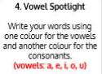  Use Vowel Spotlight to practise spelling this week’s words:  caught, centre, century, certain, circle, complete, consider, continue
9.45-10.00  Active break | L.O: To boost my concentration through movement. | Join in with the Go Noodle clip below to get you moving!  https://www.youtube.com/watch?v=wIYys4iDtHo
10.00-11.00  English | SPaG Revision LO: To explore conjunctions.  LO: To practise and apply our knowledge of suffixes: Plural | For today’s SPaG Daily Practice, click the link below to revise your knowledge of conjunctions:  https://classroom.thenational.academy/lessons/to-explore-conjunctions-c4wkee  Follow the link below to have a go at today’s English lesson:  https://classroom.thenational.academy/lessons/to-practise-and-apply-knowledge-of-suffixes-plural-including-a-test-6gt3jc
11.00- 11.15
Break
11.15-12.15  Maths | LO: To practise my recall of the 8 times table.  LO: To recall the 4 times table. | Follow the link below to practise the 8 times table:  https://www.timestables.co.uk/8-times-table.html  Follow the link below to have a go at today’s maths lesson:  https://classroom.thenational.academy/lessons/recalling-the-4-times-table-cmt64e
12.15-1.00
Dinner
1.00-1.15  Storytime | LO: To listen to a story for pleasure. | Listen to Chapter 27 of Timeless Tales of Beatrix Potter.  https://stories.audible.com/pdp/B00T50R42I?ref=adbl_ent_anon_ds_pdp_plc
1.15-2.30  Topic-History | LO: To explore the similarities and differences between Stone Age periods. | Follow the link below to have a go at today’s lesson:  https://classroom.thenational.academy/lessons/what-are-the-similarities-and-differences-between-stone-age-periods-cdhk2d
2.30-3.00  French | LO: To learn the months of the year in French. | Follow the link below to have a go at today’s lesson:  https://www.youtube.com/watch?v=Jzbs17EVKlw  Join in with this song:  https://www.youtube.com/watch?v=7_u2SigckNQ

Beat That!

Time and Subject  Wednesday | Learning Objective | Task/Link/Resources
8.45-9.00  Reading | L.O: To practise and consolidate existing reading skills. | Read your individual reading book, either in your head or out loud.
9.00-9.15  Morning Maths | LO: To consolidate recall of number facts.  Revision LO: To measure length (cm) | Complete today’s Beat That- scroll down below today’s timetable to find the questions. Remember, it is the same one every day for a week. Can you beat your own score?  Morning Maths: In Morning Maths today, you are going to revise measuring length (cm). Click the link below, choose Summer Term Week 1 and select the video Lesson 3 Measure length (cm):  https://whiterosemaths.com/homelearning/summer-archive/year-2/
9.15-9.45  Spelling | LO: To practise Year 3/4 Common Exception words. | This week, we are going to practise spelling some of our tricky orange words.  Use Rainbow Words to practise spelling this week’s words:  caught, centre, century, certain, circle, complete, consider, continue
9.45-10.00  Active break | LO: To boost my concentration through movement. | Join in with the Go Noodle clip below to get you moving!  https://www.youtube.com/watch?v=sWH4fJ0pt-I
10.00-11.00  English | SPaG Revision LO: To explore complex sentences.  LO: To plan the first section of a report. | For today’s SPaG Daily Practice, revise your knowledge of complex sentences. Click the link below for today’s lesson:  https://classroom.thenational.academy/lessons/to-explore-complex-sentences-60t66c  Follow the link below to have a go at today’s English lesson:  https://classroom.thenational.academy/lessons/to-plan-the-first-section-of-a-report-64tkac
11.00- 11.15
Break
11.15-12.15  Maths | LO: To practise my recall of the 8 times table.  LO: To use arrays to represent the 3 and 4 times tables. | Follow the link below to practise the 8 times table and get moving!  https://www.youtube.com/watch?v=SNFXWEXaCQw  Follow the link below to have a go at today’s maths lesson:  https://classroom.thenational.academy/lessons/using-arrays-to-represent-the-3-and-4-times-tables-6xk38r
12.15-1.00
Dinner
1.00-1.15  Storytime | LO: To listen to a story for pleasure. | Listen to Chapter 28 of Timeless Tales of Beatrix Potter.  https://stories.audible.com/pdp/B00T50R42I?ref=adbl_ent_anon_ds_pdp_plc
1.15-2.30  Topic-History | LO: To explore how artefacts from the Stone Age tells us about how people lived during the different periods. | Follow the link to have a go at today’s lesson:  https://classroom.thenational.academy/lessons/what-can-artefacts-from-the-stone-age-tell-us-about-how-people-lived-during-the-different-periods-6wtk8c
2.30-3.00  RHE | LO: To identify human rights and how they protect people. | Follow the link to have a go at today’s lesson:  https://classroom.thenational.academy/lessons/i-have-a-dream-crtkjd

Beat That!

Time and Subject  Thursday | Learning Objective | Task/Link/Resources
8.45-9.00  Reading | L.O: To practise and consolidate existing reading skills. | Read your individual reading book, either in your head or out loud.
9.00-9.15  Morning Maths | LO: To consolidate recall of number facts.  Revision LO: To measure length (m) | Complete today’s Beat That- scroll down below today’s timetable to find the questions. Remember, it is the same one every day for a week. Can you beat your own score?  Morning Maths: In Morning Maths today, you are going to revise measuring length (m). Click the link below, choose Summer Term Week 1 and select the video Lesson 4 Measure length (m):  https://whiterosemaths.com/homelearning/summer-archive/year-2/
9.15-9.45  Spelling | LO: To practise Year 3/4 Common Exception words. | This week, we are going to practise spelling some of our tricky orange words.  Use Bubble Letters to practise spelling this week’s words:  caught, centre, century, certain, circle, complete, consider, continue
9.45-10.00  Active break | LO: To boost my concentration through movement. | Join in with the Go Noodle clip below to get you moving!  https://www.youtube.com/watch?v=1b6axyuaKcY
10.00-11.00  English | SPaG Revision LO: To revise our understanding of simple compound and complex sentences.  LO: To write the opening of a report. | For today’s SPaG Daily Practice, we are going to revise our knowledge of simple and complex sentences and how to write them. Click the link to have a go at today’s lesson:  https://classroom.thenational.academy/lessons/to-revise-our-understanding-of-simple-compound-and-complex-sentences-74t64d  Follow the link below to have a go at today’s English lesson:  https://classroom.thenational.academy/lessons/to-write-the-opening-to-a-report-6tjp4r
11.00- 11.15
Break
11.15-12.15  Maths | LO: To practise my recall of the 8 times table.  LO: To understand multiplication can be completed in any order. | Follow the link below to practise the 8 times table:  http://www.snappymaths.com/multdiv/8xtable/interactive/newlook/8xtablebtcd.htm  Follow the link below to have a go at today’s lesson:  https://classroom.thenational.academy/lessons/understanding-multiplication-can-be-completed-in-any-order-68rp6c
12.15-1.00
Dinner
1.00-1.15  Storytime | LO: To listen to a story for pleasure. | Listen to Chapter 29 of Timeless Tales of Beatrix Potter.  https://stories.audible.com/pdp/B00T50R42I?ref=adbl_ent_anon_ds_pdp_plc
1.15-3.00  PE | LO: To learn and perform a dance routine. | Follow the link below to learn a dance routine inspired by Trolls!  https://www.youtube.com/watch?v=MCeo6Q3p7Mc

Beat That!

Time and Subject  Friday | Learning Objective | Task/Link/Resources
8.45-9.00  Reading | L.O: To practise and consolidate existing reading skills. | Read your individual reading book, either in your head or out loud.
9.00-9.15  Morning Maths | LO: To consolidate recall of number facts.  Revision LO:  To compare lengths. | Complete today’s Beat That- scroll down below today’s timetable to find the questions. Remember, it is the same one every day for a week. Can you beat your own score?  Morning Maths: In Morning Maths today, you are going to revise comparing lengths. Click the link below, choose Summer Term Week 2 and select the video Lesson 1 Compare lengths:  https://whiterosemaths.com/homelearning/summer-archive/year-2/
9.15-9.45  Spelling | LO: To practise Year 3/4 Common Exception words. | This week, we are going to practise spelling some of our tricky orange words.  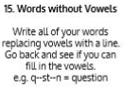  Use Words without Vowels to practise spelling this week’s words:  caught, centre, century, certain, circle, complete, consider, continue  Spelling Test:  Scroll down below today’s timetable to use the look, cover, write, check sheet to help you to test yourself on this week’s words.
9.45-10.00  Active break | L.O: To boost my concentration through movement. | Join in with the Go Noodle clip to get you moving!  https://www.youtube.com/watch?v=psUPYR235O8
10.00-11.00  English | SPaG Revision LO: To understand the two functions of apostrophes.  LO: To write compound sentences for a non-chronological report. | For today’s SPaG Daily Practice, revise your knowledge of apostrophes. Click the link below to have a go at today’s lesson:  https://classroom.thenational.academy/lessons/to-understand-the-two-functions-of-apostrophes-68vk6t  Follow the link below to have a go at today’s lesson:  https://classroom.thenational.academy/lessons/to-write-compound-sentences-for-a-non-chronological-report-68w6ad
11.00- 11.15
Break
11.15-12.15  Maths | LO: To practise my recall of the 8 times table.  LO: To use bar models to represent known times tables. | Follow the link below to practise the 8 times table:  http://www.snappymaths.com/multdiv/8xtable/interactive/newlook/8xmissintd.htm  Follow the link below to have a go at today’s lesson:  https://classroom.thenational.academy/lessons/using-bar-models-to-represent-known-times-tables-6tj62e
12.15-1.00
Dinner
1.00-1.15  Storytime | LO: To listen to a story for pleasure. | Listen to Chapter 30 of Timeless Tales of Beatrix Potter.  https://stories.audible.com/pdp/B00T50R42I?ref=adbl_ent_anon_ds_pdp_plc
1.15-3:00  Mindfulness | Golden Time  LO: To practise mindfulness. | Have a go at creating some mindfulness art:  https://www.youtube.com/watch?v=xWhXbBaCfxw  Have a go at mindfulness meditation:  https://www.youtube.com/watch?v=Bk_qU7l-fcU

Beat That!

Spelling Test
