Time and Subject  Monday | Learning Objective | Task/Link/Resources
8.45-9.00  Reading | LO: To practise and consolidate existing reading skills. | Read your individual reading book, either in your head or out loud.
9.00-9.15  Morning Maths | LO: To consolidate recall of number facts.  Revision LO: To make equal parts. | Complete today’s Beat That- scroll down below today’s timetable to find the questions. Remember, it is the same one every day for a week. Can you beat your own score?  Morning Maths: In Morning Maths today, you are going to revise making equal parts. Click the link below, choose Week 1 and select the video Lesson 1 Make equal parts:  https://whiterosemaths.com/homelearning/summer-archive/year-2/
9.15-9.45  Spelling | LO: To practise Year 3/4 common exception words. | This week, we are going to practise spelling some of our tricky orange words!  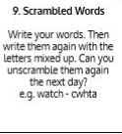  Use Scrambled Words to practise spelling this week’s orange words:  believe, bicycle, breath, breathe, build, busy, business, calendar
9.45-10.00  Active break | LO: To boost my concentration through movement. | Join in with the Go Noodle clip below to get you moving!  https://www.youtube.com/watch?v=d_GNRDic17E
10.00-11.00  English | Revision SPaG LO: To use ‘a’ or ‘an’ appropriately.  LO: To sequence and retell the build up. | For today’s SPaG Daily Practice, revise when you should use ‘a’ or ‘an’. Click here to have a go at today’s lesson:  https://www.youtube.com/watch?v=lFmPNuR6gxY  Follow the link below to have a go at today’s English lesson:  https://classroom.thenational.academy/lessons/to-sequence-and-retell-the-build-up-c5h3gt
11.00- 11.15
Break
11.15-12.15  Maths | LO: To practise my recall of the 4 times table.  LO: To subtract two 2-digit numbers without regrouping. | Follow the link below to practise the 4 times table and get moving!  https://www.bbc.co.uk/teach/supermovers/ks1-maths-the-4-times-table-with-cyril-the-swan/zmsw382  Follow the link below to have a go at today’s maths lesson:  https://classroom.thenational.academy/lessons/subtracting-two-3-digit-numbers-without-regrouping-60r3cc
12.15-1.00
Dinner
1.00-1.15  Storytime | LO: To listen to a story for pleasure. | Listen to Chapter 16 of Timeless Tales of Beatrix Potter  https://stories.audible.com/pdp/B00T50R42I?ref=adbl_ent_anon_ds_pdp_plc
1.15-2.30  Topic- Computing (online safety) | LO: To learn the SMART rule for staying safe online. | Follow the link below to have a go at today’s lesson:  https://www.childnet.com/resources/video-lessons/the-a-rule
2.30-3.00  Music | LO: To explore 6 beats in a bar. | Follow the link below to have a go at today’s lesson:  https://classroom.thenational.academy/lessons/exploring-6-beats-in-a-bar-6cw38d

Beat That!
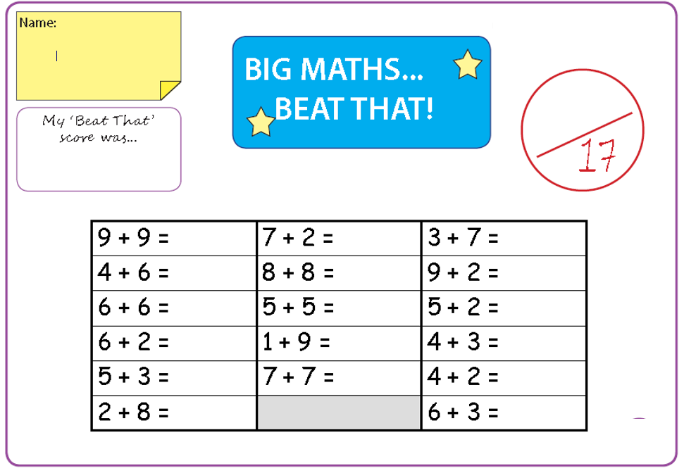

Time and Subject  Tuesday | Learning Objective | Task/Link/Resources
8.45-9.00  Reading | L.O: To practise and consolidate existing reading skills. | Read your individual reading book, either in your head or out loud.
9.00-9.15  Morning Maths | LO: To consolidate recall of number facts.  Revision LO: To recognise a half. | Complete today’s Beat That- scroll down below today’s timetable to find the questions. Remember, it is the same one every day for a week. Can you beat your own score?  Morning Maths: In Morning Maths today, you are going to revise your knowledge of halving. Click the link below, choose Week 1 and select the video Lesson 2 Recognise a half:  https://whiterosemaths.com/homelearning/summer-archive/year-2/
9.15-9.45  Spelling | LO: To practise Year 3/4 common exception words. | This week, we are going to practise spelling some of our tricky orange words!  Use Scrambled Words to practise spelling this week’s orange words. Can you unscramble the words you scrambled yesterday?  believe, bicycle, breath, breathe, build, busy, business, calendar
9.45-10.00  Active break | L.O: To boost my concentration through movement. | Join in with the Go Noodle clip below to get you moving!  https://www.youtube.com/watch?v=JU0ETGd5dgk
10.00-11.00  English | SPaG Revision LO: To explore antonyms and synonyms.  LO: To practise and apply knowledge of more suffixes: Past and present tense. | For today’s SPaG Daily Practice, click the link below to revise your knowledge of antonyms and synonyms:  https://www.bbc.co.uk/bitesize/articles/z9r8r2p  Follow the link below to have a go at today’s English lesson:  https://classroom.thenational.academy/lessons/to-practise-and-apply-knowledge-of-more-suffixes-past-and-present-tense-including-a-test-74t30c
11.00- 11.15
Break
11.15-12.15  Maths | LO: To practise my recall of the 4 times table.  LO: To apply rounding for estimating (adding) | Follow the link below to practise the 4 times table:  https://www.timestables.co.uk/4-times-table.html  Follow the link below to have a go at today’s maths lesson:  https://classroom.thenational.academy/lessons/applying-rounding-for-estimating-adding-65j62r
12.15-1.00
Dinner
1.00-1.15  Storytime | LO: To listen to a story for pleasure. | Listen to Chapter 17 of Timeless Tales of Beatrix Potter  https://stories.audible.com/pdp/B00T50R42I?ref=adbl_ent_anon_ds_pdp_plc
1.15-2.30  Topic-Computing (online safety) | LO: To Learn the SMART rule for staying safe online. | Follow the link below to have a go at today’s lesson:  https://www.childnet.com/resources/video-lessons/the-r-rule
2.30-3.00  French | LO: To practise counting to 20 in French. | Follow the link below to practise counting in French:  https://www.youtube.com/watch?v=dhj9SqrIZqI

Beat That!

Time and Subject  Wednesday | Learning Objective | Task/Link/Resources
8.45-9.00  Reading | L.O: To practise and consolidate existing reading skills. | Read your individual reading book, either in your head or out loud.
9.00-9.15  Morning Maths | LO: To consolidate recall of number facts.  Revision LO: To practise finding a half. | Complete today’s Beat That- scroll down below today’s timetable to find the questions. Remember, it is the same one every day for a week. Can you beat your own score?  Morning Maths: In Morning Maths today, you are going to revise your knowledge of halving. Click the link below, choose Week 1 and select the video Lesson 3 Find a half:  https://whiterosemaths.com/homelearning/summer-archive/year-2/
9.15-9.45  Spelling | LO: To practice Year 3/4 common exception words. | This week, we are going to practise spelling some of our tricky orange words!  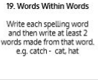  Use Words Within Words to practise spelling this week’s orange words:  believe, bicycle, breath, breathe, build, busy, business, calendar
9.45-10.00  Active break | LO: To boost my concentration through movement. | Join in with the clip below to get you moving!  https://www.youtube.com/watch?v=nUb-ZxbRXKU
10.00-11.00  English | SPaG Revision LO: To use imperative verbs to write commands.  LO: To generate vocabulary for the build up. | For today’s SPaG Daily Practice, revise your knowledge of imperative verbs (bossy verbs). Click the link below for today’s lesson:  https://www.bbc.co.uk/bitesize/articles/zv98jhv  Follow the link below to have a go at today’s English lesson:  https://classroom.thenational.academy/lessons/to-generate-vocabulary-for-the-build-up-6mu6cd
11.00- 11.15
Break
11.15-12.15  Maths | LO: To practise my recall of the 4 times table.  LO: To apply rounding for estimating (subtracting) | Follow the link below to practise the 4 times table and get moving!  https://www.youtube.com/watch?v=LT3t-uLB9qs  Follow the link below to have a go at today’s maths lesson:  https://classroom.thenational.academy/lessons/applying-rounding-for-estimating-subtracting-64w34c
12.15-1.00
Dinner
1.00-1.15  Storytime | LO: To listen to a story for pleasure. | Listen to Chapter 18 of Timeless Tales of Beatrix Potter  https://stories.audible.com/pdp/B00T50R42I?ref=adbl_ent_anon_ds_pdp_plc
1.15-2.30  Topic-Computing (online safety) | LO: To learn the SMART rule for staying safe online. | Follow the link to have a go at today’s lesson:  https://www.childnet.com/resources/video-lessons/the-t-rule
2.30-3.00  RHE | LO: To identify people who help in a community. | Follow the link to have a go at today’s lesson:  https://classroom.thenational.academy/lessons/help-is-on-hand-cgtpat

Beat That!

Time and Subject  Thursday | Learning Objective | Task/Link/Resources
8.45-9.00  Reading | L.O: To practise and consolidate existing reading skills. | Read your individual reading book, either in your head or out loud.
9.00-9.15  Morning Maths | LO: To consolidate recall of number facts.  Revision LO: To recognise a quarter. | Complete today’s Beat That- scroll down below today’s timetable to find the questions. Remember, it is the same one every day for a week. Can you beat your own score?  Morning Maths: In Morning Maths today, you are going to revise making equal parts. Click the link below, choose Week 1 and select the video Lesson 4 Recognise a quarter:  https://whiterosemaths.com/homelearning/summer-archive/year-2/
9.15-9.45  Spelling | LO: To practise Year 3/4 common exception words. | This week, we are going to practise spelling some of our tricky orange words!  Use the activity above to practise spelling this week’s orange words:  believe, bicycle, breath, breathe, build, busy, business, calendar
9.45-10.00  Active break | LO: To boost my concentration through movement. | Join in with the Go Noodle clip below to get you moving!  https://www.youtube.com/watch?v=Sk_q_ShHDBM
10.00-11.00  English | SPaG Revision LO: To identify prepositions.  LO: To write the build-up. | For today’s SPaG Daily Practice, we are going to revise our knowledge of prepositions. Click the link to have a go at today’s lesson:  https://www.bbc.co.uk/bitesize/topics/zwwp8mn/articles/zw38srd  Follow the link below to have a go at today’s English lesson:  https://classroom.thenational.academy/lessons/to-write-the-build-up-part-1-ccv62c
11.00- 11.15
Break
11.15-12.15  Maths | LO: To practise my recall of the 4 times table.  LO: To add two 3-digit numbers (regrouping in one column) | Follow the link below to practise the 4 times table:  http://www.snappymaths.com/multdiv/4xtable/interactive/newlook/4xtablebtcd.htm  Follow the link below to have a go at today’s lesson:  https://classroom.thenational.academy/lessons/adding-two-3-digit-numbers-regrouping-in-one-column-cmt64e
12.15-1.00
Dinner
1.00-1.15  Storytime | LO: To listen to a story for pleasure. | Listen to Chapter 19 of Timeless Tales of Beatrix Potter.  https://stories.audible.com/pdp/B00T50R42I?ref=adbl_ent_anon_ds_pdp_plc
1.15-3.00  PE | LO: To learn and perform a dance routine. | Follow the link below to learn a dance routine inspired by Harry Potter!  https://www.youtube.com/watch?v=btD_HCO1FT4

Beat That!

Time and Subject  Friday | Learning Objective | Task/Link/Resources
8.45-9.00  Reading | L.O: To practise and consolidate existing reading skills. | Read your individual reading book, either in your head or out loud.
9.00-9.15  Morning Maths | LO: To consolidate recall of number facts.  Revision LO:  To make equal parts. | Complete today’s Beat That- scroll down below today’s timetable to find the questions. Remember, it is the same one every day for a week. Can you beat your own score?  Morning Maths: In Morning Maths today, you are going to revise making equal parts. Click the link below, choose Week 2 and select the video Lesson 1 Make equal parts:  https://whiterosemaths.com/homelearning/summer-archive/year-2/
9.15-9.45  Spelling | LO: To practice Year 3/4 common exception words. | This week, we are going to practise spelling some of our tricky orange words!  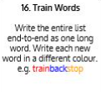  Use Train Words to practise spelling this week’s orange words:  believe, bicycle, breath, breathe, build, busy, business, calendar  Spelling Test:  Scroll down below today’s timetable to use the look, cover, write, check sheet to help you to test yourself on this week’s words.
9.45-10.00  Active break | L.O: To boost my concentration through movement. | Join in with the Go Noodle clip to get you moving!  https://www.youtube.com/watch?v=W387m-ved6o
10.00-11.00  English | SPaG Revision LO: To understand how to write a statement sentence.  LO: To write the build-up. | For today’s SPaG Daily Practice, revise your knowledge of statements and how to write them. Click the link below to have a go at today’s lesson:  https://www.bbc.co.uk/bitesize/articles/z97r2nb  Follow the link below to have a go at today’s lesson:  https://classroom.thenational.academy/lessons/to-write-the-build-up-part-2-c4tkcc
11.00- 11.15
Break
11.15-12.15  Maths | LO: To practise my recall of the 4 times table.  LO: To add two 3- digit numbers (regrouping in multiple columns) | Follow the link below to practise the 4 times table:  http://www.snappymaths.com/multdiv/4xtable/interactive/newlook/4xmissintd.htm  Follow the link below to have a go at today’s lesson:  https://classroom.thenational.academy/lessons/adding-two-3-digit-numbers-regrouping-in-multiple-columns-74u3ce
12.15-1.00
Dinner
1.00-1.15  Storytime | LO: To listen to a story for pleasure. | Listen to Chapter 20 of Timeless Tales of Beatrix Potter.  https://stories.audible.com/pdp/B00T50R42I?ref=adbl_ent_anon_ds_pdp_plc
1.15-3:00  Art | Golden Time LO: To create images using Pointillism. | Watch this video to learn about Pointillism:  https://www.youtube.com/watch?v=D4hqKPX6d68  Have a go at creating your own pictures using Pointillism. You could use paint or create the same effect with pencil or felt tips!

Beat That!

Spelling Test
