Time and Subject  Monday | Learning Objective | Task/Link/Resources
8.45-9.00  Reading | LO: To practise and consolidate existing reading skills. | Read your individual reading book, either in your head or out loud.
9.00-9.15  Morning Maths | LO: To consolidate recall of number facts.  Revision LO: To identify odd and even numbers. | Complete today’s Beat That- scroll down below today’s timetable to find the questions. Remember, it is the same one every day for a week. Can you beat your own score?  Morning Maths: In Morning Maths today, you are going to revise your knowledge of odd and even numbers. Click the link below to find the lesson and activities to complete.  https://www.bbc.co.uk/bitesize/articles/zr23c7h
9.15-9.45  Spelling | LO: To practise Unit Two RWI spelling words. | This week, we are going to practise spelling words with the prefix im-. Watch this video to refresh your memory:  https://www.bbc.co.uk/teach/class-clips-video/english-ks2-wonderful-words-prefixes/zknd7nb  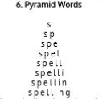  Use Pyramid Writing to practise spelling this week’s unit words:  impossible, imperfect, immature, impatient, immortal, impolite
9.45-10.00  Active break | LO: To boost my concentration through movement. | Join in with the Go Noodle clip below to get you moving!  https://www.youtube.com/watch?v=JdBlXPWM8AI
10.00-11.00  English | SPaG Revision LO: To understand what an expanded noun phrase is.  LO: To write the second part of the opening. | For today’s SPaG Daily Practice, revise your knowledge of expanded noun phrases. Follow the link to have a go at today’s lesson:  https://www.bbc.co.uk/bitesize/topics/zwwp8mn/articles/z3nfw6f  Follow the link below to have a go at today’s English lesson:  https://classroom.thenational.academy/lessons/to-write-the-second-part-of-the-opening-part-1-crtk4c
11.00- 11.15
Break
11.15-12.15  Maths | LO: To practise my recall of the 5 times table.  LO: To add and subtract 1-digit from 3-digit numbers. | Follow the link below to practise the 5 times table and get moving!  https://www.bbc.co.uk/teach/supermovers/ks1-maths-the-5-times-table/zhbm47h  Follow the link below to have a go at today’s maths lesson:  https://classroom.thenational.academy/lessons/adding-and-subtracting-1-digit-numbers-tofrom-3-digit-numbers-68uk4e
12.15-1.00
Dinner
1.00-1.15  Storytime | LO: To listen to a story for pleasure. | Listen to Chapter 11 of Timeless Tales of Beatrix Potter.  https://stories.audible.com/pdp/B00IZMHQSE?ref=adbl_ent_anon_ds_pdp_pc_cntr-2-3
1.15-2.30  Topic-  Science | LO: To explore the uses of magnetic materials. | Follow the link to have a go at today’s lesson:  https://classroom.thenational.academy/lessons/what-are-some-uses-of-magnetic-materials-60u64r
2.30-3.00  Music | LO: To explore 3 beats in a bar. | Follow the link below to have a go at today’s lesson:  https://classroom.thenational.academy/lessons/exploring-3-beats-in-a-bar-cmw34r

Beat That!
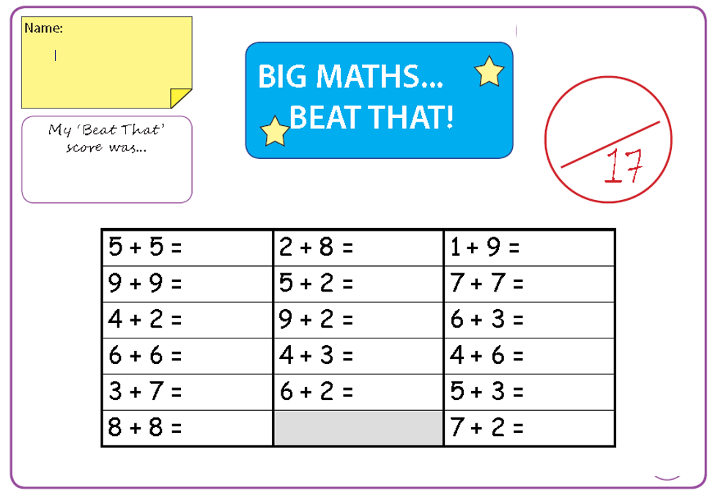

Time and Subject  Tuesday | Learning Objective | Task/Link/Resources
8.45-9.00  Reading | L.O: To practise and consolidate existing reading skills. | Read your individual reading book, either in your head or out loud.
9.00-9.15  Morning Maths | LO: To consolidate recall of number facts.  Revision LO: To make arrays. | Complete today’s Beat That- scroll down below today’s timetable to find the questions. Remember, it is the same one every day for a week. Can you beat your own score?  Morning Maths: In Morning Maths today, you are going to revise making arrays. Click the link below to find the lesson and activities to complete.  https://www.bbc.co.uk/bitesize/articles/znwwg7h
9.15-9.45  Spelling | LO: To practise Unit Two RWI spelling words. | This week, we are going to practise spelling words with the prefix im-.  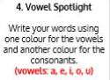  Use Vowel Spotlight to practise spelling this week’s unit words:  impossible, imperfect, immature, impatient, immortal, impolite
9.45-10.00  Active break | L.O: To boost my concentration through movement. | Join in with the Go Noodle clip below to get you moving!  https://www.youtube.com/watch?v=fTzXFPh6CPI
10.00-11.00  English | SPaG Revision LO: To understand homophones.  LO: To investigate more suffixes: Past and present tense. | For today’s SPaG Daily Practice, click the link below to revise your knowledge of homophones:  https://www.bbc.co.uk/bitesize/topics/zqhpk2p/articles/zc84cwx  Follow the link below to have a go at today’s English lesson:  https://classroom.thenational.academy/lessons/to-investigate-more-suffixes-past-and-present-tense-cnh30t
11.00- 11.15
Break
11.15-12.15  Maths | LO: To practise my recall of the 5 times table.  LO: To add multiples of 10 to 3-digit numbers. | Follow the link below to practise the 5 times table:  https://www.timestables.co.uk/5-times-table.html  Follow the link below to have a go at today’s maths lesson:  https://classroom.thenational.academy/lessons/adding-multiples-of-10-to-3-digit-numbers-cgwp6d
12.15-1.00
Dinner
1.00-1.15  Storytime | LO: To listen to a story for pleasure. | Listen to Chapter 12 of Timeless Tales of Beatrix Potter.  https://stories.audible.com/pdp/B00IZMHQSE?ref=adbl_ent_anon_ds_pdp_pc_cntr-2-3
1.15-2.30  Topic- Computing (online safety) | LO: To learn the SMART rules for staying safe online. | Follow the link below to have a go at today’s lesson:  https://www.childnet.com/resources/video-lessons/the-s-rule
2.30-3.00  French | LO: To name family members in French. | Follow the link below to practise saying the name of family members in French, then have a go at Activity 1:  https://www.bbc.co.uk/bitesize/articles/zgqp7yc

Beat That!

Time and Subject  Wednesday | Learning Objective | Task/Link/Resources
8.45-9.00  Reading | L.O: To practise and consolidate existing reading skills. | Read your individual reading book, either in your head or out loud.
9.00-9.15  Morning Maths | LO: To consolidate recall of number facts.  Revision LO: To create equal groups. | Complete today’s Beat That- scroll down below today’s timetable to find the questions. Remember, it is the same one every day for a week. Can you beat your own score?  Morning Maths: In Morning Maths today, you are going to revise creating equal groups. Click the link below to find the lesson and activities to complete.  https://www.bbc.co.uk/bitesize/articles/zm4dg7h
9.15-9.45  Spelling | LO: To practise Unit Two RWI spelling words. | This week, we are going to practise spelling words with the prefix im-.  Use Rainbow Words to practise spelling this week’s unit words:  impossible, imperfect, immature, impatient, immortal, impolite
9.45-10.00  Active break | LO: To boost my concentration through movement. | Join in with the Go Noodle clip below to get you moving!  https://www.youtube.com/watch?v=wPCGfa44bF0
10.00-11.00  English | SPaG Revision LO: To understand how to use an exclamation mark.  LO: To explore compound sentences. | For today’s SPaG Daily Practice, revise how to correctly use exclamation marks:  https://www.bbc.co.uk/bitesize/topics/z8x6cj6/articles/z3dcmsg  Follow the link below to have a go at today’s English lesson:  https://classroom.thenational.academy/lessons/to-explore-compound-sentences-6wt3jt
11.00- 11.15
Break
11.15-12.15  Maths | LO: To practise my recall of the 5 times table.  LO: To subtract multiples of 10 from 2-digit numbers. | Follow the link below to practise the 5 times table and get moving!  https://www.youtube.com/watch?v=TFcwMi8l040  Follow the link below to have a go at today’s maths lesson:  https://classroom.thenational.academy/lessons/subtracting-multiples-of-10-from-3-digit-numbers-61k34t
12.15-1.00
Dinner
1.00-1.15  Storytime | LO: To listen to a story for pleasure. | Listen to Chapter 13 of Timeless Tales of Beatrix Potter.  https://stories.audible.com/pdp/B00IZMHQSE?ref=adbl_ent_anon_ds_pdp_pc_cntr-2-3
1.15-2.30  Topic- Computing (online safety) | LO: To learn the SMART rules for staying safe online. | Follow the link to have a go at today’s lesson:  https://www.childnet.com/resources/video-lessons/the-m-rule
2.30-3.00  RHE | LO: To recognise the different groups that make up a community. | Follow the link to have a go at today’s lesson:  https://classroom.thenational.academy/lessons/we-are-a-jigsaw-6cv3ed

Beat That!

Time and Subject  Thursday | Learning Objective | Task/Link/Resources
8.45-9.00  Reading | L.O: To practise and consolidate existing reading skills. | Read your individual reading book, either in your head or out loud.
9.00-9.15  Morning Maths | LO: To consolidate recall of number facts.  Revision LO: To write multiplication sentences using the x symbol. | Complete today’s Beat That- scroll down below today’s timetable to find the questions. Remember, it is the same one every day for a week. Can you beat your own score?  Morning Maths: In Morning Maths today, you are going to revise forming multiplication sentences. Click the link below to find the lesson and activities to complete:  https://www.bbc.co.uk/bitesize/articles/zhchscw
9.15-9.45  Spelling | LO: To practise Unit Two RWI spelling words. | This week, we are going to practise spelling words with the prefix im-.  Use the activity above to practise spelling this week’s words:  impossible, imperfect, immature, impatient, immortal, impolite
9.45-10.00  Active break | LO: To boost my concentration through movement. | Join in with the Go Noodle clip below to get you moving!  https://www.youtube.com/watch?v=VPkrrDfWC0o
10.00-11.00  English | SPaG Revision LO: To understand how to use question marks.  LO: To write the second part of the opening. | For today’s SPaG Daily Practice, we are going to revise how to use question marks:  https://www.bbc.co.uk/bitesize/topics/z8x6cj6/articles/zcm3qhv  Follow the link below to have a go at today’s English lesson:  https://classroom.thenational.academy/lessons/to-write-the-second-part-of-the-opening-part-2-6xk3et
11.00- 11.15
Break
11.15-12.15  Maths | LO: To practise my recall of the 5 times table.  LO: To add and subtract multiples of 100 from 3-digit. | Follow the link below to practise the 5 times table:  http://www.snappymaths.com/multdiv/5xtable/interactive/newlook/5xtablebtcd.htm  Follow the link below to have a go at today’s lesson:  https://classroom.thenational.academy/lessons/adding-and-subtracting-multiples-of-100-tofrom-3-digit-numbers-crw62d
12.15-1.00
Dinner
1.00-1.15  Storytime | LO: To listen to a story for pleasure. | Listen to Chapter 14 of Timeless Tales of Beatrix Potter.  https://stories.audible.com/pdp/B00IZMHQSE?ref=adbl_ent_anon_ds_pdp_pc_cntr-2-3
1.15-3.00  PE | LO: To learn and perform a dance routine. | Follow the link below to learn a dance routine inspired by Aladdin!  https://www.youtube.com/watch?v=dh97m6-PKRM

Beat That!

Time and Subject  Friday | Learning Objective | Task/Link/Resources
8.45-9.00  Reading | L.O: To practise and consolidate existing reading skills. | Read your individual reading book, either in your head or out loud.
9.00-9.15  Morning Maths | LO: To consolidate recall of number facts.  Revision LO:  To use arrays to explore the commutativity of multiplication. | Complete today’s Beat That- scroll down below today’s timetable to find the questions. Remember, it is the same one every day for a week. Can you beat your own score?  Morning Maths: In Morning Maths today, you are going to revise describing arrays. Click the link below to find the lesson and activities to complete:  https://www.bbc.co.uk/bitesize/articles/zrf8jhv
9.15-9.45  Spelling | LO: To practise Unit Two RWI spelling words. | This week, we are going to practise spelling words with the prefix im-.  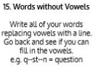  Use Words Without Vowels to practise spelling this week’s words:  impossible, imperfect, immature, impatient, immortal, impolite  Spelling Test:  Scroll down below today’s timetable to use the look, cover, write, check sheet to help you to test yourself on this week’s words.
9.45-10.00  Active break | L.O: To boost my concentration through movement. | Join in with the Go Noodle clip to get you moving!  https://www.youtube.com/watch?v=SY1VL-Jhn90
10.00-11.00  English | SPaG Revision LO: To understand how to write questions.  LO: To develop a rich understanding of words associated with night time. | For today’s SPaG Daily Practice, revise how to write questions:  https://www.bbc.co.uk/bitesize/topics/zrqqtfr/articles/z2xdng8  Follow the link below to have a go at today’s lesson:  https://classroom.thenational.academy/lessons/to-develop-a-rich-understanding-of-words-associated-with-night-time-75h6ct
11.00- 11.15
Break
11.15-12.15  Maths | LO: To practise my recall of the 5 times table.  LO: To add two 3-digit numbers (without grouping) | Follow the link below to practise the 5 times table:  http://www.snappymaths.com/multdiv/5xtable/interactive/newlook/5xmissintd.htm  Follow the link below to have a go at today’s lesson:  https://classroom.thenational.academy/lessons/adding-two-3-digit-numbers-without-regrouping-c4uk8r
12.15-1.00
Dinner
1.00-1.15  Storytime | LO: To listen to a story for pleasure. | Listen to Chapter 15 of Timeless Tales of Beatrix Potter  https://stories.audible.com/pdp/B00T50R42I?ref=adbl_ent_anon_ds_pdp_plc
1.15-3:00  Art | Golden Time  LO: To create an image of a landscape. | Draw your own landscape pictures:  https://www.youtube.com/watch?v=EJPuP50_ZqM  You could use coloured pencils, felt tips or paint!

Beat That!

Spelling Test
