Time and Subject  Monday | Learning Objective | Task/Link/Resources
8.45-9.00  Reading | LO: To practise and consolidate existing reading skills. | Read your individual reading book, either in your head or out loud.
9.00-9.15  Morning Maths | LO: To consolidate recall of number facts.  Revision LO: To represent numbers to 100. | Complete today’s Beat That- scroll down below today’s timetable to find the questions. Remember, it is the same one every day for a week. Can you beat your own score?  Morning Maths: In Morning Maths today, you are going to revise your knowledge of representing numbers to 100. Click the link below to find the lesson and activities to complete:  https://www.bbc.co.uk/bitesize/articles/z7cthbk
9.15-9.45  Spelling | LO: To practise Year 3/4 common exception words. | This week, we are going to practise spelling some of our tricky orange words!  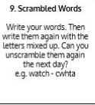  Use Scrambled Words to practise spelling this week’s orange words:  accident, accidentally, actual, actually, address, answer, appear, arrive
9.45-10.00  Active break | LO: To boost my concentration through movement. | Join in with the Go Noodle clip below to get you moving!  https://www.youtube.com/watch?v=3WnI4UNgSaY
10.00-11.00  English | SPaG Revision LO: To use apostrophes for contraction.  LO: To generate vocabulary for character description. | For today’s SPaG Daily Practice, revise your knowledge of using apostrophes for contraction. Click the link below, watch the video and complete Activity 1 and Activity 2:  https://www.bbc.co.uk/bitesize/articles/zddbn9q  Follow the link below to have a go at today’s English lesson:  https://classroom.thenational.academy/lessons/to-generate-vocabulary-for-character-description-6rtkct
11.00- 11.15
Break
11.15-12.15  Maths | LO: To practise my recall of the 2 times table.  LO: To find all the possible numbers that could have been rounded to a multiple of ten. | Follow the link below to practise the 2 times table and get moving!  https://www.bbc.co.uk/teach/supermovers/ks1-maths-the-2-times-table-with-bridget-the-lioness/zrrx92p  Follow the link below to have a go at today’s maths lesson:  https://classroom.thenational.academy/lessons/finding-all-possible-numbers-that-could-have-been-rounded-to-a-multiple-of-ten-crrp8c
12.15-1.00
Dinner
1.00-1.15  Storytime | LO: To listen to a story for pleasure. | Listen to Chapter 6 of Timeless Tales of Beatrix Potter:  https://stories.audible.com/pdp/B00IZMHQSE?ref=adbl_ent_anon_ds_pdp_pc_cntr-2-3
1.15-2.30  Topic-  Science | LO: To understand how a compass works. | Follow the link below to have a go at today’s lesson:  https://classroom.thenational.academy/lessons/how-does-a-compass-work-6rr30d
2.30-3.00  Music | LO: To understand pulse and rhythm. | Follow the link below to have a go at today’s lesson:  https://classroom.thenational.academy/lessons/understanding-pulse-and-rhythm-6tjkjd

Beat That!
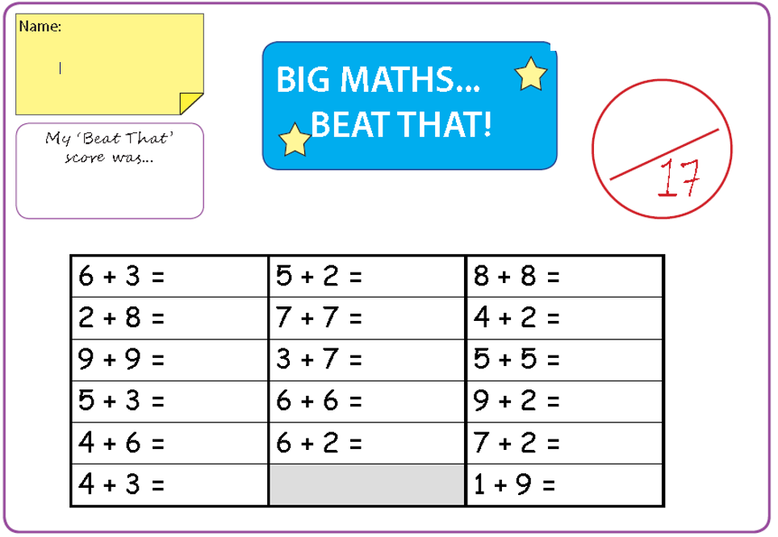

Time and Subject  Tuesday | Learning Objective | Task/Link/Resources
8.45-9.00  Reading | L.O: To practise and consolidate existing reading skills. | Read your individual reading book, either in your head or out loud.
9.00-9.15  Morning Maths | LO: To consolidate recall of number facts.  Revision LO: To subtract 2-digit numbers. | Complete today’s Beat That- scroll down below today’s timetable to find the questions. Remember, it is the same one every day for a week. Can you beat your own score?  Morning Maths: In Morning Maths today, you are going to subtract 2-digit numbers. Click the link below to find the lesson and activities to complete:  https://www.bbc.co.uk/bitesize/articles/zrnfvk7
9.15-9.45  Spelling | LO: To practise Year 3/4 common exception words. | This week, we are going to practise spelling some of our tricky orange words!  Use Scrambled Words to practise spelling this week’s orange words. Can you unscramble the words you scrambled yesterday?  accident, accidentally, actual, actually, address, answer, appear, arrive
9.45-10.00  Active break | L.O: To boost my concentration through movement. | Join in with the Go Noodle clip to get you moving!  https://www.youtube.com/watch?v=BQ9q4U2P3ig
10.00-11.00  English | SPaG Revision LO: To use apostrophes for possession.  LO: To practise and apply knowledge of suffixes: Past and present | For today’s SPaG Daily Practice, click the link below to revise your knowledge of apostrophes for possession:  https://www.bbc.co.uk/bitesize/articles/zng8r2p  Follow the link below to have a go at today’s English lesson:  https://classroom.thenational.academy/lessons/to-practise-and-apply-knowledge-of-suffixes-past-and-present-tense-including-a-test-61h3ce
11.00- 11.15
Break
11.15-12.15  Maths | LO: To practise my recall of the 2 times table.  LO: To round 2 and 3-digit numbers to the nearest 100. | Follow the link below to practise the 2 times table:  https://www.timestables.co.uk/2-times-table.html  Follow the link below to have a go at today’s maths lesson:  https://classroom.thenational.academy/lessons/rounding-2-and-3-digit-numbers-to-the-nearest-100-ctgpar
12.15-1.00
Dinner
1.00-1.15  Storytime | LO: To listen to a story for pleasure. | Listen to Chapter 7 of Timeless Tales of Beatrix Potter  https://stories.audible.com/pdp/B00IZMHQSE?ref=adbl_ent_anon_ds_pdp_pc_cntr-2-3
1.15-2.30  Topic- Science | LO: To explore how we can see a magnetic field. | Follow the link below to have a go at today’s lesson:  https://classroom.thenational.academy/lessons/how-can-we-see-a-magnetic-field-60rk8c
2.30-3.00  French | LO: To practise introducing yourself in French. | Follow the link below to revise how to introduce yourself in French:  https://www.bbc.co.uk/teach/class-clips-video/french-ks2-how-to-introduce-yourself/zf84d6f

Beat That!

Time and Subject  Wednesday | Learning Objective | Task/Link/Resources
8.45-9.00  Reading | L.O: To practise and consolidate existing reading skills. | Read your individual reading book, either in your head or out loud.
9.00-9.15  Morning Maths | LO: To consolidate recall of number facts.  Revision LO: To write numbers to 100 in numerals and words. | Complete today’s Beat That- scroll down below today’s timetable to find the questions. Remember, it is the same one every day for a week. Can you beat your own score?  Morning Maths: In Morning Maths today, you are going to revise writing numbers to 100 in numerals and words. Click the link below to find the lesson and activities to complete:  https://www.bbc.co.uk/bitesize/articles/z7pnm39
9.15-9.45  Spelling | LO: To practise Year 3/4 common exception words. | This week, we are going to practise spelling some of our tricky orange words!  Use the activity above to practise spelling this week’s orange words:  accident, accidentally, actual, actually, address, answer, appear, arrive
9.45-10.00  Active break | LO: To boost my concentration through movement. | Join in with the Go Noodle clip below to get you moving!  https://www.youtube.com/watch?v=KhfkYzUwYFk
10.00-11.00  English | SPaG Revision LO: To use commas in a list.  LO: To analyse the opening scene. | For today’s SPaG Daily Practice, revise how to correctly use commas in a list. Click the link below, watch the video and complete Activity 1 and Activity 2:  https://www.bbc.co.uk/bitesize/articles/zjs8wty  Follow the link below to have a go at today’s English lesson:  https://classroom.thenational.academy/lessons/to-analyse-the-opening-scene-70u36t
11.00- 11.15
Break
11.15-12.15  Maths | LO: To practise my recall of the 2 times table.  LO: To apply place value knowledge to problem solving. | Follow the link below to practise the 2 times table and get moving!  https://www.youtube.com/watch?v=iiR8hqJeQsw  Follow the link below to have a go at today’s maths lesson:  https://classroom.thenational.academy/lessons/applying-place-value-knowledge-to-problem-solving-71jket
12.15-1.00
Dinner
1.00-1.15  Storytime | LO: To listen to a story for pleasure. | Listen to Chapter 8 of Timeless Tales of Beatrix Potter  https://stories.audible.com/pdp/B00IZMHQSE?ref=adbl_ent_anon_ds_pdp_pc_cntr-2-3
1.15-2.30  Topic- Science | LO: To explore how we can tell if a material is magnetic or not. | Follow the link below to have a go at today’s lesson:  https://classroom.thenational.academy/lessons/how-can-we-tell-if-a-material-is-magnetic-or-not-cmtpar
2.30-3.00  RHE | LO: To understand what a community is and consider the benefits of being part of a community. | Follow the link below to have a go at today’s lesson:  https://classroom.thenational.academy/lessons/community-care-cctp8c

Beat That!

Time and Subject  Thursday | Learning Objective | Task/Link/Resources
8.45-9.00  Reading | L.O: To practise and consolidate existing reading skills. | Read your individual reading book, either in your head or out loud.
9.00-9.15  Morning Maths | LO: To consolidate recall of number facts.  Revision LO: To order objects and numbers with 3-digits. | Complete today’s Beat That- scroll down below today’s timetable to find the questions. Remember, it is the same one every day for a week. Can you beat your own score?  Morning Maths: In Morning Maths today, you are going to revise ordering objects and numbers with 3-digits. Click the link below to find the lesson and activities to complete:  https://www.bbc.co.uk/bitesize/articles/z7kw4xs
9.15-9.45  Spelling | LO: To practise Year 3/4 common exception words. | This week, we are going to practise spelling some of our tricky orange words!  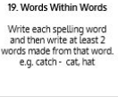  Use Words Within Words to practise spelling this week’s orange words:  accident, accidentally, actual, actually, address, answer, appear, arrive
9.45-10.00  Active break | LO: To boost my concentration through movement. | Join in with the Go Noodle clip below to get you moving!  https://www.youtube.com/watch?v=1b6axyuaKcY
10.00-11.00  English | SPaG Revision LO: To use commas in a list.  LO: To write the first part of the opening. | For today’s SPaG Daily Practice, we are going to continue with yesterday’s learning about commas in a list. Click the link below, watch the video again and complete Activity 3:  https://www.bbc.co.uk/bitesize/articles/zjs8wty  Follow the link below to have a go at today’s English lesson:  https://classroom.thenational.academy/lessons/to-write-the-first-part-of-the-opening-part-1-6ctp6c
11.00- 11.15
Break
11.15-12.15  Maths | LO: To practise my recall of the 2 times table.  LO: To find solutions to a problem. | Follow the link below to practise the 2 times table:  http://www.snappymaths.com/multdiv/2xtable/interactive/newlook/2xtablebtcd.htm  Follow the link below to have a go at today’s lesson:  https://classroom.thenational.academy/lessons/finding-solutions-to-a-problem-c4t38c
12.15-1.00
Dinner
1.00-1.15  Storytime | LO: To listen to a story for pleasure. | Listen to Chapter 9 of Timeless Tales of Beatrix Potter  https://stories.audible.com/pdp/B00IZMHQSE?ref=adbl_ent_anon_ds_pdp_pc_cntr-2-3
1.15-3.00  PE | LO: To learn and perform a dance routine. | Follow the link below to learn a dance routine inspired by The Greatest Showman!  https://www.youtube.com/watch?v=EJmpCH9p2X8

Beat That!

Time and Subject  Friday | Learning Objective | Task/Link/Resources
8.45-9.00  Reading | L.O: To practise and consolidate existing reading skills. | Read your individual reading book, either in your head or out loud.
9.00-9.15  Morning Maths | LO: To consolidate recall of number facts.  Revision LO:  To find half of a number or set of objects. | Complete today’s Beat That- scroll down below today’s timetable to find the questions. Remember, it is the same one every day for a week. Can you beat your own score?  Morning Maths: In Morning Maths today, you are going to revise finding half of a set of objects or number. Click the link below to find the lesson and activities to complete:  https://www.bbc.co.uk/bitesize/articles/zbpxdp3
9.15-9.45  Spelling | LO: To practise Year 3/4 common exception words. | This week, we are going to practise spelling some of our tricky orange words!  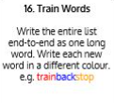  Use the Train Words to practise spelling this week’s orange words:  accident, accidentally, actual, actually, address, answer, appear, arrive  Spelling Test:  Scroll down below today’s timetable to use the look, cover, write, check sheet to help you to test yourself on this week’s words.
9.45-10.00  Active break | L.O: To boost my concentration through movement. | Join in with the Go Noodle clip to get you moving!  https://www.youtube.com/watch?v=aEIpC4e2aBY
10.00-11.00  English | SPaG Revision LO: To identify the four sentence types.  LO: To write the first part of the opening. | For today’s SPaG Daily Practice, revise your knowledge of the four sentence types. Click the link below, watch the video and complete Activities 1, 2 and 3:  https://www.bbc.co.uk/bitesize/articles/z7b3trd  Follow the link below to have a go at today’s lesson:  https://classroom.thenational.academy/lessons/to-write-the-first-part-of-the-opening-part-2-ccr36t
11.00- 11.15
Break
11.15-12.15  Maths | LO: To practise my recall of the 2 times table.  LO: To apply my knowledge of place value. | Follow the link below to practise the 2 times table:  http://www.snappymaths.com/multdiv/2xtable/interactive/newlook/2xmissintd.htm  Follow the link below to have a go at today’s lesson:  https://classroom.thenational.academy/lessons/place-value-application-lesson-6dk3er
12.15-1.00
Dinner
1.00-1.15  Storytime | LO: To listen to a story for pleasure. | Listen to Chapter 10 of Timeless Tales of Beatrix Potter  https://stories.audible.com/pdp/B00IZMHQSE?ref=adbl_ent_anon_ds_pdp_pc_cntr-2-3
1.15-3:00  Art | Golden Time  LO: To use my skills as a mathematician to create symmetry art. | Create your own symmetry art:  https://www.youtube.com/watch?v=MR9siBu1NwE

Beat That!

Spelling Test
