Time and Subject  Monday | Learning Objective | Task/Link/Resources
8.45-9.00  Reading | LO: To practise and consolidate existing reading skills. | Read your individual reading book, either in your head or out loud.
9.00-9.15  Morning Maths | LO: To consolidate recall of number facts.  Revision LO: To partition tens and ones. | Complete today’s Beat That- scroll down below today’s timetable to find the questions. Remember, it is the same one every day for a week. Can you beat your own score?  Morning Maths: In Morning Maths today, you are going to revise your knowledge of partitioning tens and ones. Click the link below to find the lesson and activities to complete:  https://www.bbc.co.uk/bitesize/articles/zncq4xs
9.15-9.45  Spelling | LO: To practice Unit One RWI Spelling words. | This week, we are revising spelling words with the prefixes in-, dis- and un- and learning to add the prefix mis-. Watch this video to refresh your memory! https://www.bbc.co.uk/teach/class-clips-video/english-ks2-wonderful-words-prefixes/zknd7nb  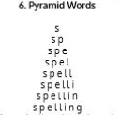  Use pyramid writing to practise spelling this week’s unit words:  disagree, disappear, disapprove, dishonest, dislike, incapable, incomplete, incorrect, independent, invisible, unhappy, unkind, unlock, unsafe
9.45-10.00  Active break | LO: To boost my concentration through movement. | Join in with the Go Noodle clip below to get you moving!  https://www.youtube.com/watch?v=3WnI4UNgSaY
10.00-11.00  English | SPaG Revision LO: To identify proper and common nouns.  LO: To identify the main characters and the setting in a visual narrative. | For today’s SPaG Daily Practice, revise your knowledge of proper and common nouns. Click the link below, watch the video and complete Activity 1 and Activity 2:  https://www.bbc.co.uk/bitesize/articles/zjrdwty  Follow the link below to have a go at today’s English lesson:  https://classroom.thenational.academy/lessons/to-identify-the-main-characters-and-the-setting-in-a-visual-narrative-c8w68t
11.00- 11.15
Break
11.15-12.15  Maths | LO: To practise my recall of the 3 times table.  LO: To read and write three-digit numbers. | Follow the link below to practise the 3 times table and get moving!  https://www.bbc.co.uk/teach/supermovers/ks2-maths-the-3-times-table/z6sw382  Follow the link below to have a go at today’s maths lesson:  https://classroom.thenational.academy/lessons/reading-and-writing-3-digit-numbers-ccrk4r
12.15-1.00
Dinner
1.00-1.15  Storytime | LO: To listen to a story for pleasure. | Listen to Chapter 1 of Timeless Tales of Beatrix Potter  https://stories.audible.com/pdp/B00IZMHQSE?ref=adbl_ent_anon_ds_pdp_pc_cntr-2-3
1.15-2.30  Topic-  Science | LO: To explain what a force is and give examples of some forces in everyday life. | Follow the links below to learn about Forces and complete the activities, before making a mind map of the important facts you have learned:  https://www.bbc.co.uk/bitesize/topics/zvpp34j/articles/zywcrdm
2.30-3.00  Music | LO: To understand pulse and rhythm. | Follow the link below to have a go at today’s lesson:  https://classroom.thenational.academy/lessons/understanding-pulse-and-rhythm-6tjkjd

Beat That!
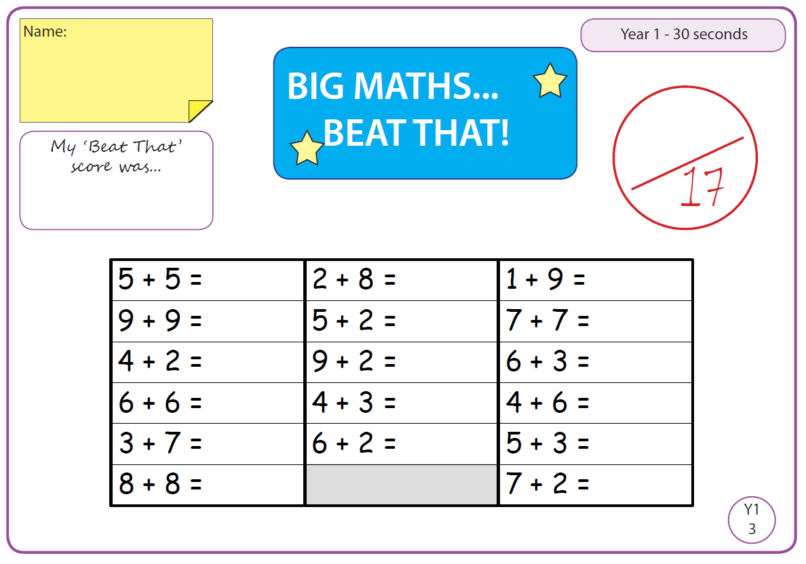

Time and Subject  Tuesday | Learning Objective | Task/Link/Resources
8.45-9.00  Reading | L.O: To practise and consolidate existing reading skills. | Read your individual reading book, either in your head or out loud.
9.00-9.15  Morning Maths | LO: To consolidate recall of number facts.  Revision LO: To revise adding two-digit numbers. | Complete today’s Beat That- scroll down below today’s timetable to find the questions. Remember, it is the same one every day for a week. Can you beat your own score?  Morning Maths: In Morning Maths today, you are going to revise adding two-digit numbers. Click the link below to find the lesson and activities to complete:  https://www.bbc.co.uk/bitesize/articles/zvxxt39
9.15-9.45  Spelling | LO: To practice Unit One RWI Spelling words. | This week, we are revising spelling words with the prefixes in-, dis- and un- and learning to add the prefix mis-.  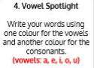  Use Vowel Spotlight to practise spelling this week’s unit words:  disagree, disappear, disapprove, dishonest, dislike, incapable, incomplete, incorrect, independent, invisible, unhappy, unkind, unlock, unsafe
9.45-10.00  Active break | L.O: To boost my concentration through movement. | Join in with the Go Noodle clip to get you moving!  https://www.youtube.com/watch?v=BQ9q4U2P3ig
10.00-11.00  English | SPaG Revision LO: To identify adjectives.  LO: To investigate suffixes: Past and present tense | For today’s SPaG Daily Practice, click the link below to revise your knowledge of adjectives:  https://www.bbc.co.uk/bitesize/articles/zf6c47h  Follow the link below to have a go at today’s English lesson:  https://classroom.thenational.academy/lessons/to-investigate-suffixes-past-and-present-tense-6nhkjc
11.00- 11.15
Break
11.15-12.15  Maths | LO: To practise my recall of the 3 times table.  LO: To partition numbers in different ways. | Follow the link below to practise the 3 times table:  https://www.timestables.co.uk/3-times-table.html  Follow the link below to have a go at today’s maths lesson:  https://classroom.thenational.academy/lessons/partitioning-numbers-in-different-ways-cgw34d
12.15-1.00
Dinner
1.00-1.15  Storytime | LO: To listen to a story for pleasure. | Listen to Chapter 2 of Timeless Tales of Beatrix Potter  https://stories.audible.com/pdp/B00IZMHQSE?ref=adbl_ent_anon_ds_pdp_pc_cntr-2-3
1.15-2.30  Topic- Science | LO: To understand that friction is a force which opposes motion and causes objects to slow down and/or stop. | Follow the links to learn about friction  https://www.bbc.co.uk/bitesize/topics/zsxxsbk/articles/zxqrdxs  Conduct your own friction investigation at home:  https://www.science-sparks.com/friction-and-speed/
2.30-3.00  French | LO: To practise introducing yourself in French. | Follow the link below to revise how to introduce yourself in French:  https://www.youtube.com/watch?v=VMt3dxpYYx8

Beat That!

Time and Subject  Wednesday | Learning Objective | Task/Link/Resources
8.45-9.00  Reading | L.O: To practise and consolidate existing reading skills. | Read your individual reading book, either in your head or out loud.
9.00-9.15  Morning Maths | LO: To consolidate recall of number facts.  Revision LO: To use addition and subtraction bonds to 20. | Complete today’s Beat That- scroll down below today’s timetable to find the questions. Remember, it is the same one every day for a week. Can you beat your own score?  Morning Maths: In Morning Maths today, you are going to revise addition and subtraction bonds to 20. Click the link below to find the lesson and activities to complete:  https://www.bbc.co.uk/bitesize/articles/zjn3gwx
9.15-9.45  Spelling | LO: To practice Unit One RWI Spelling words. This week we are looking at suffixes. | This week, we are revising spelling words with the prefixes in-, dis- and un- and learning to add the prefix mis-.  Use Rainbow Words to practise spelling this week’s unit words:  disagree, disappear, disapprove, dishonest, dislike, incapable, incomplete, incorrect, independent, invisible, unhappy, unkind, unlock, unsafe
9.45-10.00  Active break | LO: To boost my concentration through movement. | Join in with the Go Noodle clip below to get you moving!  https://www.youtube.com/watch?v=KhfkYzUwYFk
10.00-11.00  English | SPaG Revision LO: To identify verbs.  LO: To explore simple sentences. | For today’s SPaG Daily Practice, revise your knowledge of verbs. Click the link below, watch the video and complete Activity 1 and Activity 2:  https://www.bbc.co.uk/bitesize/articles/zfc2mfr  Follow the link below to have a go at today’s English lesson:  https://classroom.thenational.academy/lessons/to-explore-simple-sentences-cmwp8r
11.00- 11.15
Break
11.15-12.15  Maths | LO: To practise my recall of the 3 times table.  LO: To order and compare three digit numbers. | Follow the link below to practise the 3 times table and get moving!  https://www.youtube.com/watch?v=t03yW7Oxsoc  Follow the link below to have a go at today’s maths lesson:  https://classroom.thenational.academy/lessons/ordering-and-comparing-3-digit-numbers-68w68d
12.15-1.00
Dinner
1.00-1.15  Storytime | LO: To listen to a story for pleasure. | Listen to Chapter 3 of Timeless Tales of Beatrix Potter  https://stories.audible.com/pdp/B00IZMHQSE?ref=adbl_ent_anon_ds_pdp_pc_cntr-2-3
1.15-2.30  Topic | LO: To understand what magnets are. | Follow the link below to have a go at today’s lesson:  https://classroom.thenational.academy/lessons/what-are-magnets-cgvkee
2.30-3.00  RHE | LO: To understand what a community is and consider the benefits of being part of a community. | Follow the link below to have a go at today’s lesson:  https://classroom.thenational.academy/lessons/community-care-cctp8c

Beat That!

Beat That!

Time and Subject  Thursday | Learning Objective | Task/Link/Resources
8.45-9.00  Reading | L.O: To practise and consolidate existing reading skills. | Read your individual reading book, either in your head or out loud.
9.00-9.15  Morning Maths | LO: To consolidate recall of number facts.  Revision LO: To add and subtract two and one-digit numbers. | Complete today’s Beat That- scroll down below today’s timetable to find the questions. Remember, it is the same one every day for a week. Can you beat your own score?  Morning Maths: In Morning Maths today, you are going to revise adding and subtracting two and one-digit numbers. Click the link below to find the lesson and activities to complete:  https://www.bbc.co.uk/bitesize/articles/z6vm6v4
9.15-9.45  Spelling | LO: To practice Unit One RWI Spelling words. | This week, we are revising spelling words with the prefixes in-, dis- and un- and learning to add the prefix mis-.  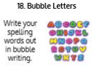  Use Bubble Letters to practise spelling this week’s unit words:  disagree, disappear, disapprove, dishonest, dislike, incapable, incomplete, incorrect, independent, invisible, unhappy, unkind, unlock, unsafe
9.45-10.00  Active break | LO: To boost my concentration through movement. | Join in with the Go Noodle clip below to get you moving!  https://www.youtube.com/watch?v=1b6axyuaKcY
10.00-11.00  English | SPaG Revision LO: To identify verbs.  LO: To sequence and retell the opening. | For today’s SPaG Daily Practice, click the link below to revise your knowledge of adverbs:  https://www.bbc.co.uk/bitesize/articles/zbn492p  Follow the link below to have a go at today’s English lesson:  https://classroom.thenational.academy/lessons/to-sequence-and-retell-the-opening-6nhked
11.00- 11.15
Break
11.15-12.15  Maths | LO: To practise my recall of the 3 times table.  LO: To add and subtract ten and a hundred. | Follow the link below to practise the 3 times table:  http://www.snappymaths.com/multdiv/3xtable/interactive/newlook/3xtablebtcd.htm  Follow the link below to have a go at today’s lesson:  https://classroom.thenational.academy/lessons/adding-and-subtracting-3-digit-numbers-cmw36t
12.15-1.00
Dinner
1.00-1.15  Storytime | LO: To listen to a story for pleasure. | Listen to Chapter 4 of Timeless Tales of Beatrix Potter  https://stories.audible.com/pdp/B00IZMHQSE?ref=adbl_ent_anon_ds_pdp_pc_cntr-2-3
1.15-3.00  PE | LO: To learn and perform a dance routine. | Follow the link below to learn a dance routine inspired by Shrek!  https://www.youtube.com/watch?v=Btxws8qvYAA

Beat That!

Time and Subject  Friday | Learning Objective | Task/Link/Resources
8.45-9.00  Reading | L.O: To practise and consolidate existing reading skills. | Read your individual reading book, either in your head or out loud.
9.00-9.15  Morning Maths | LO: To consolidate recall of number facts.  Revision LO:  To practise counting in 2s. | Complete today’s Beat That- scroll down below today’s timetable to find the questions. Remember, it is the same one every day for a week. Can you beat your own score?  Morning Maths: In Morning Maths today, you are going to revise counting in 2s. Click the link below to find the lesson and activities to complete:  https://www.bbc.co.uk/bitesize/articles/z693rj6
9.15-9.45  Spelling | LO: To practise Unit One RWI Spelling words. | This week, we are revising spelling words with the prefixes in-, dis- and un- and learning to add the prefix mis-.  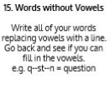  Use Words Without Vowels to practise spelling this week’s unit words:  disagree, disappear, disapprove, dishonest, dislike, incapable, incomplete, incorrect, independent, invisible, unhappy, unkind, unlock, unsafe  Spelling Test:  Scroll down below today’s timetable to use the look, cover, write, check sheet to help you to test yourself on this week’s words.
9.45-10.00  Active break | L.O: To boost my concentration through movement. | Join in with the Go Noodle clip to get you moving!  https://www.youtube.com/watch?v=aEIpC4e2aBY
10.00-11.00  English | SPaG LO: To develop my understanding of pronouns.  LO: To develop a rich understanding of words associated with night time. | For today’s SPaG Daily Practice, click the link below to revise your knowledge of pronouns.  https://www.bbc.co.uk/bitesize/articles/zjsnm39  Follow the link below to have a go at today’s lesson:  https://classroom.thenational.academy/lessons/to-develop-a-rich-understanding-of-words-associated-with-night-time-60r3gc
11.00- 11.15
Break
11.15-12.15  Maths | LO: To practise my recall of the 3 times table.  LO: To round 2 and 3 digit numbers to the nearest ten. | Follow the link below to practise the 3 times table:  http://www.snappymaths.com/multdiv/3xtable/interactive/newlook/3xmissintd.htm  Follow the link below to have a go at today’s lesson:  https://classroom.thenational.academy/lessons/rounding-2-and-3-digit-numbers-to-the-nearest-10-6gu3er
12.15-1.00
Dinner
1.00-1.15  Storytime | LO: To listen to a story for pleasure. | Listen to Chapter 5 of Timeless Tales of Beatrix Potter  https://stories.audible.com/pdp/B00IZMHQSE?ref=adbl_ent_anon_ds_pdp_pc_cntr-2-3
1.15-3:00  Art | Golden Time  LO: To develop skills in drawing landscapes. | Create your own landscape drawing like Ken Done:  https://www.bbc.co.uk/bitesize/clips/zdsb9j6

Beat That!

Spelling Test
