School Vision Update
We have been updating our School Vision with Governors, Staff and children. We have formed our key thoughts into this poster which you will see around school

Attendance
Well done to all classes in green.
Please can you ensure that all holiday in school time requests are made in writing. Office@sandal.wakefield.sch.uk

KEY
100% | PERFECT!
>97% | AWESOME JOB
>95% | GOOD
>94% | ALMOST THERE

Class | %
2EJ | 99.0%
6RW | 97.2%
4JS | 96.7%
4ER | 96.2%
2CW | 96.0%
6RS | 95.9%
5HF | 94.7%
2KM | 94.3%

Swimming News

All year groups had 50 minutes to complete as many lengths as possible.
They worked really hard to achieve these fantastic results.

14 Year 3 children - 1806 lengths
8 Year 4 children -1280 lengths
9 Year 5 children - 1426 lengths
8 Year 6 children - 1380 lengths

Total - 5892 lengths

We still some sponsor money to come in but we are currently at £2870!

Well done to all our swimmers.
Science Event at Kettlethorpe
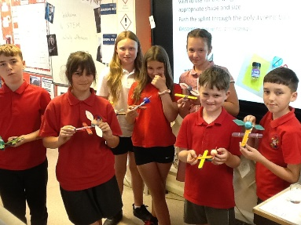
On Wednesday afternoon, some of our Year 6 pupils attended Kettlethorpe high school to take part in their Harry Potter themed STEM challenge event. The children took part in 3 investigations involving bunsen burners and then had to construct a catapult to fire the golden snitch furthest. The children were all fantastic representatives for the school and used their scientific knowledge in creative ways to construct their catapults. Well done Year 6!

Cycle Safety
For obvious safety reasons, if your child uses a bicycle or scooter to travel to school, please can you enure that they wear a helmet.

Water Safety
Having fun in the sun during the summer holidays often includes water, be it in a paddling pool, Lido, villa pool, lake, river or the sea.
Please see the advice below.

Further information & resources
- The Royal National Lifeboat Institution
- The Royal Life Saving Society
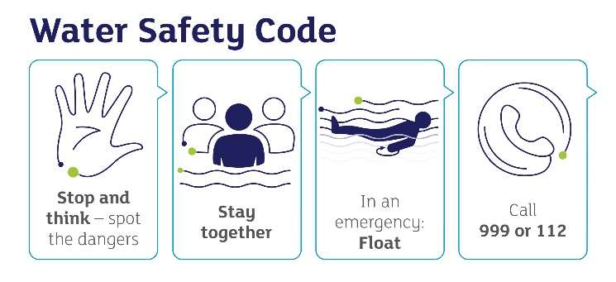
There are many dangers with water, which can include:
- It can be very cold
- There may be hidden currents
- It can be difficult to get out (steep slippery banks)
- It can be deep
- There may be hidden rubbish, e.g. shopping trolleys, broken glass
- There may be no lifeguards there
- It is difficult to estimate depth
- It may be polluted and may make you ill

Stay together
- It is always better to go to the water with a friend or family member
- Children should always go near water with an adult
- An adult can point out dangers or help if somebody gets into trouble.

Float
If you fall into the water unexpectedly – float until you can control your breathing. Then call for help or swim to safety.

Call 999
You may be able to help yourself and others if you know what to do in an emergency.
If you see someone in difficulty, tell somebody, preferably a Lifeguard if there is one nearby, or go to the nearest telephone, dial 999, ask for the Fire Service at inland water sites and the Coastguard at the beach.

Please take care when crossing the road when coming to and going home from school.

Stay safe and enjoy the sunny weekend!

Mrs Hunt
Interim Headteacher

Date(s) | Event in School | Key Notes for Parents
Thursday 29th June | Year 6 Disco | 3.30 – 5.00 pm
27th June | Jorvik Viking Centre, York  Visit. Year 5
Monday 3rd July | Sports Day | Year 5 9.30 – 11.00 AM  Year 6 1.30 – 3.00 PM
Tuesday 4th July | Sports Day | Year 1 9.30 – 11.00 AM  Year 2 1.30 – 3.00 PM
Thursday 6th July | Sports Day | Year 3 9.30 – 11.00 AM  Year 4 1.30 – 3.00 PM
Thursday 13th July | Sports Day | Foundation Stage AM
Friday 14th July | Whole School Transition Day
11th July | Coronation Theme Day  Whole School  (More details to follow)
12th and 13th July | Murton Park, York Visit  Year Year 4
Thursday 13th July | The Lion King | Year 6  Performances at 2pm and 6pm
Monday 17th July | Parents Picnic | Year 6  2pm
Wednesday 19th July | End of Year Reports | Whole School
Wednesday 19th  July | Leaver’s Assembly for parents | 9.00 – 10.00

“Call an EIT”

Do you have worries about your child’s return to school in September?
Would you like strategies on what you could do to try to help your child?
Would you like to speak to somebody and get advice on what could be done to help?

If you have answered “yes” to any of the above, then the “Call an EIT” service is available for parents and carers throughout the school summer holidays.

We have Educational Improvement Teachers (EITs) available to take your call to listen to your worries and provide support and impartial advice.

The EITs are available to take your telephone call on the following dates:
Tuesday 25th July | 9.30am – 12.00pm
Tuesday 1st August
Tuesday 8th August
Tuesday 15th August
Tuesday 22nd August
Tuesday 29th August
Thursday 31st August
Tuesday 5th September
Thursday 7th September

If you wish to “Call an EIT”, please call the Educational Psychology Service on 01924 307403 and ask to speak to an EIT.

