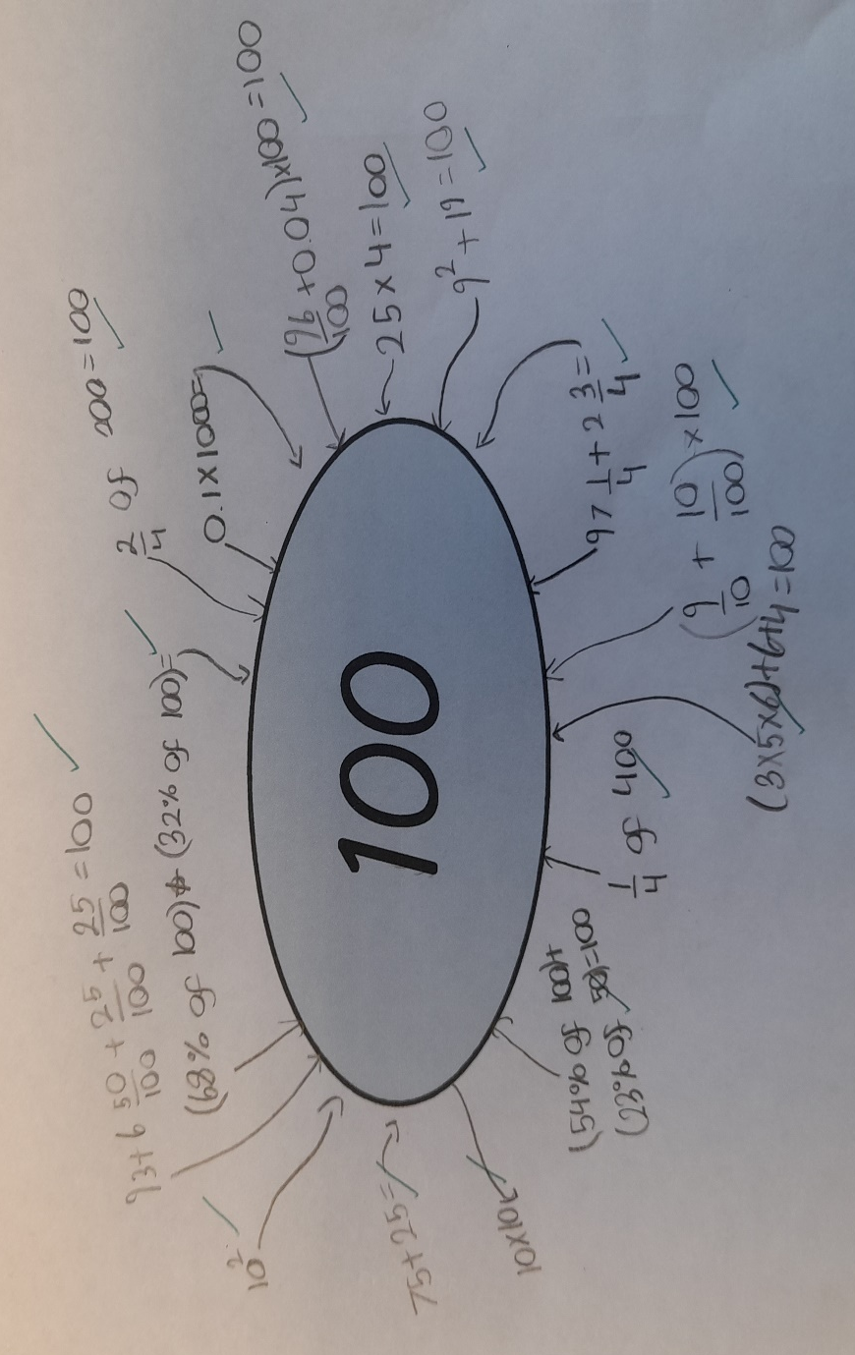
In maths, for Captain Moore 100, the children were firstly asked to make the number 100 using any combination of numbers and operations. To extend their thinking further, they were then asked to create the number 100 using 7 given numbers. Each number could only be used once. Please look at the examples below:

